The idea is to develop an application with 1 or more pages. Please find the details below.
Initial Screen: Once the user enters the correct credentials it has to allow the user to the subsequent screen
Screen 1:
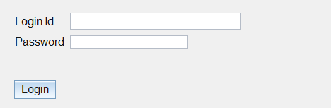
Screen 2: (Actual designed screen that has to be displayed)
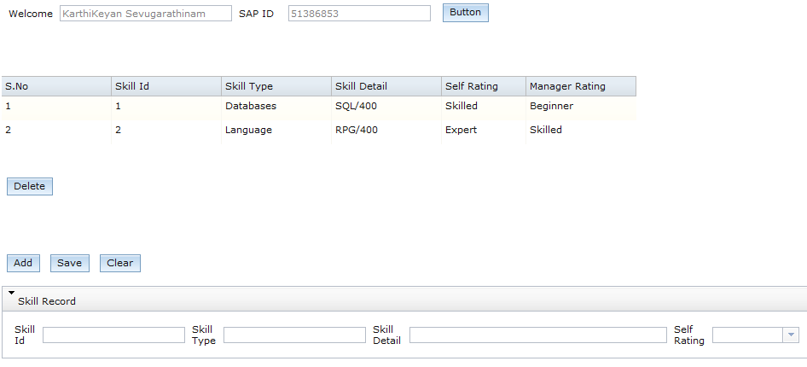

Screen 3: Currently displayed screen 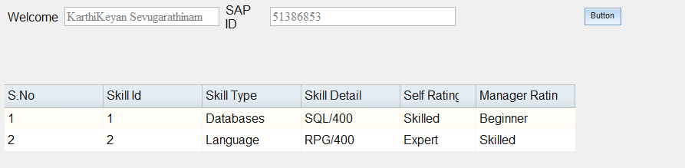
We are trying hard to find out the reason for some of the grid_ui or buttons not being displayed. Please find the source code attached. Thanks

