When I directly do get on /3/0/0 it returns me manufacturer data.

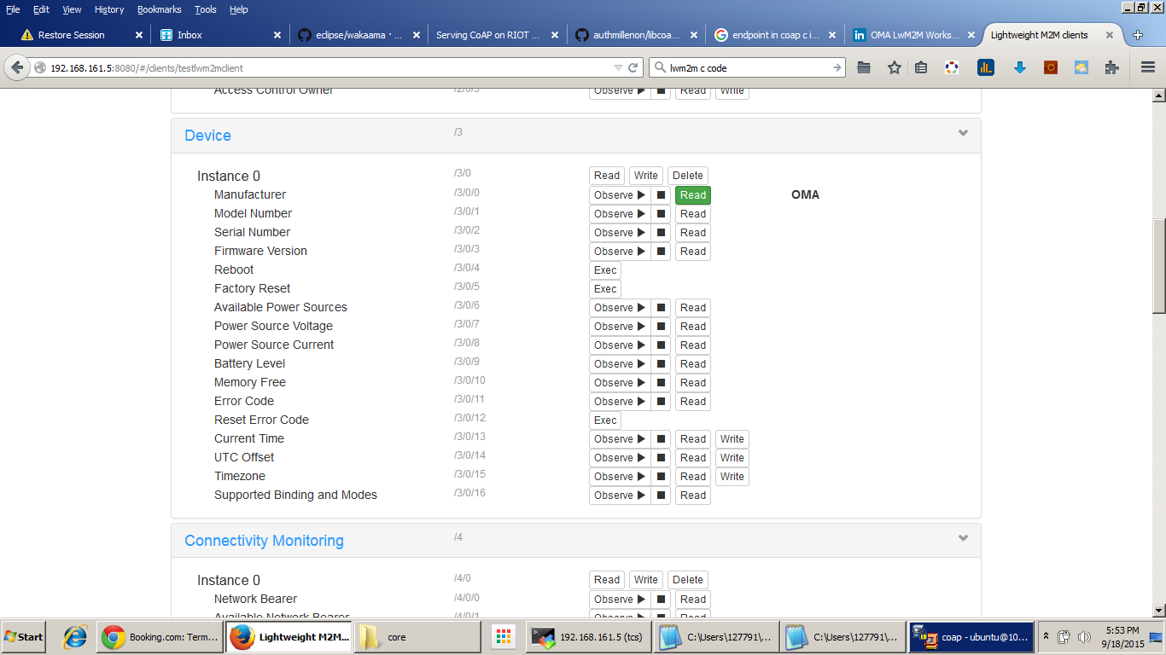

But when I try to do get on a custom resource -
I have first do a get on object and then resources are shown and I can do get resource

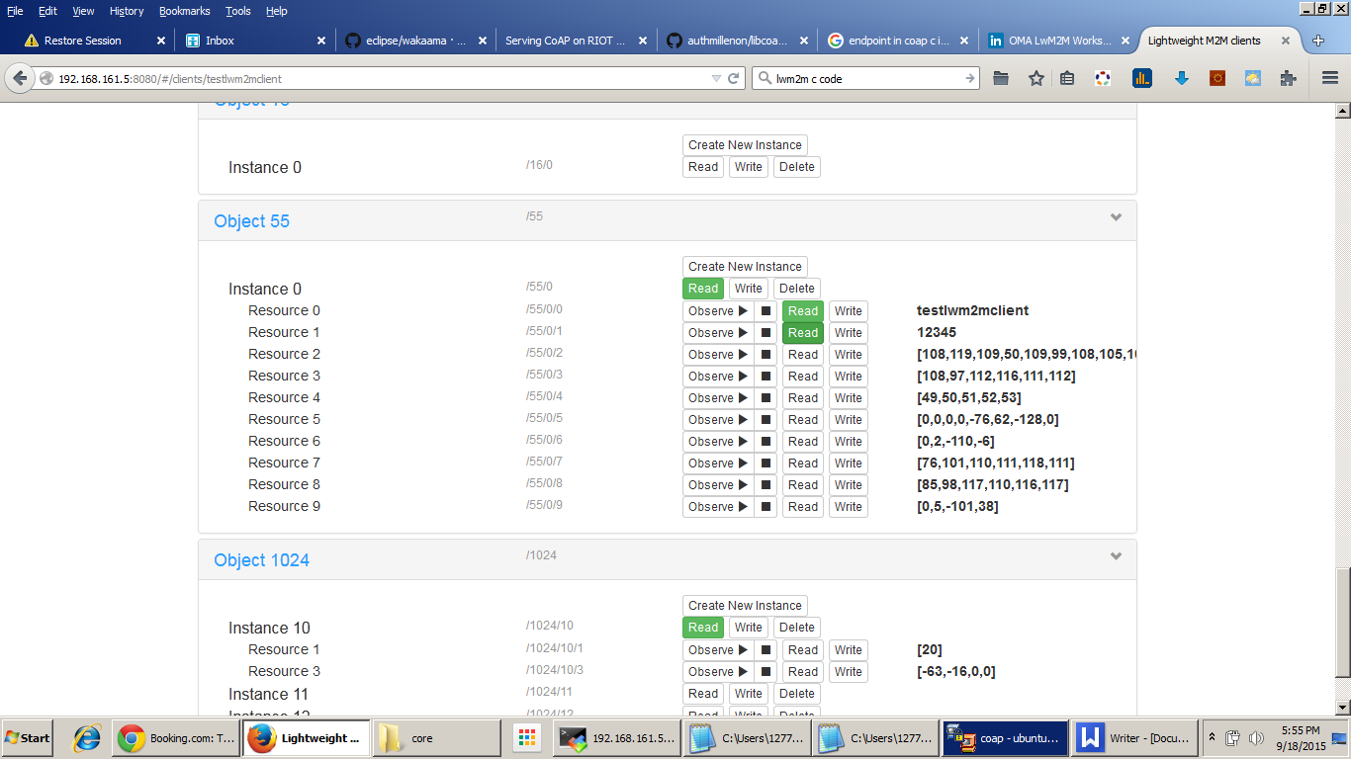

1. How to enable direct get call on custom resources like we can on the normative object of lwm2m spec eg. device resource i.e. /3
2. How to show name of the resources like manufacturer etc . ? Like /3/0/0 is shown as manufacturer but not /55/0/0 as “myresourcename”

