Please complete this form to submit a Tangle EE Project Initiative  
  
SUBMISSION DEADLINE: 24-April-2020  
  
Please send your completed proposal form no later than 24 April 2020 to:  
  
[Alex.westerhof@iota.org](mailto:Alex.westerhof@iota.org)   
[Jan@iota.org](mailto:Jan@iota.org)   
[jelle.millenaar@iota.org](mailto:jelle.millenaar@iota.org)  
  
If you have any questions or would like an initial review of your Project Initiative Proposal before submitting, please feel free to reach out via Slack directly.  
  
**Guidance on Project Initiatives**

Project Initiative Proposals from all members are welcomed with the key objective being to stimulate collaborative innovation and a continuous stream of value outcomes for all members.

Project Initiatives are submitted at the start of each quarter which are reviewed and discussed by the working group members. Once the matchmaking and Project teams have been formed, activities start where the outcome and results are showcased and shared with the working group each quarter end.  
  
  
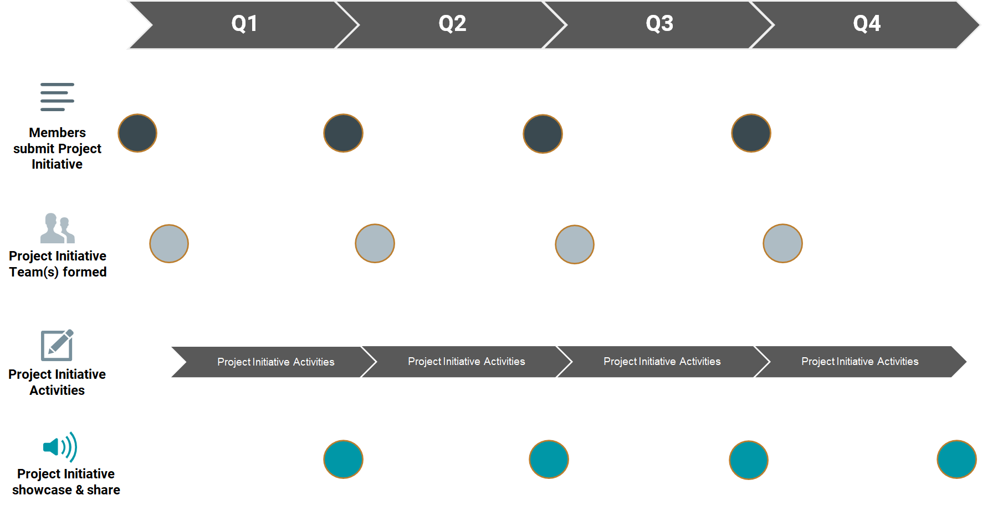

|  |  |
| --- | --- |
| **Project Initiative Name** | Enterprise Data Management in the Tangle |
| **Eclipse Project** | Eclipse Decentralized Marketplaces |
| **Submitted by:**  Name: Organization: E-mail: | Steve Todd  Dell Technologies  steve.todd@dell.com |

**Problem Statement: Example**

|  |
| --- |
| **As** corporate data assets become increasingly decentralized, enterprise companies struggle to create a “data portfolio view” of their own assets.  **I need to** be able to define and package …  • … a “**Data Dashboard”** that identifies and classifies data assets that have been registered in the Tangle and that belong to a specific enterprise, and is able to provide summary views of different provenance about those data sets.  **so that** I can expose my solution offer into the shopping **cart, enabling** …  • … a view into the possibilities of measuring the trustworthiness of that data, based on its enterprise attributes  • … future research projects that correlate data trustworthiness to data value  **I know I am successful when**…  • … multiple parties begin collaborating in the area of decentralized data management of enterprise assets, and its relation to data valuation, and beginning to form related standards and specifications |

**What are the benefits of solving the problem?  
How will this create value & positive impact?**

|  |
| --- |
| As decentralized applications begin analyzing raw data streams from decentralized sources, there are no standards describing corporate ownership, provenance, or lineage of the data (as well as other important attributes). Creating a dashboard to visualize these attributes in an enterprise setting will bring a higher level of confidence to the analysis of decentralized data. |

**Expected outcomes, expected deliverables**

|  |
| --- |
| The deliverables will be a dashboard that displays enterprise data that is registered in the Tangle. This implies that some sort of data generation engine is registering data sets in the tangle, along with accompanying metadata that describes attributes about the company that is generating the data. |

**Expected Timeframe to complete**

|  |
| --- |
| 3 Months |

**We will contribute the following ourselves:**

|  |
| --- |
| We will contribute developers that can help register enterprise data in the Tangle and begin to learn the tools that are used to query and display tangle data. |

**We seek to work with / seek support from the following WG members**

|  |
| --- |
| We would seek support from community members that can contribute skillsets in the area of visualizing data assets registered in the Tangle. |

**Please indicate estimated minimum & maximum # of Project team members required:**

|  |
| --- |
| Minimum: 3 Maximum: 6 |

**Please indicate the organization & individual(s) required: [I have trouble accessing google drive]**Members & Contact overview: <https://drive.google.com/drive/folders/0AJUmXGO65JTnUk9PVA>

|  |  |  |  |  |  |
| --- | --- | --- | --- | --- | --- |
| **Project Role** | **Name** | **Organization** |  | **Email** | **Confirmed/tentative** |
|  |  |  |  |  |  |
|  |  |  |  |  |  |
|  |  |  |  |  |  |
|  |  |  |  |  |  |
|  |  |  |  |  |  |
|  |  |  |  |  |  |

**Are you willing to introduce the problem statement during a Project Call**  
Yes  
  
**Are you willing to showcase and share the (e.g. PoC) results after the project sprint has been completed**

Yes