Please complete this form to submit a Tangle EE Project Initiative  
  
SUBMISSION DEADLINE: 24-April-2020  
  
Please send your completed proposal form no later than 24 April 2020 to:  
  
[Alex.westerhof@iota.org](mailto:Alex.westerhof@iota.org)   
[Jan@iota.org](mailto:Jan@iota.org)   
[jelle.millenaar@iota.org](mailto:jelle.millenaar@iota.org)  
  
If you have any questions or would like an initial review of your Project Initiative Proposal before submitting, please feel free to reach out via Slack directly.  
  
**Guidance on Project Initiatives**

Project Initiative Proposals from all members are welcomed with the key objective being to stimulate collaborative innovation and a continuous stream of value outcomes for all members.

Project Initiatives are submitted at the start of each quarter which are reviewed and discussed by the working group members. Once the matchmaking and Project teams have been formed, activities start where the outcome and results are showcased and shared with the working group each quarter end.  
  
  
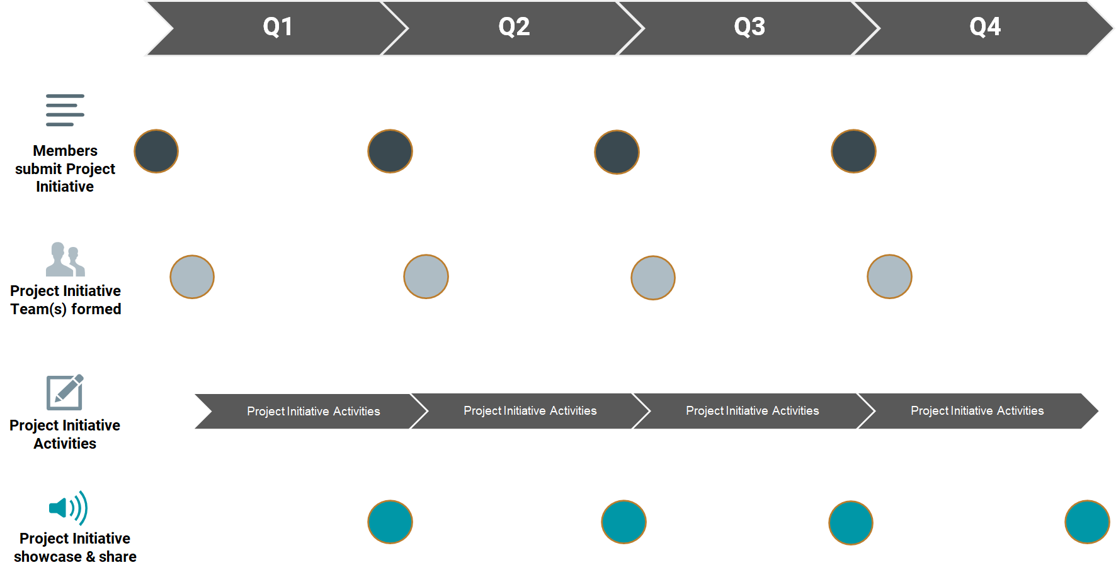

|  |  |
| --- | --- |
| **Project Initiative Name** |  |
| **Eclipse Project** | Eclipse Unified Identity **or** Eclipse Decentralized Marketplaces **or** Both |
| **Submitted by:**  Name: Organization: E-mail: |  |

**Problem Statement: Example**

|  |
| --- |
| **As** the Industry 4.0 Smart Grid Product Manager,  **I need to** be able to define and package …  • … my industry 4.0 **“Power Grid Transformation” (PGT)** solution with it’s multiple components and technical options + add-ons **in a service and business rule driven product catalogue, and available in an API**  **so that** I can expose my solution offer into the shopping **cart, enabling** …  • … my sales agents and power utility customers to **select, configure and order** the appropriate combination of PGT products and services (which includes **grid specific Artificial Intelligence and control systems** …. which are underpinned by **a range of smart infrastructure from various partners**, spanning IoT, 5G, SDN’s NFV’s and compute at the edge, etc – all controlled seamlessly from the cloud)  • … and then when the order button is pressed, all those devices and services are **seamlessly provisioned across me and my partners systems and the fulfilment progress**  **I know I am successful when**…  • … all the devices and systems have arrived at a power substation and are **activated “zero touch”** by simply turning on each device’s power switch, enabling **each substation** to have **PGT protection & performance enhancements**  **and also**, in the knowledge…  • … that all those devices and services are **fully controlled and managed “in life” from the cloud, leveraging the basis of a secure supply chain**, and with the assurance that all the devices & systems are secure and not hackable  **and**…  • … that the **billing for the solution sold, implemented and in use** will accurately reflect the pricing in my catalogue and automatically **my supplying partners** are also able to bill me as per their pricing to me |

**What are the benefits of solving the problem?  
How will this create value & positive impact?**

|  |
| --- |
|  |

**Expected outcomes, expected deliverables**

|  |
| --- |
|  |

**Expected Timeframe to complete**

|  |
| --- |
| 3 Months |

**We will contribute the following ourselves:**

|  |
| --- |
| Capabilities, resources etc. |

**We seek to work with / seek support from the following WG members**

|  |
| --- |
| XXXX because XXXX XXXX because XXXX |

**Please indicate estimated minimum & maximum # of Project team members required:**

|  |
| --- |
| Minimum:  Maximum: |

**Please indicate the organization & individual(s) required:**Members & Contact overview: <https://drive.google.com/drive/folders/0AJUmXGO65JTnUk9PVA>

|  |  |  |  |  |
| --- | --- | --- | --- | --- |
| **Project Role** | **Name** | **Organization** | **Email** | **Confirmed/tentative** |
|  |  |  |  |  |
|  |  |  |  |  |
|  |  |  |  |  |
|  |  |  |  |  |
|  |  |  |  |  |
|  |  |  |  |  |

**Are you willing to introduce the problem statement during a Project Call**  
Yes / No  
  
**Are you willing to showcase and share the (e.g. PoC) results after the project sprint has been completed**

Yes/No