Unsaved Changes
If the editor contains changes to the resource since the resource was last saved (i.e., it is "dirty"), an asterisk should be used to prefix the resource name presented in the editor tab:
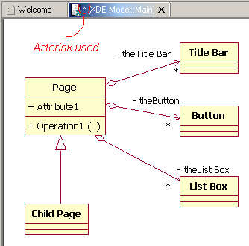
Guideline 5.18
If the resource is dirty, prefix the resource name presented in the editor tab with an asterisk.

