Default SWT Text margins vs Combo on Win32 (Windows 2000)

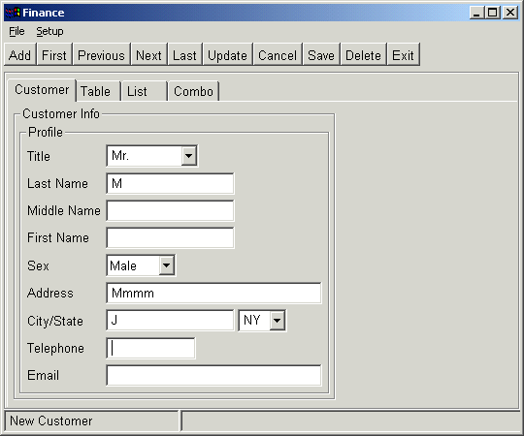

1. Left and Right Margins
See Combo “Sex” & Text “Address”, the left margin of Text is greater than Combo
Note: if Combo is not set READ_ONLY (editable = “true”) it’s OK, as the comparison
of Combo “Title” and Text “Last Name”

2. Top and Bottom Margins
As Text “City” and Combo “State”, the Top (Bottom) margins of Combo is higher than
Text

