Analysis of Current Site

Project Goals
- grow eclipse community, set of contributors (very important for long term sustainability)
- pervasive adoption of eclipse as tooling platform
- compete with .net (Eclipse/IBM goal)
- grab developers (mindshare, plugins)

Audience
- users (JDT, desktop)
- developers (free Java IDE)
- developers (framework users)
- developers (contributers)
- analysts/press

Community
- OTI
- Developers supported by consortium companies
- Open source developers
- IBM
- Consortium
- Consultants

Top Issues with www.eclipse.org
1. Difficult to navigate, find things, search.
2. Boring
3. Doesn't feel like the community's place.
- Why is there a "community" link, isn't the whole thing the community's page?
- It feels more like "OTI Eclipse" page rather than the community's.
4. People don't know what Eclipse is.
5. Pages differ in style/layout from one project to another

Website Goals
1. Eclipse needs to feel relevant, important, real.
2. The site should feel alive, be a place to go weekly. There are all sorts of things going on in Eclipse community and the site should reflect this.
3. Should feel a bit edgy, chaotic because its open source. Should be lively, informal, yet professional.
4. Need to avoid it feeling too stuffy and corporate since it will turn off open source developers.
5. Need to make it clear that there are places for people to contribute, shape eclipse.
6. Should feel like the place where the community comes to together.
7. Needs to be relatively low cost to maintain by people of differing html and graphic skills. [Q: The site itself could be an Eclipse project?]
8. Must balance needs of different users.
9. The following questions are probably typical:
Q: What is it?
Q: What's a plugin? How do I write one?
Q: What platforms will it run on?
Q: Which download do I want?
Q: Which repositories can I use it against?
Q: What are consortium members doing?
Q: My company is interested in moving our tooling to Eclipse -- what "real" stuff is being done with Eclipse?
Q: My company is interested in moving to using Eclipse -- what kind of support do I get? (Note: opportunity to vector person off to Eclipse supported products including WSAD).

Presentation Issues

- The first page of the site is absolutely critical. It needs to convey that Eclipse is cool and that there's stuff happening. It needs to feel alive. At present we waste 1/2 our initial visible space telling people what Eclipse is.

- The site should feel relevant to returning visitors, with a clear way to find background info if you don't know what it is (link to About). The main page should show the meat of what it is (screen shots, news, cool new plugins), and would assume you had heard of it at least vaguely.

Organization/Navigation Issues

- The eclipse project names are ambiguous and confusing. For example, "Eclipse" vs. "Eclipse Project". We popularly refer to the “SDK” but you can’t really find it anywhere. The names “Tools” and “Technology” are also a problem because the names alone imply more or less than the projects are about. This makes it difficult to use them in a navigational model, especially if this is the sole form of navigation since those who don’t know what they are can’t tell from the names.
- The division between eclipse/eclipse projects/eclipse subprojects contributes to getting lost. This is how *we* have structured the projects wrt. the PMCs etc. but its not what people are immediately interested in -- they just want to see the cool stuff. For example, its probably confusing to a newbie that JDT isn't part of the eclipse tools project and they may not think to look in there for it.

Our project tree looks like:

Eclipse
Eclipse Project ::Isn't that the same as Eclipse?
Platform :: Popular but buried
Core :: This is where people (finally) find the FAQ's etc. they need
Debug
Team
UI
...
Java IDE :: Popular but buried
Core
Debug
UI
PDE
Eclipse Tools :: Aren't JDT and PDE also tools?
C/C++ :: These are actually interesting but you may never find them
GEF
EMF
Cobol
Eclipse Technology :: Isn't all the above technology?
AspectJ
AJDT
Stellation

- Our current organization mirrors our project organization. We need to organize it around what we think people want to know (or what we want them to know). Our tree is very deep which hurts navigation/searching.

- The consortium is part of the community too, need to balance their needs

Presentation - Issue Details
- "Welcome to Eclipse" paragraph is nice for first timers but wastes space for those who already know what Eclipse is.

- Left navigation bar isn't that helpful and takes up a lot of space since you can't use the bottom of that column.

- Frames are bad -- can't get (and save) a link to something and the url displayed at the top of the browser as you navigate doesn't update

- News headlines should have parapraph of text on main page. Right now we just have single text line which isn't enough to let someone know if they want to read more.

- Old news is not news (e.g back to June 5th). Instead of taking up valuable home page space, old news should be in an archive page.

- All FAQ's should be accessed from one link pref. on home page since if you are confused you won't know which FAQ to hunt down (or where).

Technical issues
- Searching for whitepaper doesn't reveal any

Proposal

The site should serve the following audiences:
- people developing plugins (want to show its easy to do, there's support)
- Java developers who downloaded eclipse as a free IDE
- other language developers (ie. Q: What languages can I use it for?)
- those working on the platform, or keeping up with latest of it
- those deciding whether to move their products to eclipse
- those trying to understand what they can do with eclipse

Template pages will be provided. The pages will be designed such that they all fit a consistent theme, making navigation easier, and will be simple to author and maintain. As new subprojects are started (e.g. in Eclipse Tools), they will take the appropriate template page and fill in their details. The following template pages will be provided:

- Home/community
- Project
- Subproject
- Component
- Plugins list
- Other/Generic

There are two styles of pages, community pages and structural pages. The structural pages are consistent with the ones we have now, and are organized along the project/subproject/component lines. The community pages allow us to tie information in from various places to create a focus for people in that area. For example, a “Plugin Dev” page will provide articles, tips, etc., for people writing plugins. The community pages allow us more flexibility in fine tuning the message we want to send to the different types of eclipse participants. Currently, for example, there isn’t a good place for Jeff to talk about performance work. Now there will be.
The community pages will follow somewhat of a “newspaper” model, 2 or three columns with short messages and links to longer articles, news items, etc. This model will allow us to modify the site content as need arises, and allow us more flexibility to emphasize different areas by their placement. It is also a more readable model than page wide paragraphs and produces denser information without clutter. They will have a news column, plus one or two columns of information boxes. The contents of these boxes vary by area. The home page will have three columns, a “Getting Started” area, a top “Feature” area, an upcoming events area, and space for several information boxes (of text and/or links) whose theme and content can be chosen as need arises.

Proposed Pages and Content

Page: Home (www.eclipse.org)

Audience
- entire eclipse community

Flavour
- technical slant, but contains non technical information as well
- this is where you go to get the pulse of what's happening in eclipse
- people should come away believing eclipse is active and valid
- semi-newspaper format

Mockup
See Fig 1 and Fig 3 at end. Fig 3 was the original mockup but there may be some issues with being able to program it in HTML and have low cost of maintenance. Fig 1 is an alternative that doesn’t have these issues, but we’d like it to be a bit livelier.

Top Tabs
The proposal for the tabs has undergone several revisions and will probably continue to do so. Its important because it says what we are emphasizing on the site, yet needs to be fair to all the eclipse projects, the consortium, and community at large. There is a tension between wanting the tabs to represent the various projects (structural wrt. our organization of the PMC's), and wanting them to be thematic. The problem with them being structural is that it doesn't help someone who doesn't know already.

The 'major' tabs appear as booktabs along the top, underneath the banner. They represent different communities, and each would take you to a page with content contributed by and relevant to that community. The secondary links would be lower profile and appear in the banner itself (see accompanying mockup). These allow people to navigate down in the PMC's, as they could before. I would like us to not get too hung up on the words at this stage (i.e. there is probably a better name for "IDE User Home").

Major tabs - communities:
[Plugin Dev | SDK Dev | IDE User Home | Plugins Showcase | Research | Commercial Corner ]

Links in banner - structural:
{Projects | Consortium | Help}

(alternatively,)
{Eclipse Project | Tools Project | Technology Project | Consortium | Help}

Note: the banner icon is 'Home'

The pages that each tab would take you to would have the following kind of content:
Plugin Dev | Articles on getting started, writing your own plugin, performance tips, etc. (more below).
SDK Dev | Integration build discussion/status, guidelines, milestone plans, etc.
IDE User Home | This is where people go if they using Eclipse as a tooling platform. Install instructions, list of platforms supported, list of providers available, etc. Areas for Java/C++/Cobol. This is where have our "See our cool IDE" user pages; these aren't the JDT tech pages (but they may link to them).
Plugins Showcase | This is where we show off all the plugins available for eclipse. It combines both those hosted by eclipse, and those external:  - Hosted (EMF, GEF, etc, culled from Eclipse Tools and Eclipse Technology projects, but not including IDE's)  - External (plugins hosted in source forge, elsewhere)
Research | (not sure if we need this vs. Eclipse Technology page)
Commercial Corner | Info/links to WSAD, etc. Also good place for Consortium to show their stuff, announcement of a new consultant's services, etc.

Why these tabs?
- Plugin Dev: answers question, "How hard is it to write a plugin? How much support for doing this is there?"
- SDK Dev: answers question, "How do I get involved with building Eclipse itself?"
- IDE User Home: answers question, "What languages will it support? Will my (language) community be able to use it?" Also, those who heard of Eclipse as "free Java IDE" can go here.
- Plugins Showcase: answers question, "What add-ons exist for it?"
- Commercial Corner: answers question, "Is this real? What's the industry support/participation like?"

Feature Box
The Feature Box is an area at the top of the home page where we can draw people’s attention to something we think of current interest. The area is large enough to support either a small and a medium box of information, or one large one (big enough to support a screen shot plus blurb). Ideas for potential content include:
- An article (quote, link)
- The “New and Noteworthy in M4” type of announcement
- A cool new plugin (hosted or external, screen shot, words, link)
- Announcement about a grant

Getting Started Box
It is important the people who are new to the site that they have clear information on what eclipse is, which download to take, and how to get going. A “Getting Started” section will appear on the home page to provide this information. See mockup Fig 1. The goal is to balance the space required for this information without making it the focus of the home page.

Info Boxes
(examples of potential titles and content):

Plugged In
- Snippet of interesting discussion from newsgroup, mail list. ***Requires editor, updated once or twice /month

Just Minted
- New plugin in the community

Build Status
- (e.g. successful declaration of milestone build)

R&D
- "Eclipse Innovation Grants" - http://dev.eclipse.org/mhonarc/lists/eclipse-dev/msg01341.html

Eclipse At Large
- list of links to external Eclipse sites we like. There are too many to fit, so <more...> takes you to page with them all, and description of each.

- hints and tips -- culled from dev mail list, eg. http://dev.eclipse.org/mhonarc/lists/eclipse-dev/msg01390.html,
Thought this might be of interest for all of us since Kai and I had the
same problem when launching the target from our development workspace with
newest builds: org.eclipse.tomcat is now required by org.eclipse.help,
org.eclipse.help.ui and org.eclipse.update.ui. Depending on your setup the
problem can be solved by adding org.eclipse.tomcat to the development
workspace or by enabling the external org.eclipse.tomcat.

Site Update
- e.g. culled from dev mail list, http://dev.eclipse.org/mhonarc/lists/eclipse-dev/msg01427.html, "I have added a link to the "Running Eclipse" document to the Getting Started section of the Eclipse Project FAQ. ..."

Commercial
- if consortium member has an announcement, it goes here (e.g. new product version)
- if a new consultant is starting up, they can announce themselves here
- if someone is looking for a consultant, they can ask here (currently it goes in newsgroup but gets lost)

Page: Plugin Dev

Audience
- new to writing plugins
- experienced writing plugins, doing ongoing development

Flavour
- super technical

Feature Box
(single large, examples):
- Jeff talking about performance
- Call for articles

Info Boxes
- last N hints and tips
- current build status (same as posted to dev-eclipse)
- proposed
- swt snippets

Page: SDK Dev

Audience
- those on the bleeding edge, taking latest builds
- working on SDK, either committer, submitter, bug reporter
- writing plugins (external) and want to stay up on latest happenings

Flavour
- super technical

Info Boxes
- last N hints and tips
- current build status (same as posted to dev-eclipse)

- submit a bug (Platform, JDT, PDE)
- info on know which 'Product' (Platform, JDT, PDE) and which component to submit a bug to
- *** Note: what we are calling Products in bugzilla are actually subprojects
- subproject pages (Platform, JDT, PDE)

Standard subproject template

Each subproject will follow this template. By using the same template, it makes it easier for people to navigate the site:
- description
- doc (online html javadoc, other doc)
- downloads
- faq's
- how to participate
- getting started
- bugs
- component list
- plans/schedules

Components can follow the same template, but this could be up to the project/subproject in question.

Mockups
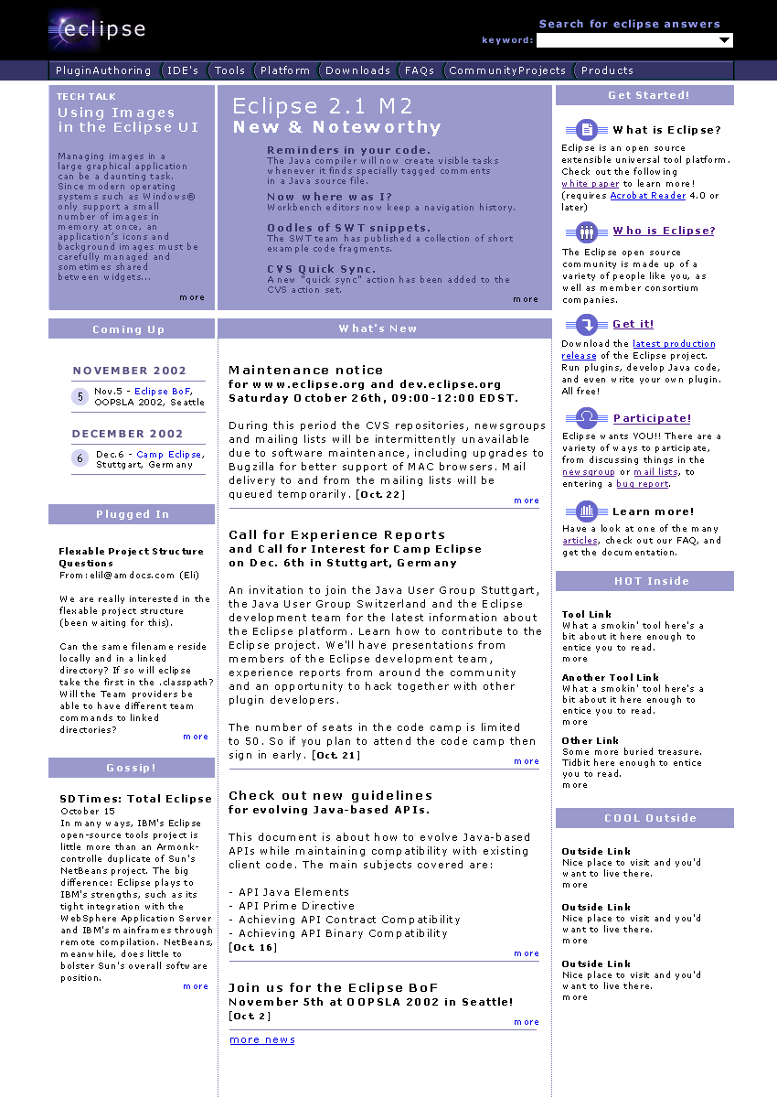

Fig. 1: Mockup of Home Page
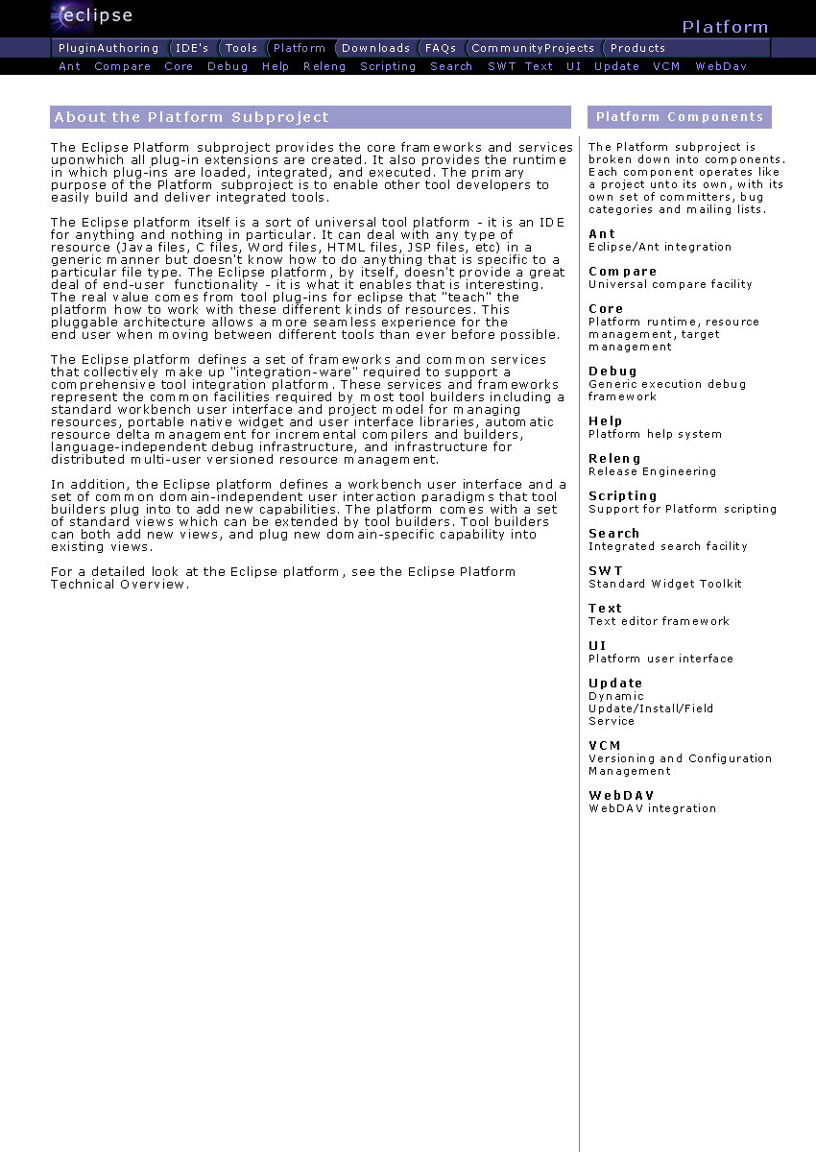
Fig 2: Mockup of Subproject Page
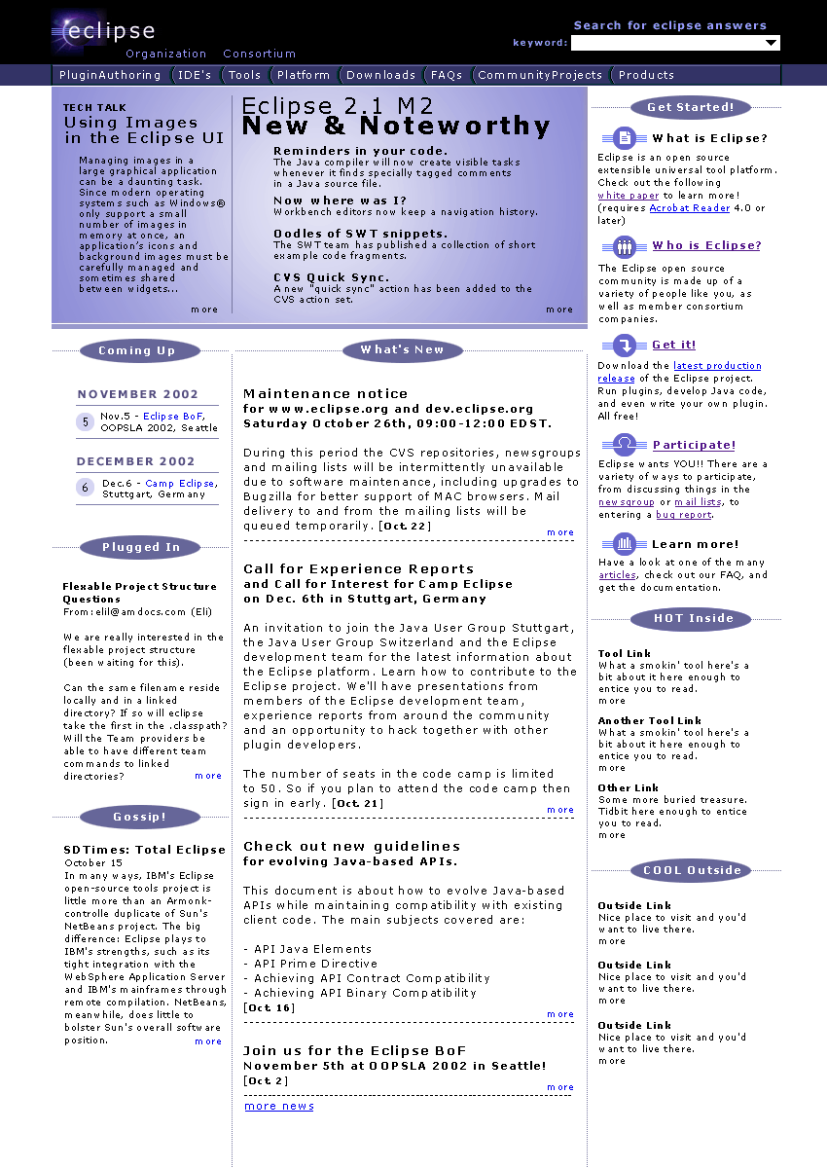
Fig 3: Original Mockup (some web programming issues)

Existing Web Map and Correspondance
(this section work in progress)

Legend
:subject: = existing page/link
[subject] = proposed new page/link/info box

Home page left column links

:consortium:

:projects:
Eclipse Project
Eclipse Tools Project
Eclipse Technology Project
[Organization]

:downloads:
(note: this is actually just downloads for the SDK)
[Get Started -> Get It (current product level -- 2.0.2) ]
[? - where do you get other SDK builds? (tbd)]
[? - where do you get downloads for the other projects/subprojects -- centralized?, Plugins page? ]

:articles:
[Get Started -> Learn More]
[Plugin Dev page]

:newsgroups:
[Get Started -> Participate]

:mailing lists:
[Get Started -> Participate]

:community:
Note: much of this will now be seen or at least linked to from the home page
Resources, Projects, ... :: Blurb about contributing news, email addr
Upcomming Events [Home page -> News column]
Open source technologies used in eclipse [Get Started -> What is Eclipse (?)]
Sources of eclipse information :: wiki, other links [Home page links box -> Eclipse at Large, dedicated page]
About open source :: [Get Started -> Who is Eclipse]

:search:
[Search box home page/every page]

:bugs:
[Get Started -> Participate ]

------------------------------------------------

Eclipse project links

:Platform:
Components

:JDT:
Core
Debug
UI

:PDE:
Core
UI

:documentation:
2.0 Doc
1.0 Doc
Workbench User Guide
Java Development User Guide
PDE Guide
Platform Plug-in Developer Guide
JDT Plug-in Developer Guide

:development:
Conventions and guidelines
Bug Reports
CVS Repository
Mailing Lists

------------------------------------------------

:Community Projects and Plugins:
- Downloads -> Eclipse Tools Project -> Other downloads (maybe other ways of getting to it)
- open source projects/providers list/commercial

