Eclipse openPASS – leveraging open source collaboration and pushing standardization for virtual traffic simulation in development of automated driving
Along with the software defined car, the automotive industry makes increasingly use of open source approaches for non-differentiating software in automotive development, e.g. simulation for automated driving. “Code first” approaches speed up the processes of standardization in this field, i.e. open source implementations shape the standards, too. Modularization of software components and API harmonization are key enablers for the productive use of open source software, that can be seamlessly integrated in existing simulation toolchains. Full open-source implementation means full transparency which creates credibility when using virtual simulation in V&V.
The openPASS (open Platform for Assessment of Safety Systems) platform is being developed under the umbrella of the Eclipse Foundation. It is an ecosystem of open source simulation components to conduct scenario based traffic simulation, e.g. for determining a Positive Risk Balance of an AD function. Driver members of the openPASS working group are BMW, Bosch, Mercedes-Benz Tech Innovation, TÜV Süd and Volkswagen.
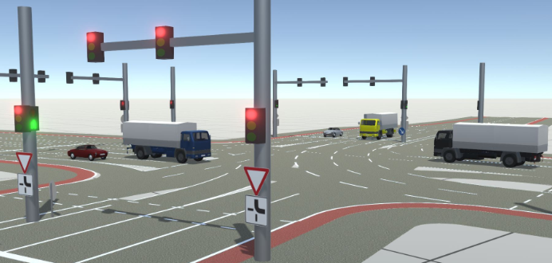
As a simulation tool, openPASS offers “off-the-shelf” solutions for these use cases in the field of simulation for effectiveness assessment:
Crash re-simulation: transforming data from the GIDAS PCM (pre-crash trajectories) into scenario files, simulation including collision evaluation
Traffic scenario-based simulations: including stochastic variations, realistic model-based interactions between traffic participants, combined with triggered actions (e.g. cut-in)
Strong support for simulation standards and a modular setup allow to tailor the platform to a wide variety of simulation use cases. openPASS supports the following simulation standards:
- Simulation configuration: As a user, I can parameterize traffic scenarios (objects & parameters describing agents and their behavior) edited as ASAM OpenDRIVE and ASAM OpenSCENARIO inputs for openPASS simulations.
- Simulation model interfaces: As a user, I can easily and straightforward couple simulation models with openPASS. This is enabled by supporting ASAM OSI and Modelica FMI and SSP
In 2023, openPASS has taken the next step from an open source platform to a modular ecosystem for scenario-based traffic simulation for ADAS and AD. The project introduces in v1.0 a re-designed modular architecture that enables the re-use of the engine for ASAM OpenSCENARIO developed in openPASS across different simulation environments. Furthermore, it allows to use proprietary scenario systems (“engines”) implementing the harmonized Mantle API with the openPASS simulator, too.
For further information, please visit https://openpass.eclipse.org/ and https://gitlab.eclipse.org/eclipse/openpass
References: J. Dobberstein, A. Das (2023): Consistent usage of OpenSCENARIO across different simulation environments starting from openPASS, SafetyWeek 2023

