openPASS Steering Committee

**Meeting date**: 16th February 2024

**Location**: MS Teams

**Meeting minutes**: https://wiki.eclipse.org/openPASS-WG

**Participants**:

|  |  |  |
| --- | --- | --- |
| Name | Company | Participation |
| Arun Das | BMW Group | X |
| Manel Hammouda | BMW Group |  |
| Thomas Platzer | BMW Group | X |
| Michael Plagge | Eclipse Foundation |  |
| Jan Dobberstein | Mercedes Benz AG on behalf of Mercedes-Benz Tech Innovation | X |
| Per Lewerenz | Mercedes Benz AG on behalf of Mercedes-Benz Tech Innovation | X |
| Dr. Daniel Schmidt | Robert Bosch GmbH | X |
| Tuan Duong Quang | TÜV SÜD Auto Service GmbH |  |
| Dr. Stefan Schoenawa | Volkswagen AG | X |
| Gwendal Lucas | Volkswagen AG |  |

1. **IIHS**

BMW had further discussion on how to use opSimulation and will attend the Roadside Safety Conference 2024 in Orlando, FL.

1. **Documentation**

Instead of a GUI-based tutorial for PCM use case, MB/MBTI will add a section on PCM simulation.

The Sphinx documentation source code of each project remains in the separate repositories. Goal: umbrella repository to integrate the built documentation.

The SC will have a docu workshop to align the available content according to the new YouTube tutorials.

1. **Post Crash Dynamics**

See slide (page 2). Next steps: MBTI will propose unified “Dynamics_Collision”

1. **Next meetings / AOB – follow-up product management**

The openPASS AC Mantle workshop will take place in Stuttgart on April 10, 2024.

BMW suggested to discuss shared project management ressources within current developers / involved parties instead of replacing the

The other parties will internally evaluate how to support the openPASS project coordination efforts.

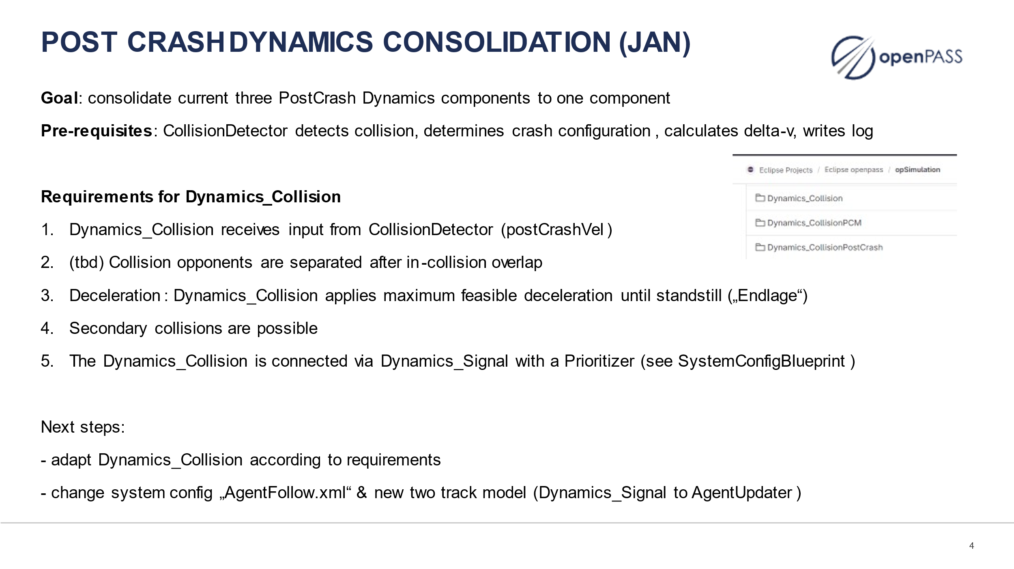

Agenda March 13, 2 pm – 3 pm

* Follow-up IIHS (all)
* Documentation action points (all)
  + tutorial PCM use case #256
  + opGUI
  + automated integration in CI #243
  + outdated AgentComponents #254
* Post crash dynamics consolidation (Jan) !174 #248
* Next meetings
  + AC March 27
  + Mantle workshop week 15 (April 10)
  + Docu / website tbd