openPASS Steering Committee

Meeting date: 5 December 2025
Location: MS Teams
Meeting minutes: Meeting Minutes · Wiki · Eclipse openpass · GitLab
Participants:

Name | Company | 2025-12-05
Arun Das | BMW Group
Thomas Platzer | BMW Group | X
Katharina Donauer | BMW Group
Christopher Radinger | BMW Group
Michael Schwarzbach | BMW Group
Michael Plagge | Eclipse Foundation
Jan Dobberstein | Mercedes Benz AG on behalf of Mercedes-Benz Tech Innovation | X
Dr. Per Lewerenz | Mercedes Benz AG on behalf of Mercedes-Benz Tech Innovation | X
Dr. Daniel Schmidt | Robert Bosch GmbH | X
Dr. Stefan Schoenawa | Volkswagen AG | X
Dr. Gwendal Lucas | Volkswagen AG | X

Minutes:
- Letter of Support EU proposal
  - openPASS members supports the consortium, very prominent set of partners
  - LoS of Eclipse Foundation is already finalized.
- Status GUI
  - CI build of opGUI for Linux successful
  - Eclipse openPASS - opGUI for GTGenSimulator (#75) [opGUI] - Jenkins
- Other openPASS members will test the release candidate and provide feedback in the opGUI MR
- IP Clearing
  - Review has been successfully completed
  - automotive.openpass 2024.06 (#527) · Issue · eclipsefdn/emo-team/emo
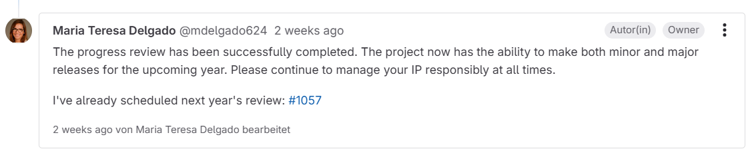
- Outlook 2026
  - See release plan
  - BMW: Windows CI will be removed è dedicated agents will be free
  - MBTI and Bosch will raise ticket to assign further resource packages
  - Next release due in 6/2026
  - BMW aims for openPASS 2.0 release (gt-gen change) in Q1 2026
  - MB: Per is leaving MB by the end of 2025, ongoing internal discussions how to proceed wrt development efforts

