AgilPro Metamodel
vs
XPDL 1.0 Specification

By Steve Egbert
Bull HN Information Systems Inc.
steve.egbert@bull.com

This paper is an assessment of the compatibility between the AgilPro metamodel and XPDL for the purpose of identifying enhancements needed for the Eclipse JWT project. I have decided to initially approach this issue from the direction of importing an arbitrary XPDL into the AgilPro metamodel. To my mind, this is the quickest way of determining if the metamodel is complete enough to describe anything that can be described by XPDL.

I have also decided to initially focus on the XPDL 1.0 specification, with Bonita extensions. The XPDL 2.0 specification is massively more complicated than the 1.0 spec, and a thorough treatment of it would take considerably longer. Starting with the 1.0 spec will give us a basis to get some initial traction on the project, and if this document proves not suitable, we can take a different track more rapidly.

I am including the Bonita extensions because every XPDL implementation is expected to have vendor specific enhancements. The Bonita engine is the implementation that I am familiar with, so that is what I am able to document. Hopefully the issues that are highlighted accommodating the Bonita extensions will be sufficient to accommodate other vendor specific extensions.

Conventions:
Unfortunately, we have terminology overloading between AgilPro and XPDL. For example, the term Activity. An AgilPro Activity corresponds to an XPDL Workflow Process or an APDL ActivitySet, and an XPDL Activity corresponds to an AgilPro Action. Therefore, when there is need to differentiate, this document will use the namespace colon notation. (AgilPro:Action and XPDL:Action)

General Model Mapping Discussion

One of the first things that jumps out at you when you begin to compare the XPDL specification with the AgilPro metamodel, is that most of the entities in XPDL have many more parameters than are currently present in AgilPro. A significant portion of these are not required to be present in a valid XPDL by the XPDL schema. This does not necessarily mean it is optional for us to support these parameters. A distinction should be made between being optional in the schema, and whether or nor the data is needed to execute a workflow process. A particular vendor implementation may need the information specified in some of these optional parameters, and so they would be required for that implementation. I think we will need to support all of them.

Another issue is how to handle vendor specific extensions. XPDL1.0 has an ExtendedAttributes element sprinkled at various strategic locations throughout the specification, within which custom extensions can be added. In addition to this mechanism, the XPDL2.0 schema allows additional namespace qualified attributes and elements to be added pretty much wherever attributes and elements exist in the schema. This is intended to allow direct expansion of the schema by adding vendor specific attributes and elements directly into the existing structure without having to resort to embedding them in the awkward ExtendedAttributes element.

Michael Giroux of Bull has suggested we use Eclipse extension points to accommodate various vendor specific plugins to our JWT plugin. We would have to provide an extension point in, at a minimum, our data model, our validation engine, and our workflow language export module, and probably other areas as well. A vendor specific plugin would extend each of these areas to be able to handle the vendor specific features.

A similar issue is certain XPDL elements that are not rigorously defined. For example, the XPDL1.0.Xpression element, which is used in conditions, is defined as type xsd:all, which means any combination of characters or elements.

XPDL:Package maps to AgilPro:package

XPDL:WorkflowProcess maps to AgilPro:Activity

XPDL:(Basic)Activity maps to AgilPro:Action +
(AgilPro:Fork/Join or AgilPro:Decision/Merge nodes)
AgilPro:Actions may have only one incoming and one outgoing AgilPro:ActivityEdge.
All XPDL:Activities may have multiple incoming and outgoing XPDL:Transitions. They have embedded join and split semantics. This can be modeled in AgilPro by an association of AgilPro:Merge/Join and AgilPro:Decision/Fork nodes with the AgilPro:Action node, such as:

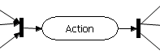 or 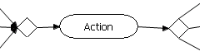

In addition, the nodes that are used must be enhanced to contain semantics about the nature of the junction. The node that combines incoming transitions needs simple AND/OR semantics. The outgoing semantics is more complicated. The outgoing transitions can be grouped, and within each group the outgoing transitions can be concurrently activated or alternately activated. Within a group of alternately activated transitions there is the concept of the ordering of the transitions being important. At present, I see no way to order the outgoing transitions.

Since Decision implies semantics, I would propose we use Merge/Decision nodes to hold the joining/splitting semantics. The AgilPro:JoinNode would have the default OR behavior, where the output is activated whenever any of the inputs are activated. The AgilPro:ForkNode would have the default AND behavior, where all of the outputs are activated when the input is activated.

The XPDL schema allows multiple joining and splitting elements per XPDL:Activity as in:
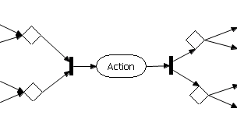
However, multiple joining elements are logically inconsistent, because there is no way to specify which transitions go to which joining element. There is a way to associate outgoing transitions with the splitting elements, however language in other parts of the XPDL spec implies that an XPDL:Activity implements only one splitting element. It really does not matter for the purposes of this document, as long as we have an element that contains the splitting syntax ( the AgilPro:DecisionNode) and a way to hook them together (the AgilPro:ForkNode), the model can handle either case.

Therefore I am adopting the following for the normal model of the XPDL:(Basic)Activity
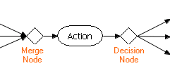

XPDL:Route maps to AgilPro:Fork/Join or AgilPro:Decision/Merge nodes
An XPDL:Route is the same as a Basic Activity where the activity does nothing. It is provided so that the embedded transition joining and splitting semantics can be used to construct more complex cascading transition conditions. It would map to AgilPro like an XPDL:(Basic)Activity without the AgilPro:Action inside.
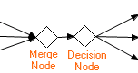

XPDL:BlockActivity maps to AgilPro:ActivityLinkNode + (AgilPro:Fork/Join or AgilPro:Decision/Merge nodes)
An XPDL:BlockActivity is an activity that executes a self contained activity-transition map. This map is contained elsewhere in the same XPDL file (In an XPDL:ActivitySet)

NOTE: The AgilPro:ActivityLinkNode has not been released yet, so this section is tentative.

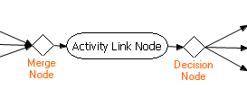

XPDL:(Subflow)Activity does not currently map
An XPDL:Subflow is rather like an XPDL:BlockActivity, except the elements inside the Subflow are described by a different XPDL file.

I would suggest that we should not try to diagram the inner elements in this AgilPro editor. Rather, since it is a separate XPDL file, when the subflow element is opened for viewing or editing, we should create another instance of the AgilPro editor.

XPDL:Transition maps to AgilPro:ActivityEdge + AgilPro:Guard
An XPDL:Transition maps directly to an AgilPro:ActivityEdge. An XPDL:Transition may have an XPDL:Condition. I suggest we put the condition semantics, which consist of a type and an expression in the AgilPro:Guard element.

XPDL:Participant maps to AgilPro:Role
The XPDL:Participant performs the same function as AgilPro:Role. However, XPDL:Participant has a number of additional types of participation which we will need to support. Unfortunately, one of the XPDL:Participant types is named Role.

XPDL:Deadline does not map
An XPDL:Activity may contain an XPDL:Deadline, which specifies a duration or absolute time of the deadline of the activity, and specifies exception handling if the deadline is not met. There is currently no such entity in AgilPro.

Detailed XPDL Coverage Analysis
of the XPDL Schema

Green Highlight will identify areas that are currently supported by the metamodel.

Yellow Highlight will identify those areas that are not supported by the metamodel, but are optional in the XPDL schema. This does not necessarily mean that it is optional for us to support them.

Red Highlight will identify areas that are not currently supported by the metamodel and are required by the XPDL schema or Bonita extensions. We will have to provide support for these items in some manner.

Pink Highlight will identify areas that are not currently supported by the metamodel and are required by the XPDL schema or Bonita extensions, but could possibly be derived from elsewhere than the metamodel.

Turquoise Highlight will identify areas that are not currently supported by the metamodel and are required by the XPDL schema or Bonita extensions, but can be derived, provided we do not need to re-export an identical XPDL

Non Highlighted areas are areas I have not dealt with yet.

Please note that these colorations are my opinions, and it may very well be that there is an alternate way to model XPDL items with existing AgilPro elements which I have not yet thought of, which will indeed support XPDL items that I have marked as not supported. I eagerly seek such critiques.

Package
- ID – A unique NMTOKEN – Required
- Name – String – Optional – corresponds to AgilPro:Name parameter
- Package Header - Required
Only used in Package element
  - XPDLVersion – String - Required
XPDL Specification version
This can likely be derived from settings in the tool. We will probably need to select the XPDL flavor to generate, as different Vendor implementations will support different things.
  - Vendor – String - Required
Origin of process definitions, NOT the vendor of the tool.
  - Created – String - Required
Date the Package was created. If we wanted to make it when the package was last modified, we could derive this value.
  - Description –String - Optional – Modeled by AgilPro Comment
  - Documentation – String - Optional
OS Specific path to help/documentation file
  - PriorityUnit –String – Optional
User defined Semantics
  - CostUnit – String – Optional
Simulation Data Units
In the upcoming version 1.2.0 of AgilPro we include some of this information in the newly meta-model element “Model”, see the changed meta-model below. And it is very easy to include new properties in the meta-model and can be done in a few minutes: simply change the EMF ecore-file, generate the model code again, and it’s done. So we can easily include things such as PriorityUnit or CostUnit.
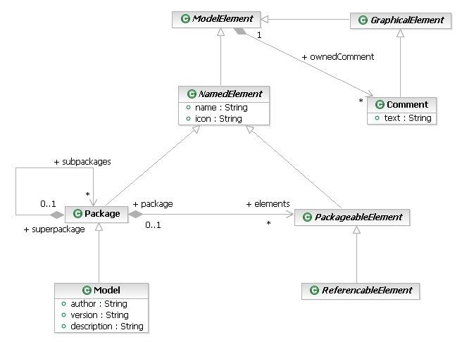

- Redefinable Header - Optional
Defines values that are valid throughout the package BUT may be redefined for a specific WorkflowProcess by another RedefinableHeader element in the WorkflowProcess element
  - PublicationStatus – Enumeration- Optional
    - “UNDER_REVISION”
    - “RELEASED”
    - “UNDER_TEST”
  - Author – String – Optional
  - Version - String - Optional
  - Codepage – String - Optional
  - Countrykey – String - Optional
  - Responsibles - Optional – Sequence of strings
- Conformance Class – Enumeration - Optional
Only used in Package element
  - "FULL_BLOCKED"
  - LOOP_BLOCKED"
  - NON_BLOCKED"
- Script – Optional
Only used in Package element
  - Type - Required
Identifies expression scripting language.
Recommended, but not required:
    - text/javascript
    - text/vbscript
    - text/tcl
    - text/ecmascript
    - text/xml
  - Version – String – Optional
version of scripting language
  - Grammar – anyURI – Optional
reference to grammar specification. ie: XML, schema, DTD, or BNF
- External Packages – Optional -
- Type Declarations – Optional -
- Participants – sequence of XPDL:Participant elements used in the Package. XPDL:Participant corresponds to AgilPro:Role.
- Applications – sequence of XPDL:Application elements used by the Package. XPDL:Application corresponds to AgilPro:Application.
- DataFields – sequence of XPDL:DataField elements available for use in this Package. XPDL:DataField corresponds to AgilPro:Data
- Workflow Processes – a sequence of all the XPDL:WorkflowProcess elements in the package. XPDL:WorkflowProcess elements correspond to the AgilPro:Actions that are directly under the AgilPro:Project
- Extended Attributes
Vendor defined extensions

WorkflowProcess
An XPDL:WorkflowProcess corresponds to an AgilPro:Action.
- ID – A unique NMTOKEN - Required
- Name – String – Optional - handled by AgilPro:Activity.Name
- AccessLevel – Enumeration – Optional
  - PUBLIC
  - PRIVATE
- ProcessHeader - Required
  - DurationUnit – Enumeration – Optional
    - “Y”
    - “M”
    - “D”
    - “h”
    - “m”
    - “s”
  - Created – String - Optional
  - Description – String – Optional – corresponds to AgilPro:Activity.Comment
  - Priority – String - Optional
  - Limit – String - Optional
  - ValidFrom – String - Optional
  - ValidTo – String - Optional
  - TimeEstimation – Optional
    - WaitingTime – String - Optional
    - WorkingTime – String - Optional
    - Duration – String – Optional
This is handled by AgilPro:Activity.TotalTime, however this is in seconds, and the XPDL:Duration’s units are specified in the XPDL:ProcessHeader.DurationUnits property
- Redefinable Header - Optional
Defines values that are valid throughout the package BUT may be redefined for a specific WorkflowProcess by another RedefinableHeader element in the WorkflowProcess element
  - PublicationStatus – Enumeration- Optional
    - “UNDER_REVISION”
    - “RELEASED”
    - “UNDER_TEST”
  - Author – String – Optional
  - Version - String - Optional
  - Codepage – String - Optional
  - Countrykey – String - Optional
  - Responsibles - Optional – Sequence of strings
- FormalParamters - Optional
- DataFields - Optional
- Participants – Optional – Sequence of XPDL:Participant elements that are used in the workflow process. XPDL:Participant corresponds to AgilPro:Role
- Applications - Optional
- ActivitySets – Optional - Sequence of XPDL:ActivitySet elements. These elements correspond to every XPDL:BlockActivity anywhere in this XPDL:WorkflowProcess, and contain lists of the elements in the corresponding XPDL:BlockActivity. XPDL:BlockActivity corresponds to AgilPro:StructuredActivityNode.
- Activities – Optional - Sequence of XPDL:Activity elements that are direct children of this XPDL:Workflow Process. An XPDL:Activity corresponds to AgilPro:Action
- Transitions – Optional - Sequence of XPDL:Transition elements that are direct children of this XPDL:WorkflowProcess. XPDL:Transition corresponds to AgilPro:ActivityEdge.
- ExtendedAttributes
- Iterations

Activity
- Id – xsd:NMTOKEN – Required
- Name String – Optional - handled by AgilPro:Action.Name
- Description – String – Optional – corresponds to AgilPro:Action.Comment
- Limit – String – Optional – corresponds to AgilPro:TotalTime, however AgilPro:TotalTime is in seconds and XPDL:Limit is in XPDL:DurationUnits
Expected duration for time management purposes
- --Choice--
- Performer – String – Optional – handled by AgilPro:Role association
Link to performer
- StartMode – Choice – Optional
Depending on the XPDL Engine, it may be possible to infer the start mode from the performer
  - Automatic
  - Manual
- FinishMode – choice – Optional
  - Automatic
  - Manual
- Priority – String - Optional
- Deadline – XPDL:Deadline element - Optional
- SimulationInformation - Optional
  - Instantiation – Enumeration – Optional
    - “ONCE”
    - “MULTIPLE”
  - TimeEstimation – Optional
    - WaitingTime – String - Optional
    - WorkingTime – String – Optional
    - Duration – String – Optional
- Icon – Optional – String - handled by AgilPro:Icon
path and filename of Icon to represent the Activity
- Documentation – String – Optional
path and filename to description of activity
- TransitionRestrictions – Optional – Sequence of any number of:
  - TransitionRestriction
    - Split – corresponds to AgilPro:DecisionNode
      - Type – Optional – Enumeration
        - “AND”
        - “XOR”
      - TransactionRefs – Optional – Sequence of references to XPDL:Transction.Ids
    - Join – corresponds to AgilPro:MergeNode
      - Type – Optional – Enumeration
        - “AND”
        - “XOR”
XPDL:TransitionRestrictions will be handled by AgilPro:MergeNodes and AgilPro:Decision nodes associated with the AgilPro:Action.
ExtendedAttributes
  - Bonita:Hook
  - Bonita:Properties

Participant
XSD:Participant corresponds to AgilPro:Role
- Id – Required – xsd:NMTOKEN
- Name – Optional – String – handled by AgilPro:Role.Name
- ParticipantType – Required – Enumeration
  - “RESOURCE_SET”
  - “RESOURCE”
  - “ROLE”
  - “ORGANIZATIONAL_UNIT”
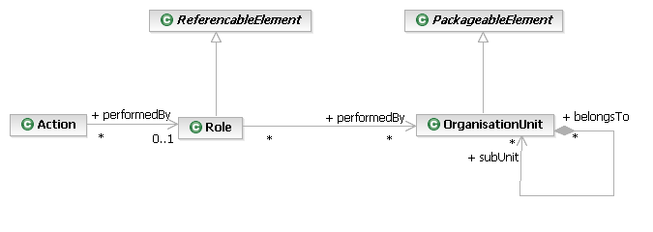
  - “HUMAN”
  - “SYSTEM”
- Description – Optional – String – handled by AgilPro:Comment
- ExternalReference – Optional
  - xref – Optional – xsd:NMTOKEN
  - location – Required – xsd:anyURI
  - namespace – Optional – xsd:anyURI
- ExtendedAttributes

