Hyades v2.0
Features Requirements

Version 0.1
Revision History
Date | Version | Description | Author
09/12/2004 | 0.1 | Initial Creation | Serge Lucio
Review History
Date | Version | Comments | Reviewer/Approver

Table of Contents
1. Introduction 5
1.1 Purpose 5
1.2 Scope 5
1.3 Definitions, Acronyms, and Abbreviations 5
1.4 References 5
1.5 Overview 5
2. User Experience 6
2.1 Profiling and Logging User Interfaces 6
2.1.1 Profiling and Logging Agents selection at application start time 6
2.1.2 Profiling Analysis Views Consolidation (P2) 7
2.1.3 Statistical views extension points (P1) 8
2.1.4 Statistical views support for statistical models (P1) 9
2.1.5 Profiling views support for history (P2) 9
2.2 Testing User Interfaces 9
2.2.1 Merge Test and Execution Navigator into Test Explorer 9
2.2.2 New Test Case wizard (P1) 11
2.2.3 Test Context editor enhancements (P1) 11
2.2.4 Test Explorer Extension Points (P1) 11
2.2.5 Datapool editor improvements (P2) 11
2.2.6 General Editor Improvements (P3) 12
2.2.7 Execution History Editor (P1) 12
2.3 Combined use of Test and Profiling & Logging (P1) 12
3. Data Models 12
3.1 Test 12
3.1.1 Testability Interface meta-model (P1) 12
3.1.2 Testability interface implementation (P3) 12
3.2 Trace 12
3.2.1 Support for non-Java applications (P1) 12
3.2.2 Support for parameters data (P1) 13
3.3 Statistical 13
3.4 Execution history (P3) 13
4. Data Collection 13
4.1 64-bit support (P1) 13
5. Execution 13
5.1 64-bit support (P1) 13
5.2 Test Component execution (P1) 13
5.3 Support for test execution from Test Harness (P1) 13
5.4 Test harness enhancements to support additional monitoring agents (P2) 13
5.5 Specialized API for direct invocation of test behaviors (P1) 13
5.6 Test assets deployment of test assets (P1) 14
6. Supplementary Requirements 14
6.1 OMG UML 2 Testing Profile Support 14
6.1.1 Terminology Update (P1) 14
6.1.2 Sample Test Types Alignment (P1) 14
6.2 Performance 14
6.3 Eclipse 3.0 Support 14
6.3.1 Look & feel support (P2) 14
6.3.2 Progressive discovery support (P2) 14
7. Online User Documentation and Help System Requirements 14

Features Requirements

Introduction
This document provides a detailed description and prioritization of the features planned for the Hyades roadmap. It reflects feedback provided to the Hyades planning group by contributing companies as well as additional input collected through Bugzilla and the Hyades newsgroup.

Purpose
The purpose of this document is to:
- Provide a detailed description of the features to be implemented as a basis for working groups discussion
- Help scope the content of Hyades v2.0 by prioritizing these features
- Communicate to Hyades users the features to be delivered in Hyades v2.0 as well as future developments

Scope
The scope of this document is primarily Hyades v2.0 features.
The proposals and mock-ups included in this document are primarily intended to illustrate the feature to be delivered or ways to solve existing limitations. It should be understood as a basis for detailed discussions within the Hyades working groups, and not as a commitment.

Definitions, Acronyms, and Abbreviations
See Hyades Glossary. <TBD: Create and post on Hyades website>

References
Hyades Dec 2004 face-to-face meeting minutes <TBD: Insert link to Hyades website>
Hyades Newsgroups
Hyades Defect Tracking (Bugzilla)

Overview
The document is structured as following:
- User experience: Describes all the improvements/modifications planned in the user interface exposed by Hyades.
- Data models
- Data collection
- Execution
- Supplementary requirements
Priorities should be understood as following:
- P1: The feature is committed for the target release
- P2: The feature is not committed but in-scope for the target release
- P3: The feature is not committed and not in-scope for the target release. It is deferred to a subsequent release.

User Experience

Profiling and Logging User Interfaces

Profiling and Logging Agents selection at application start time
The current process for starting an application with data collectors is based on a wizard, which can be activated from the “Profiling and Logging” or “Java” perspectives toolbar. This process is not integrated nor aligned with the standard Eclipse launch process. Additionally, as the number of agents is increasing, the following page enabling users to enable/disable specific data collection is not scalable:
The proposal is to include profiling as a first class Eclipse launch configuration and introduce a higher level concept used to manipulate sets of data collectors (hereafter called data collection configuration).
A data collection configuration is a collection of agents to be engaged along with a set of filters and triggers (to start and stop the collection). Hyades would provide pre-defined data collection configurations to support the existing types of configurations: Memory analysis, performance analysis, code coverage.
The Hyades integration in the launch configuration would essentially provide a way to select a specific data collection configuration, create new ones, edit existing ones:
A proposal for the user interface would be the following:
The filters tab defines the scope of the collection.
The options tab enables the selection of available agents.
The limits tab defines the triggers to start and stop the data collection.
This proposal needs to be further defined by the UI group.

Profiling Analysis Views Consolidation (P2)
The number of profiling views has been increasing to the point where it clutters the User Interface when users select the “Open With…” action on any of the nodes in the “Profiling Monitor” view.
The goal is to adapt the user interface metaphor to take this growing number of view into account.
Package Statistics, Instance Statistics, Method Statistics, Class Statistics, Object References, Code coverage (P2)
These pre-defined sets of tables are essentially providing a pre-defined set of rows/columns to be displayed in a table or tree-table. As tool providers will extend Hyades, we expect to see the number of combinations of rows/columns grow without boundaries. As a result, it is important to provide a unique table view, which can be tailored by the user to fit specific needs. Specifically, a user should be able to select the content of the rows and columns to be displayed.
Analyzing the content of the existing views, the rows are systematically used to display the elements on which information has been collected, columns are used to display the collected data itself.
The following proposal enables users to select what type of content is displayed for the rows. A combo-menu is displayed enabling to switch from Classes (Package/Classes/Methods), to Objects (Package/Class/Methods), to Threads (Thread/Classes/Objects/Methods):
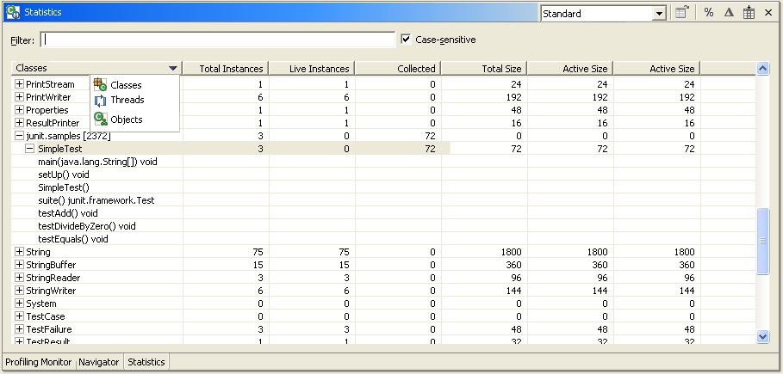
Additionally, users can leverage the filtering to select the details to be displayed in the rows as well as the columns. Tool providers can pre-define a set of filters that can be easily selected:
The filter dialog enables the user to select a filter set, which consists of a set of rows to be displayed and a set of columns. A filter set can be defined or modified from the same dialog.
Thread Interactions, Object Interactions, Class Interactions, Process Interactions, Agent Interactions (P3)
There is already a first level of consolidation which exists for these views. Specifically, the views are made only available at certain levels in the “Profiling Monitor” hierarchy. For instance, the “Agent interaction” view cannot be opened from a “Profiling agent” node, but only from a “Hosts” or upper node.

Execution flow, Method Invocation and Execution flow table (P3)
These different views are essentially providing the same information using slightly different format or filtering. The table vs graphical format mitigates accessibility, but also provides a compact view for users to navigate through the information. The method invocation view is essentially a filtered view on the execution flow.
The proposal consists in relying on the filtering to narrow the displayed information and use a display option to switch between a graphical or table display.

Statistical views extension points (P1)
Tables should provide support for data columns providers in the statistical views.
Tables should enable context menus for table columns, specifically for navigation purpose.

Statistical views support for statistical models (P1)
The profiling views are currently “hard-wired” to the trace model. There is a general need to present information provided from other models, and specifically the statistical model.
Hyades should provide a standard statistical views column provider for statistical counters.

Profiling views support for history (P2)
One of the primary focus of these views is to streamline the navigation through profiling data, which might be fairly large. For interactions, the navigation pattern is typically to navigate through time on a given lifeline, to drill into a given transaction from this lifeline, to go back to the origin of the transaction, etc. As part of the navigation process, it is fairly common to zoom in/out, scroll up down, select messages, lifelines, navigate to other views, etc.
On the challenges is that none of these views provides support for Eclipse history: . This would greatly improve the usability of the profiling data navigation.
The proposal consists to include support for history in the profiling views.

Testing User Interfaces

Merge Test and Execution Navigator into Test Explorer (P1)

UI Overview (P1)
The Test and Execution navigators provide base functionality for managing the test assets (navigation, open, rename, delete). As the number of test assets is growing (introduction of datapools and deployments), there is a need to introduce a better UI metaphor that supports this complexity.
A proposal consists in using a similar paradigm to the one already in place in tools leveraging Eclipse, essentially based on the notion of “logical folders” grouping the assets per type. A mockup of the UI would be the following:

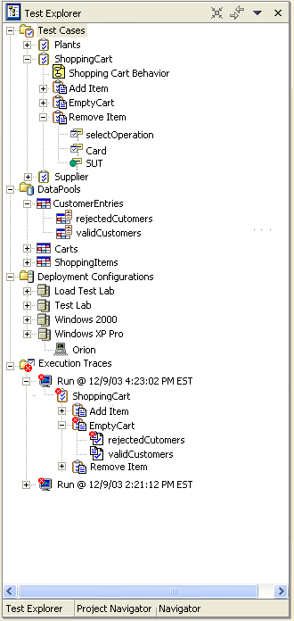
1. Standard tools for synchronizing with editors, filtering, sorting
2. Test Case, DataPools, Deployment Configurations and Test Log logical folders
3. Test Context
4. Test Context Behavior
5. Test Cases
6. Test Components
7. DataPool
8. Equivalence Class
9. Deployment Configuration
10. Node Instance
11. Test Log
12. Test Context with failed verdict
13. Test Case with passed verdict
14. Failed Equivalence class
15. Passed Equivalence class

The following logical folders should be supported: Test Cases, Test Components, Deployment Configurations, DataPools, Execution Logs.

Test Explorer Actions (P2)
The Test Explorer should support basic Eclipse functionality including filtering, sorting, synchronization with editor, working set. (P2)
Some standard actions should be supported on the different nodes.
On the Test Cases folder:
- New
  - Test Case,
  - Test Context
On the DataPool folder:
- New
  - Datapool
On the Deployment Configuration:
- New
  - Deployment Configuration
On the Test Components:
- New
  - Test Component

New Test Case wizard (P1)
The “New Test Case” wizard should be extensible and usable without a pre-existing Project or Test Context.
This means that:
- The wizard should provide the ability to select or create a new project (P1).
- The wizard should provides the ability to select or create a new Test Context (P1).
- The wizard should provide the ability to select a registered test type (P1)
- The wizard should provide and extension points for a test type provider to contribute its own wizard pages (P1)

Test Context editor enhancements (P1)
The Test Context editor should be extended to enable users to associate Deployment Configurations and DataPools.
The Test Context editor should be extended to support the definition of a Test Objective. Two specific kinds of Test Objectives should be supported: Strings and Files.
The Test Context editor should expose an extension point to enable the support of different Test Objective types.

Test Explorer Extension Points (P1)
Providing extensibility to the test explorer is key to the success of the interoperability at the user experience level. Specifically, the content of the tree should be customizable at several levels, where tools might provide specific editors tailored towards specific needs.
Hyades should provide content providers for:
- Test Cases
- DataPools
- Deployment Configurations
- Test Components
For each of these content providers, Hyades should provide a default implementation.

Datapool editor improvements (P2)
The Datapool editor should be improved based on the feedback received for Hyades v1.2.
Specific improvements include:
- Navigation to Test Case behavior
- Cell editors should be extensible to support
  - Specific cell editors
  - Cell content verification
Eclipse 3.0 is planning to provide a more robust table and tree-table widget. Hyades should adopt this new control.

General Editor Improvements (P3)
None of the current editors support undo/redo.
Editors should be upgraded to support undo/redo.

Execution History Editor (P1)
The existing execution history editor needs to be aligned with the Test Run Explorer:
- Icons need to be the same between the Test Run Explorer overview of the Execution log and the Execution History Editor
- Navigation between the Test Run Explorer and Execution history editor should be supported
The execution history editor should provide an outline view (P2).
The execution history editor should provide navigations between the execution events and associated elements in the trace, or statistical model.

Combined use of Test and Profiling & Logging (P1)
There is no support for running tests (test suites, test cases, test component behaviors) while collecting logging, tracing or profiling data.
It should be possible to activate a given profiling configuration on a deployment configuration.

Data Models

Test

Testability Interface meta-model (P1)
The current behavioral model enables the definition of Test Components’ behaviors using messages in an interactions model. This assumes that the classes and operations available on the SUT are modeled. The current model doesn’t enable to model this interface, which makes the existing behavioral model almost un-usable.
The proposal consists in introducing a specific resource that would represent the testability interface of the SUT.

Testability interface implementation (P3)
The testability interface offers a standard way to specify the classes/objects/operations available on the SUT. To enable further interoperability between tools, the proposal consists in defining a standard implementation of a testability interface. This would enable any test tool to interact with any kind of application independently from its nature (protocol, user interface, programmatic interface, etc.)

Trace

Support for non-Java applications (P1)
The trace model should provide support for protocol-based applications (P1).
The trace model should provide support for C++ applications (P2).
The trace model should provide support for C applications (P2).

Support for parameters data (P1)
The trace model should provide support capturing parameters data:
- Support for simple type parameters: String, Numeric values (P1)
- Support for complex type parameters (P3)

Statistical
To be determined.

Execution history (P3)
The execution history currently doesn’t support traceability to the behavioral model messages and actions. This would greatly improve the user experience to understand the execution history

Data Collection

64-bit support (P1)
The existing data collection framework is not built or tested on Intel 64-bit architectures. The data collection framework should be upgraded to support this architecture (P1)
There data collection framework should be upgraded to take advantage of 64-bit architecture capabilities (e.g. addressable space).

Execution

64-bit support (P1)
The existing execution framework is not built or tested on Intel 64-bit architectures. The execution framework should be upgraded to support this architecture (P1)
There execution framework should be upgraded to take advantage of 64-bit architecture capabilities (e.g. addressable space).

Test Component execution (P1)
The current user interface and framework doesn’t support the execution of test components. Test Components are a very important part of the definition of complex tests. Enabling their individual execution is required to enable their debugging.
The proposal is to make Test Components directly executable. But, a Test Component should not generate a verdict

Support for test execution from Test Harness (P1)
The test harness API needs to be extended to allow Executor’s to invoke Tests via the test harness

Test harness enhancements to support additional monitoring agents (P2)
Facilitate collecting logs and stats in addition to the execution histories
Include multiple ways to specify which agents are invoked

Specialized API for direct invocation of test behaviors (P1)
The proposal consists in offering a specific API to invoke a test behavior (Test Context behavior, Test Case, Test Component behavior), from another behavior. Specifically in Java, this will enable the execution to be performed within the same JVM.

Test assets deployment of test assets (P1)
The existing execution APIs to do support the deployment of test assets. As deployments were introduced in Hyades v1.2, the deployment of test execution becomes more important.
The proposal consists in providing services to deploy the test assets (P1), and automatically deploy the test assets for the sample test assets Hyades provides (P2).

Supplementary Requirements

OMG UML 2 Testing Profile Support

Terminology Update (P1)
The testing terminology needs to be updated to reflect recent changes in the definition of the UML 2 Testing Profile.
Specifically, the following terms need to be updated:
- Test Suite is renamed Test Context
- Execution history to be renamed Log (UML 2 Testing Profile term) or Execution Log (to differentiate it from a Profiling and Logging logs).

Sample Test Types Alignment (P1)
The existing JUnit, manual and HTTP tests do not comply with the OMG UML 2 Testing Profile in their implementation. Examples of mis-alignments include:
- Test actions are modeled as Test Cases (where they should be individual actions or messages)
- Test Cases do not support Test Objectives,
- Etc.

Performance
To be determined.

Eclipse 3.0 Support

Look & feel support (P2)
The look&feel of Hyades should be aligned with Eclipse 3.0. This includes for instance: flat icons, flat buttons, etc.

Progressive discovery support (P2)
Eclipse 3.0 introduces the concept of progressive discovery. Progressive discovery is a way to deal with the complexity of the User Interface as more and more plug-ins are becoming available by exposing to the user only the menus, toolbar buttons, preferences, etc. that users use. The mechanisms to implement progressive discovery are activities and triggers.
Hyades should include support for activities and triggers (P2).

Online User Documentation and Help System Requirements
The online help should be end-user oriented. The specifics of the documentation related to (P3)

