Hyades Limited Capacity Device Support - Usage Models

Revision History
Rev. | Date | Author | Company | Summary of Changes
0.1 | June 10, 2004 | Vishnu Naikawadi | Intel Corporation | First draft

Introduction
The world of handheld and embedded devices is ever growing while their adoption will increase more and more in the future. Vast number of handheld devices and applications for them are being developed. Keeping this in view, there is certainly a need for extending the support of Hyades to such devices in future. This document describes about different usage models in which Hyades can provide support for the handheld devices. Though this document refers to handheld devices the scope in general includes all the devices that have limited capacity in terms of specifications such as processing power, memory, etc – for e.g. Network devices, Set-top boxes, Cell Phones, Pagers, Embedded devices, Personal Digital Assistants, Smart Cards.

Handheld Devices Categorization
The limited capacity devices consist of variety of devices providing services in different domains and accordingly the device specifications vary in terms of processing power, architecture support, size, hardware, memory, operating system, software, communication protocols (in case of connected devices), performance, multi-process support, thread support, etc. So, a single solution may not be able to cater to all of these types of devices. One way to solve this issue is by providing specific solutions for a set of similar type of devices.

These devices can be broadly categorized as below based on the their capacity specifications (could be any of the parameters discussed in the previous paragraph).
- Small Capacity Devices – e.g. smart card
- Medium Capacity Devices – e.g. Cell Phones, pagers, Entry level PDAs
- Full Capacity Devices – e.g. PDAs, Set-top Boxes, Embedded Systems

The next sections will illustrate the usage models for Hyades support for each of these categories. The handheld devices have an issue of several technologies, platforms, operating systems and protocols and in some cases they could be non-standard. It is a separate challenge to provide support on all such platforms uniformly that needs to be solved during the design/implementation phase. This document discusses only about the use cases for hyades support involving such devices.

Usage Scenario – Small Capacity Devices
Fig.1 shows the usage scenario for Hyades support on devices with very small capacity. Since such devices have limited resources it may not have enough capacity to host the Hyades Collection Engine. In this case, HCE can be hosted on a separate machine and a proxy agent can be developed that runs as an agent on the same machine where HCE is running. The HCE process could be running on the same machine as the Eclipse Workbench (or some other client). And the Hyades proxy agent works as mediator component that communicates with the collector running on the target handheld device. For all purposes the proxy agent is like any other agent as far as HCE is concerned. Only difference is that it is remotely communicating with the collector running on the handheld device. The message protocol used for communication between the proxy agent and the collector running on the handheld device could be standard or proprietary over the supported physical connection protocol like TCP/IP, Serial or USB.
The advantages with such support are
- No need to put a version of Hyades DCE on the handheld device
- No change as far as Hyades components are concerned except for writing the corresponding proxy agent.
The disadvantages are limited capability and extra layer of communication.

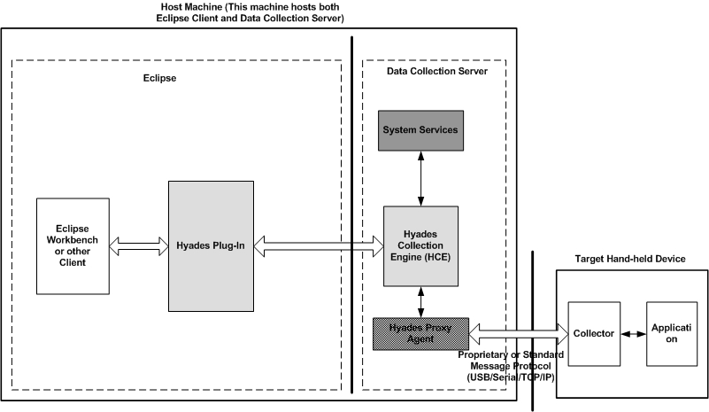

Figure 1 – Hyades Support for Small Capacity Handheld Devices

Usage Scenario – Medium Capacity Devices
Fig.2 shows the usage scenario for Hyades support on devices with medium capacity. In this case, the capacity may not be high enough to host the regular Hyades Collection Engine on the device. But it is possible to host a minimal version of the Hyades Collection Engine. This mini-RAC (or HCE) can be run on the handheld device itself along with the agents or collectors (assuming the device OS supports multiple processes since agents run in separate process) meant to perform data collection on the device. The features of the mini-RAC can be selective based on the handheld device capacity though the lowest denominator configuration can have very basic and necessary features to perform collection and communication.
The possible architectural modifications to provide support are
- Implement a Mini-RAC that could be a sliced-down version of regular RAC or separate independent implementation to support such devices.
- No Security
- Non-availability of all system services or make simple versions available
- HCE and Agents could be running in the same process on the device.
- Communication mechanism and protocol interface between HCE and Agents can be changed to fit into the device capabilities. The Agent interface may need to be changed.

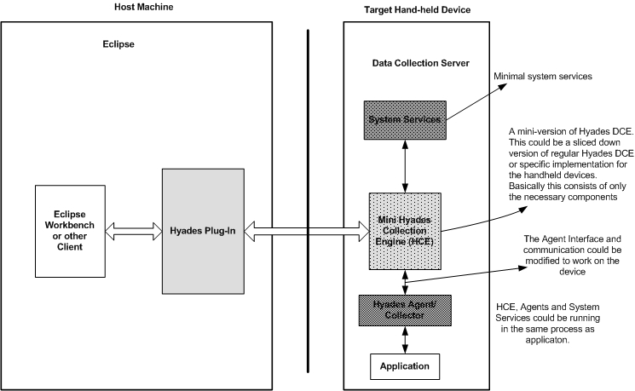

Figure 2 – Hyades Support for Medium Capacity Handheld Devices

Usage Scenario – Full Capacity Devices
Fig.3 shows the usage scenario for Hyades support on devices with relatively good memory and are comparable to normal desktop machines. In such case, the usage model is identical to the desktop or other types of machines. As can be seen in the diagram, the regular Hyades Collection Engine is running on the handheld device though some features (that are not necessary) like security may be turned off. The Hyades server-side components (like HCE, Agents and System Services) will be running on the handheld device itself.

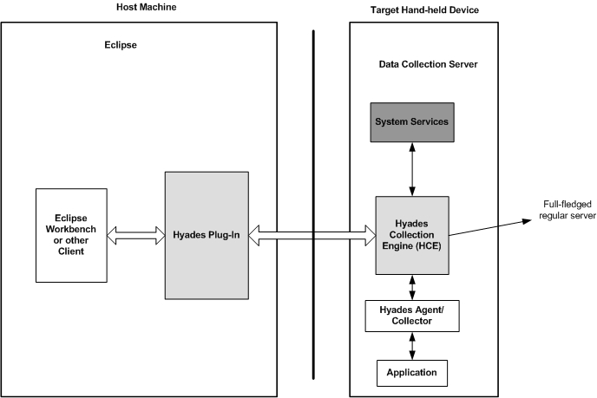

Figure 3 – Hyades Support for Full Capacity Handheld Devices

