Hyades Message Pipeline

Revision History
Rev. | Date | Author | Summary of Changes
0.1 | July 7, 2004 | A. Kaylor | First draft

Introduction
This document will discuss the basic plug-in architecture used for message processing by the Hyades Collector Engine (HCE). The goal of this plug-in architecture is to give the HCE the needed flexibility to support a variety of communications needs while maintaining internal simplicity.

Plug-in Strategy
The basic architectural strategy is to provide a mechanism whereby individual layers can be dynamically loaded to process messages. The libraries to be loaded are specified in the HCE configuration file.

The basic types of plug-ins are transport layers, payload normalizers and command extractors. See Figure 1 below. The HCE can be configured to load multiple instances of each plug-in type. The instance which will be used to process any given message is determined by the HCE configuration (see the “Message Flow” section below).

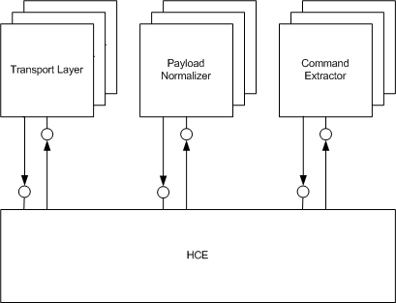
Figure 1 – Plug-in Layers

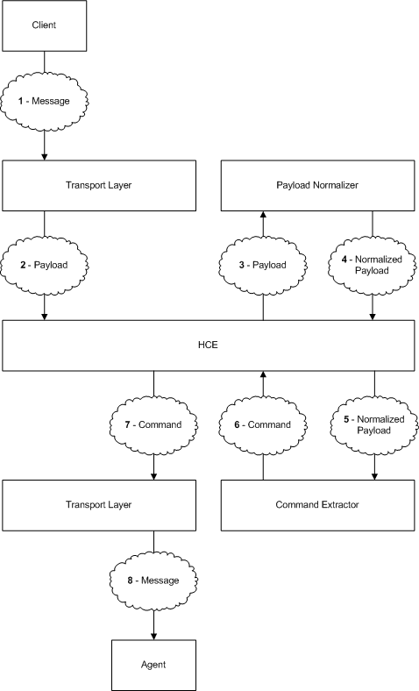
Figure 2 – Typical Message Flow

Message Flow
In general, a message will arrive from some external source (i.e. client or agent) and be received by a transport layer. The transport layer provides the actual connection mechanism (socket, secure socket, named pipe, etc.) and reads incoming messages into a buffer for further processing. Depending on the transport layer, the incoming message may contain some message envelope which the transport layer will process and strip off before forwarding the message. The message will then be passed to one or more payload normalizers which will filter or reformat the message as necessary to get it into the format expected by the command extractor. The command extractor will process the message and divide it into individual commands to be sent to target components. The command extractor may reformat the message yet again to put it in a format expected by the HCE delivery mechanism. Finally, the command will be sent to a transport layer for delivery to the target component. The transport layer may wrap the command in a message envelope before sending it. See Figure 2 above.

Note that the HCE itself does not care about the contents of the data being passed around until the command extractor passes commands to the HCE (step 6 above), and even then the HCE will only read the command header. Otherwise, the HCE merely passes data among plug-ins in the pipeline.

The exact plug-in layers involved in the process described above are determined by the HCE configuration. For each transport layer, the HCE configuration will specify a pipeline of additional plug-ins which should process the message. However, the transport layer used for outgoing messages is determined by the connection method used by the target component.

For example, if a message arrives on the HTTP transport, it will initially be processed by the HTTP transport layer which will read the HTTP command and extract the payload. It would then be passed on to a payload normalizer which performs UU-decoding. Finally, the message would be passed to a basic command extractor which would read the binary protocol format and divide the message into one or more commands to be sent.

Alternatively, if the incoming message is a SOAP message (not currently supported but accounted for in the design), the message would again be received by the HTTP transport layer which would extract the SOAP message. A payload normalizer may not be required in this case, but one could be used to verify the message format and reject improperly formed messages. Finally, the command extractor would provide a SOAP engine which determined the component for which the message was intended and wrapped it in the command header expected by the HCE for further processing. The transport layer delivering the message could then strip off the HCE command header before forwarding the message to the intended target.

It is worth noting that the pipeline specified in the HCE configuration refers to instances of plug-ins, as referenced by the configuration entry by which they were loaded. Therefore, it is possible, for example, to set up two different pipelines starting with a socket transport layer if there are two instances of that layer listening to different ports.

