Brian Carroll
March 12, 2007
Version 01

Using LDP to create an ADAM Application Partition for the Higgins STS

Goals of this process
The steps described in this document accomplish:
- Creating a Naming Context
- Adding an organizationalUnit (ou=identities)
- Adding one instance of higginsPerson to verify they can be added

Notes:
- The procedure described herein is needed for development, testing, and evaluation environments to establish an LDAP directory for testing. For production use, the Higgins STS would have been configured to use an existing user directory or authority.
- The examples use the freely downloadable Microsoft Active Directory Application Mode (ADAM SP1) for Windows XP. This was chosen because it is a stable Directory server that runs on Windows XP where I do development. The specific steps may vary for other servers (such as OpenLDAP), but the general procedure will be similar for other servers.

Previous steps (preconditions)
The steps we must have successfully completed are:
- Installed ADAM SP1 on Windows XP
- Created an instance of ADAM and named it SSO
- Imported the Microsoft schemas for user and inetOrgPerson
- Extended the schema with the new objectClass, higginsPerson

Subsequent steps
None. We are ready to test the Higgins STS

Planning and Preparation
The Higgins STS uses a configuration file called Configuration.xml. The values select for the Naming Context must match the value specified in the Configuration.xml file. Here are some excerpts from the file:
<!--
/*******************************************************************************
* Copyright (c) 2006 IBM Corporation.
* All rights reserved. This program and the accompanying materials
* are made available under the terms of the Eclipse Public License v1.0
* which accompanies this distribution, and is available at
* http://www.eclipse.org/legal/epl-v10.html
*
* Contributors:
* Michael McIntosh (IBM Corporation) - initial definition
*******************************************************************************/
-->
<STSConfiguration>
<CardId
Value="file:///C:/higgins.config.xml?id=Higgins-LDAP-Server"/>
…

<LDAPProvider
Value="ldap://localhost:389"/>
<LDAPPrincipal
Value="cn=root"/>
<LDAPCredential
Value="higgins"/>
<LDAPEntryPrefix
Value="uid="/>
<LDAPEntrySuffix
Value=",ou=identities,dc=higgins,dc=eclipse,dc=org"/>
…

</STSConfiguration>

In particular:
- The value of LDAPProvider must match the hostname and port of the LDAP server (i.e. you ADAM instance)
- The LDAPEntrySuffix must match the partial Distinguished Name (DN) of the path to the higginsPersons instances.

Note that we are still investigating the role of LDAPrincipal and LDAPCredential, but expect those are you Windows logon id and password. That could be troubling, since they are embedded in both the Higgins STS Configuraion. XML file and the Higgins IdAS

Creating a Naming Context (i.e. an ADAM Application Partition)
Goal of this step is to create a Naming Context (also called an Application Partition in ADAM parlance) to serve as the top level container for user instances for whom the Higgins STS will be asked to issue tokens.

From the C:\Windows\ADAM directory (or wherever ADAM was installed) run LDP.EXE
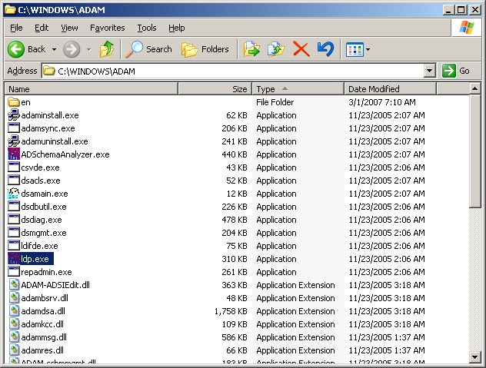

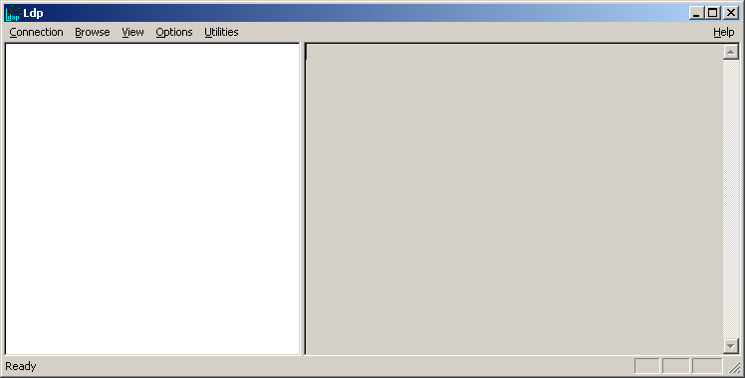
Connect to the ADAM instance (example instance is named SSO). From the menu click on Connection → Connect…
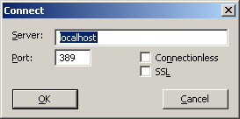
Enter localhost for the Server and 389 for the Port and click OK
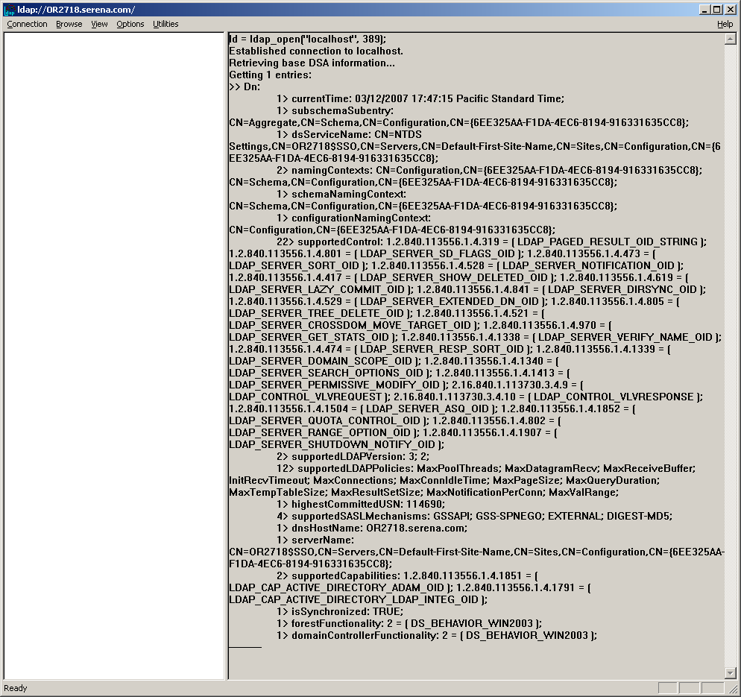
From the menu Connection → Bind…
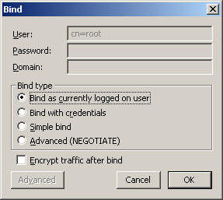
Click on “Bind a currently logged on user” and press OK
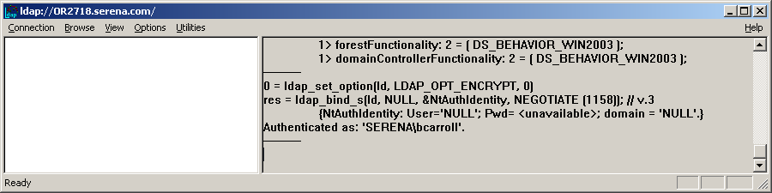
From the menu Browse → Add Child…
You will see a somewhat non-intuitive dialog box. The trick is to type in name-value pairs in the upper box and add them to the lower box
Use the Distinguished Name (DN) of DC=Higgins,DC=eclipse,DC=org
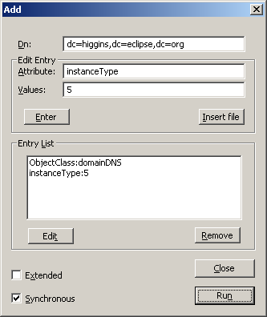
When you press Run, a successful execution will result in output similar to that shown, below:

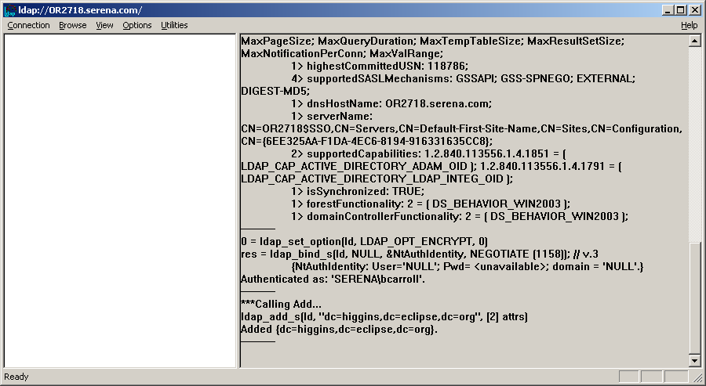

Adding an organizationalUnit
We now switch to the ADAM-adsiedit tool to add an organizationalUnit
Launch ADAM-adsiedit by Start → Programs → ADAM → ADAM ADSI EDIT
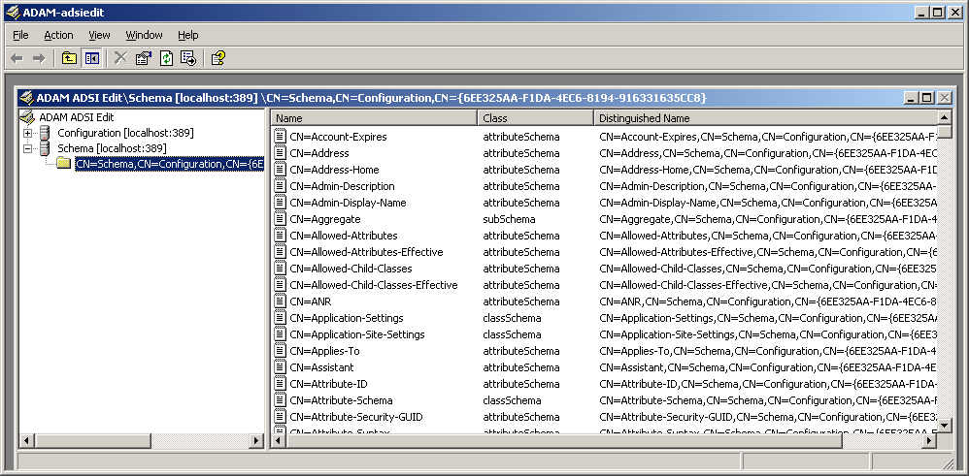

Now connect to the new Application Paritition. Select the root node ADAM ADSI Edit in the tree in the left pane, right mouse and select Connect To … The dialog will appear that looks like:
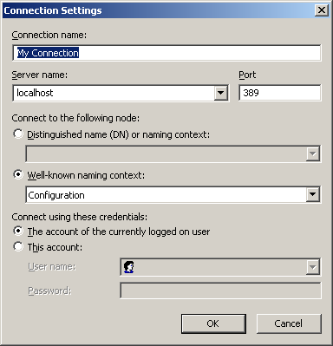
Change it to look like:
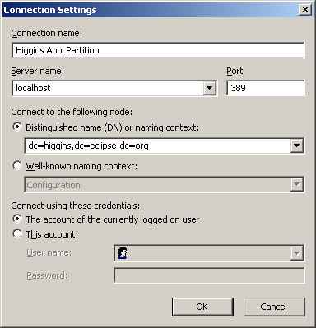

Click OK
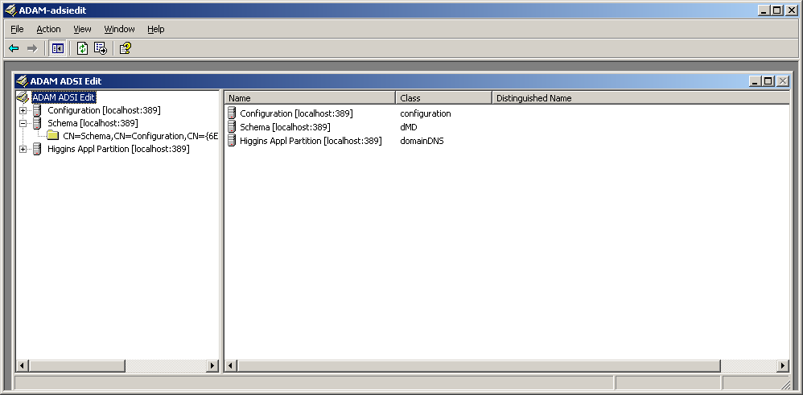
Expand the resulting tree in the main window and select DC=Higgins,dc=eclipse,dc=org
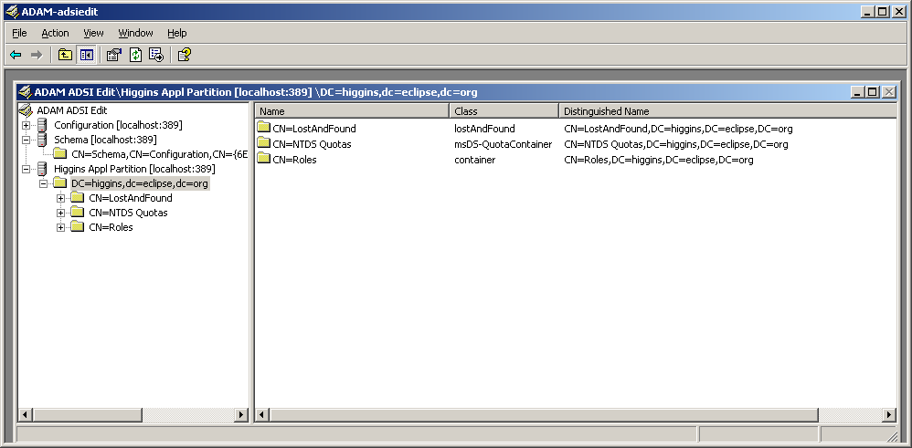
Right mouse and select New → Object…
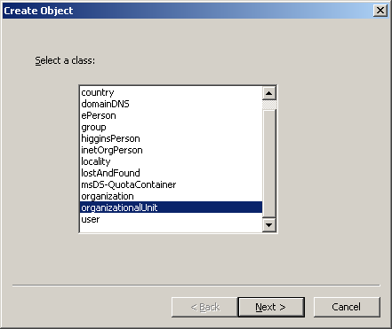
In the listbox, scroll down to and then select organizationalUnit, and press Next
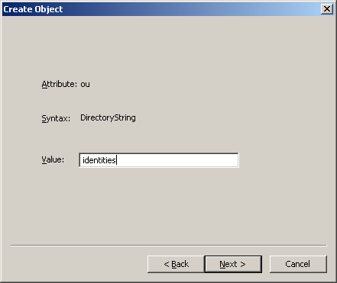
Enter a value of identities and press Next
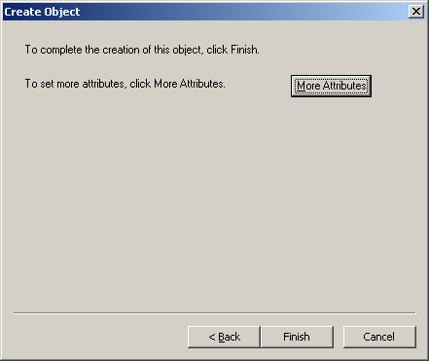
You can now see the organizationalUnit OU=identities instance
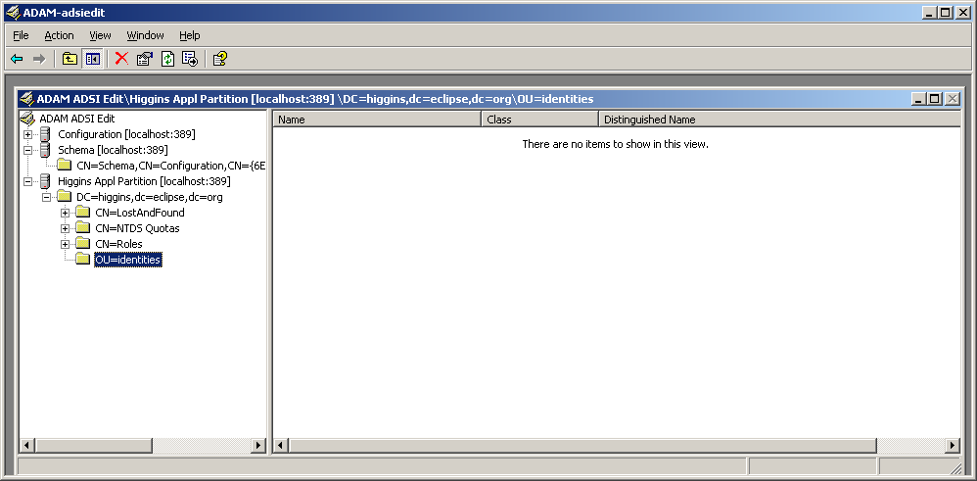

Populating the LDAP directory with instances of higginsPerson
Select ou=identities and right mouse. Select New → Object…
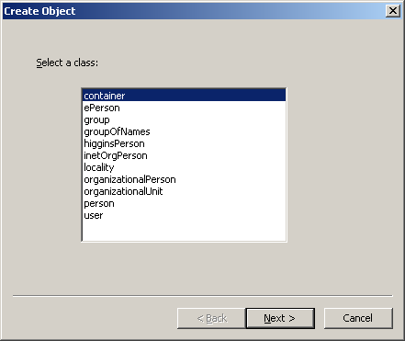
Because we had earlier expanded the schema to define higginsPerson, we can see that objectClass in the list. Select higginsPerson and click Next
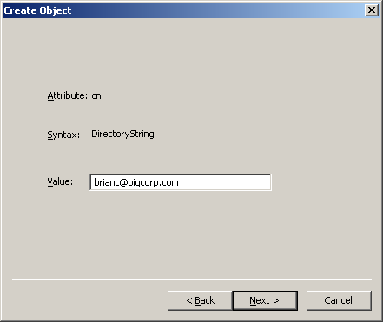

You will see:
Click the More Attributes pushbutton
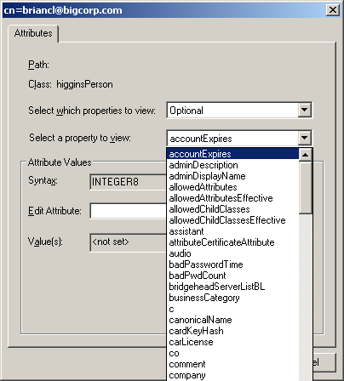

This dialog is non-intuitive. Once you select an Attribute from the Select which properties to view: dropdown list, you enter the value in the Edit Attribute text box. Then you press the Set button to associate the value with the property. You can then repeat the process with other attributes.
Note that the cn attribute will have already been set to the name you provided (brianc@bigcorp.com
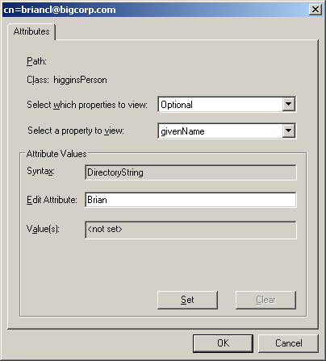
And press Set for each property., for each press Set
Select a few attributes from the properties to populate:
Property/Attribute | Value
givenName | Brian

When done adding attributes, press OK
Then click on Finish.
You can see the instance of higginsPerson in the right pane. To view its attributes, select it right mouse and select Properties:
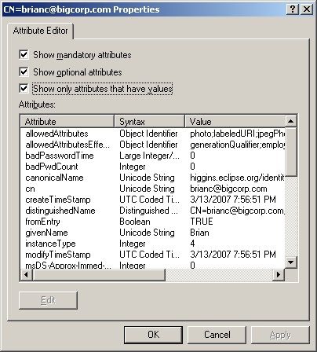
Since we just wanted to inspect the attributes of this higginsPerson instance, press Cancel

Now that we are convinced we have the schema correctly extended and can populate the LDAP directory with higginsPerson instances, we will use the web interface on the Higgins STS to populate additional instances.

Using the Higgins STS to populate higginsPerson instances
[I think this is not possible currently.]

