Naive XML to XSI
This document describes a transformation of an XML file to be XSI compliant by the simple strategy of attaching an xsi:type attribute with name equal to the element name to all elements with an xsi:type.
I first coded it manually and then wondered how such low level stuff could be handled in UMLX. It's just a matter of working at an appropriate meta-level. So given an XML parser that annotates input objects as the XML Attribute/Root/Element types it's straightforward.

XML Meta-Model
Or at least an adequate approximation.
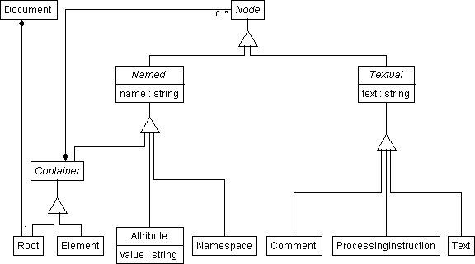

Transforms
4 transforms, with NonXsiTypeElement inheriting from a concrete Node transform.
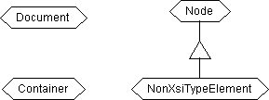

Document
Document and its composition hierarchy are preserved. The Container aspect of the Root is annotated.
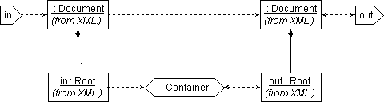

Container
All Nodes of a Container are annotated too.
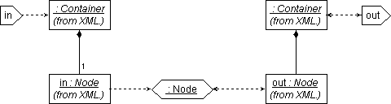

Node
The Container aspect of a Node is annotated.

NonXsiTypeElement
Additionally Elements without an xsi:type Attribute get one. (Additionally, because the base transform is not abstract and so is also invoked.)
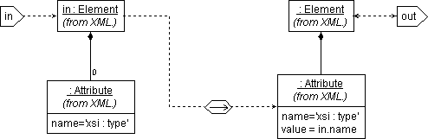

Implementation
This is not a very challenging transform. Manual coding gives:

In NiceXSL
stylesheet @version = "1.0" {
xmlns:xsi = "http://www.w3.org/2001/XMLSchema-instance"
match (/) {
apply-templates (.) mode = AddXsi;
}
match (*[not(@xsi:type)]) mode = AddXsi {
copy {
@xsi:type:=name();
copy-of (@*);
apply-templates (node()) mode = AddXsi;
}
}
match (/ | *[@xsi:type]) mode = AddXsi {
copy {
copy-of (@*);
apply-templates (node()) mode = AddXsi;
}
}
}

In XSL generated from the NiceXSL
<xsl:stylesheet xmlns:xsl="http://www.w3.org/1999/XSL/Transform" version="1.0" xmlns:xsi="http://www.w3.org/2001/XMLSchema-instance">
<xsl:template match="/">
<xsl:apply-templates select="." mode="AddXsi"/>
</xsl:template>
<xsl:template match="*[not(@xsi:type)]" mode="AddXsi">
<xsl:copy>
<xsl:attribute name="xsi:type">
<xsl:value-of select="name()"/>
</xsl:attribute>
<xsl:copy-of select="@*"/>
<xsl:apply-templates select="node()" mode="AddXsi"/>
</xsl:copy>
</xsl:template>
<xsl:template match="/ | *[@xsi:type]" mode="AddXsi">
<xsl:copy>
<xsl:copy-of select="@*"/>
<xsl:apply-templates select="node()" mode="AddXsi"/>
</xsl:copy>
</xsl:template>
</xsl:stylesheet>

