Role: Tester


  This role is responsible for the core activities of the test effort, which involves identifying, defining, implementing and conducting the necessary tests, as well as logging the outcomes of that testing and analyzing the results.
  Role Sets: Roles
Expand All Sections Collapse All Sections
Relationships
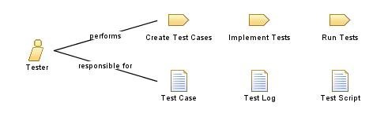
Additionally Performs:  - Plan the Project  - Plan Iteration | Modifies:  - Test Case  - Test Script  - Test Log  - Work Items List
Back to top
Main Description
This role is primarily responsible for:
- identifying the most appropriate implementation approach for a given test
- implementing individual tests
- setting up and executing the tests
- logging outcomes and verifying test execution
- analyzing and recovering from execution errors
Back to top
Staffing
Skills | The knowledge and skill sets may vary depending on the types of tests begin executed and the phases of the project lifecycle, however, in general, staff filling the this role should have the following skills:  - knowledge of testing approaches and techniques  - diagnostic and problem-solving skills  - knowledge of the system or application begin tested (desirable)  - knowledge of networking and system architecture (desirable)  Where automated testing is required, these skills should be considered in addition to those already noted above:  - training in the appropriate use of test automation tools  - experience using test automation tools  - programming skills  - debugging and diagnostic skills  Note also that specific skill requirements vary depending on the type of testing being conducted. For example, the skills needed to successfully utilize system load testing automation tools are different from those needed for the automation of system functional testing.
Assignment Approaches | This role can be assigned in the following ways:  - Assign one or more test staff members to perform this role. This is a fairly standard approach and is particularly suitable for small teams and for any sized test team where the team is made up of an experienced group of testers of relatively equal skill levels.  - Assign one or more test staff members to perform only this role. This works well in large teams, and is also useful to separate responsibilities when some of the test staff have more test automation experience than other team members.
Back to top
This program and the accompanying materials are made available under the
Eclipse Public License v1.0 which accompanies this distribution.
View copyright information here: OpenUP Copyright

