EPF F2F Committer Meeting – Bilbao, Spain

Logistics
- Bilbao, Spain, generously hosted by European Software Institute
- Meeting location: ESI headquaters:
Parque Tecnologico de Zamudio, building 204,
Zamudio, Vizcaya
- Monday March 6, 10:00 AM – Tuesday March 7, 16:00 (4 PM)
- Recommended hotel: HOTEL ARETXARTE, http://www.aretxarte.com/
<<More convenient from transportation (to/from ESI/Airport) point of view. It’s a 5 minutes walk to ESI>>.
For more information around accommodations, see separate info sheet.
Getting to ESI from Hotel Aretxarte:
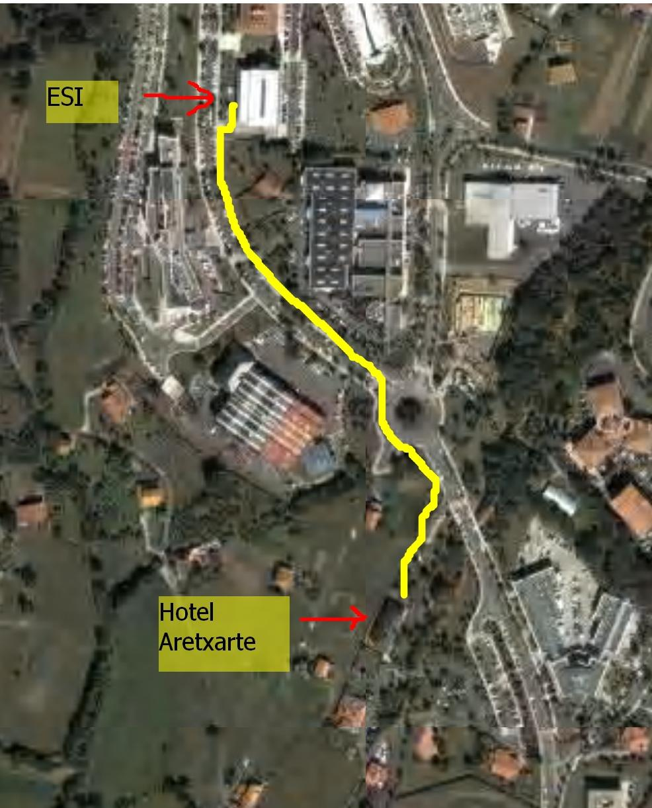

Objectives
The objectives of this meeting is to allow our potential European committers to attend an F2F meeting to get up to speed with the project so they can be active contributors. Objectives could include:
- Learn to know each other
- Understand who plans to contribute what, and what resources are available
- Present results from US committer meeting
- Learn about EPF core technologies
- Have working sessions allowing progress on relevant subprojects

Attendees
These are the people I have listed so far. Please let me know if there are any updates.
- Sander Hoogendoorn, Capgemini <May only attend one day>
- Henk Kolk, Capgemini
- Christoph Steindl, Catalysts
- Asier Azaceta, ESI
- Aitor Bediaga, ESI
- Jason Mansell, ESI
- Terry Bailey, ESI
- Xabier Larrucea, ESI
- Per Kroll, IBM
- Bruce MacIsaac, IBM
- Winfried Stenzel, Method Park
- Philippe Desfray, Softeam <May only attend March 6>
- Ana Pereira, Whatever Consulting Group <May arrive late on March 6>
- Mark Dickson, DSDM Consortium
- Barry Fazackerley?, DSDM Consortium <not confirmed>
- Julian Holmes, Capgemini
- Cees Michielsen, Telelogic

Current number of attendees: 17

A number of other people have said that they are interested, but you need to send an e-mail to me and Asier to confirm whether you are coming or not.

Agenda
Throughout, we will make sure to allow time for few-on-few technical discussions, and team-building. It is hence essential that we use breakfasts, breaks and dinners to achieve this objective. We will adjust the schedule below to make sure that we allow for building teams and trust among participants.
I am sure there are other topics that we should cover. Please raise these asap, and we will adjust accordingly.

Monday 10:00 – 13:00
- Introductions
- Quick walkthrough of how the project is organized. What exists today? Who is a part of the project? Walkthrough of dev plan.
- Each company walks through what they want to contribute. The more specific you can be, the better. Ideally something like "We would like to improve BUP in the area of MDA. We have the following material available to use as a baseline. This would mean that we could foresee adding this type of content to BUP <list>, " Or, "We would like to add agile practices around team collaboration, such as guidelines around "TDD, Information Radiators, and Office space layouts that work" <10-30 min, no corporate pitches, please>
Monday 14:00-18:00
- Continue company contribution walkthrough if not done.
- Identify issues that needs discussion
- Identify workgroups, either around current subprojects, or around even more specific domains. If 4 committers want to do MDA stuff, maybe they would discuss if they have the same view of what to add. Discuss what can be done
Monday 20:00-
- Team dinner - A key aspect of the meeting is to network. Make sure to also leverage breaks to learn to know each other!

Tuesday 8:00 – 12:30
- Discuss some of the issues raised previous day (such as a need for more info on what it means to be a committer...)
- Continue work groups
- Present action plans for each work group
Tuesday 13:30 – 16:00
- Discuss and agree to execution. Future F2F meetings, weekly meetings, ...

