Welcome to the Basic Unified Process (BUP)
BUP is an iterative software development process that is minimal, complete, and extensible.
BUP takes an agile approach to development valuing team collaboration and benefits to the stakeholders over unproductive deliverables and formality. The process provides this progressive approach to building systems within a proven, structured lifecycle.

BUP Core Concepts:
These are the core concepts that influence BUP roles, tasks, and artifacts.

It's the people!   | Focus on the collaboration within a development team including the product stakeholders to maximize results
Do it again, and again, and ... | Application of an iterative lifecycle that mitigates risk early and often, and shows results early and often
Know what they really want.  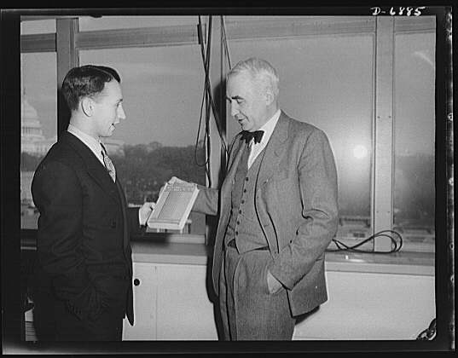 | Management of requirements in a form that represents stakeholder value and drives the development process
Long live architecture!   | Cognizance of architecture as a means to increase quality and technical understandability

Core Concept: It’s the People!
People, Ideas, Hardware – In that Order! USAF Colonel John Boyd

Software is Created by People – not Processes or Tools
Software development methodologies and software development tools do not create software, people do. Great software development methodologies and great tools cannot compensate for a dis-engaged software development team. The BUP collaborative principles and practices are a reminder and an affirmation that only people can develop software. The BUP collaborative principles and practices are woven into all BUP roles, tasks and artifacts as guidance for keeping the team engaged.

BUP Collaborative Principles
BUP’s four collaborative principles are trust, vision, intent, and skill. These four principles are derived from the work of USAF pilot and strategist Colonel John Boyd. Colonel Boyd argued culture provided a competitive advantage to an organization. Development of trust, focus, skill, and intent enabled a team quickened a teams tempo of operation and enabled that team to operate more quickly than its competition. Agility therefore is the ability to operating at a quicker tempo than a competitor, and agility emerges from these four collaborative principles.

Trust | The flexibility to quickly respond to change depends on quick decision making and it trust enables us to take the initiative and make decisions quickly in an environment of uncertainty and indecision.
Vision | Vision gives people direction, in those situations where no firm guidance has been given (which should be most of the time). Vision is the unifying medium that coordinates the initiative of many individual actions with team intent.
Intent | A leader does not prescribe how the subordinate should accomplish the goal, rather the subordinate is given freedom to take the initiative which enables flexibility and creativity in execution
Skill | The intuitive knowledge that enables one to see emergent patterns and immediately decide on a course of action. Formal decision making can slow the decision making process.

BUP Collaborative Practices
These are the seven actionable practices that guide and are applied specific BUP tasks and roles in realizing the collaborative principles.

Shared Clear Vision | Ensure all participants share both the same mental model of the project objective and process.
Manage By Intent | When assigning a task explain the intent behind the task and so enable the assignee(s) to take advantage of change in the situation. Furthermore assign work with a coarse granularity (e.g. 2 to 3 days) and allow assignee(s) to devise their own short term plan.
Buddy Up | Multiple participants shall be responsible for a task.
Tear Down the Walls | Create strong cross functional co-located teams. Prevent a caste system from emerging. Regularly meet customers and partners face to face.
Engage the Experts | Engage those who have a stake in solving the problem and those can contribute to solving the problem (Customers, domain experts, QA) .
Don’t Go Dark | Take personal responsibility for ensuring that you remain connected to vision and do not isolate yourself from your collaborators.
Confession is Good for the Soul | On a regular basis:  - reflect on the process and how to improve it.  - Boldly state your views of the project and open yourself to the critical comments of your peers.
Train Incessantly | Make time to learn from every experience. This is not just time for stand up training but also continuous on the job training.

Core Concept: Do It Again and Again….
<< really cool inspirational photo goes here>>

Iterations, Phases, and Risks
Some kind of discussion here about risk, cost of change, and why UP processes have phases. Relate phases and iterations to architecture and requirements management.

BUP Iterative Principles
Two, three, four, or five key principles giving the philosophical justification for iterations with phases.

BUP Iterative Practices
Some specific actionable practices that can be linked to BUP roles, tasks, and artifacts.

Core Concept: Know What They Really Want

Requirements and Uncertainty

BUP Requirements Management Principles
A couple of principles behind our requirements management philosophy

BUP Requirements Management Practices
Some specific actionable practices that can be linked to BUP roles, tasks, and artifacts.

Core Concept: Long Live Architecture

Architecture
Why is architecture important, and why it doesn’t just “emerge”.

BUP Architecture Principles
A couple of principles behind our architecture philosophy

BUP Architecture Practices
Some specific actionable practices that can be linked to BUP roles, tasks, and artifacts.

