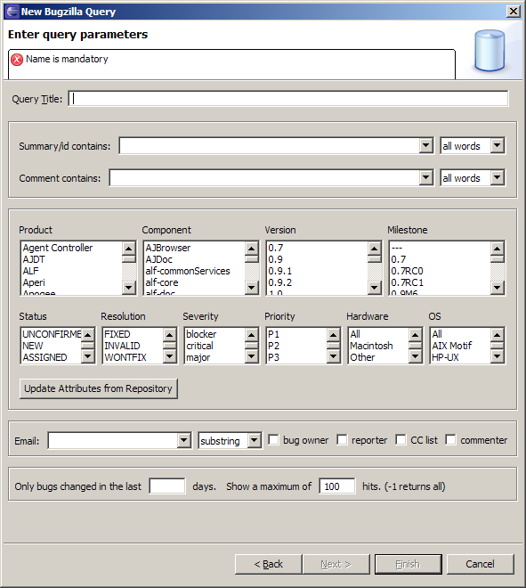
Figure 1 Mylar in EPF - Bugzilla Query Form
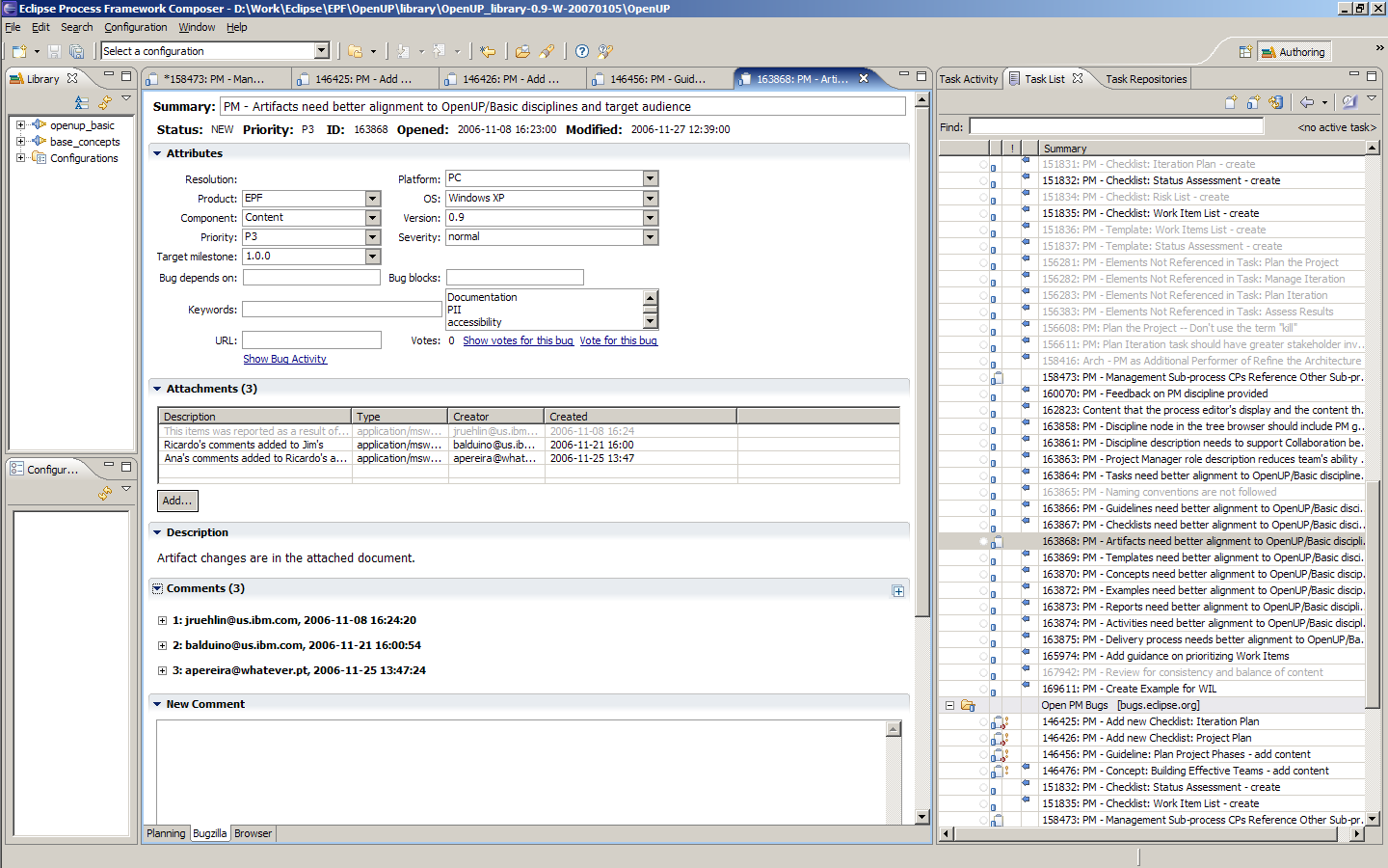
Figure 2 Mylar in EPF – Bugzilla Tab – Part 1
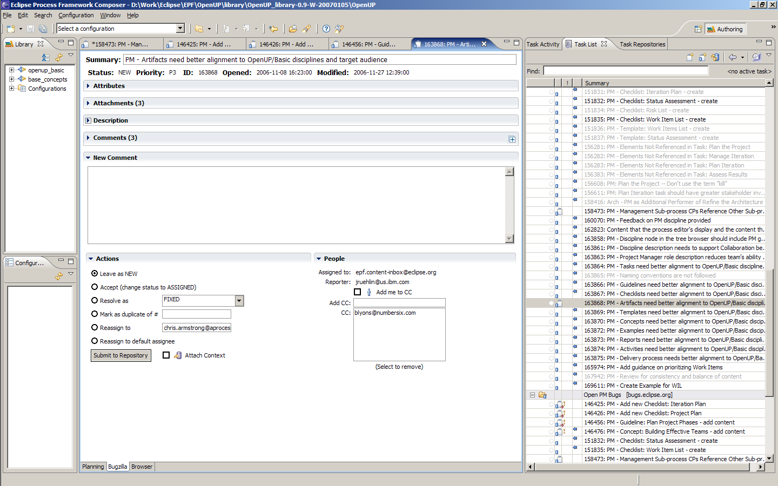
Figure 3 Mylar in EPF – Bugzilla Tab – Part 2
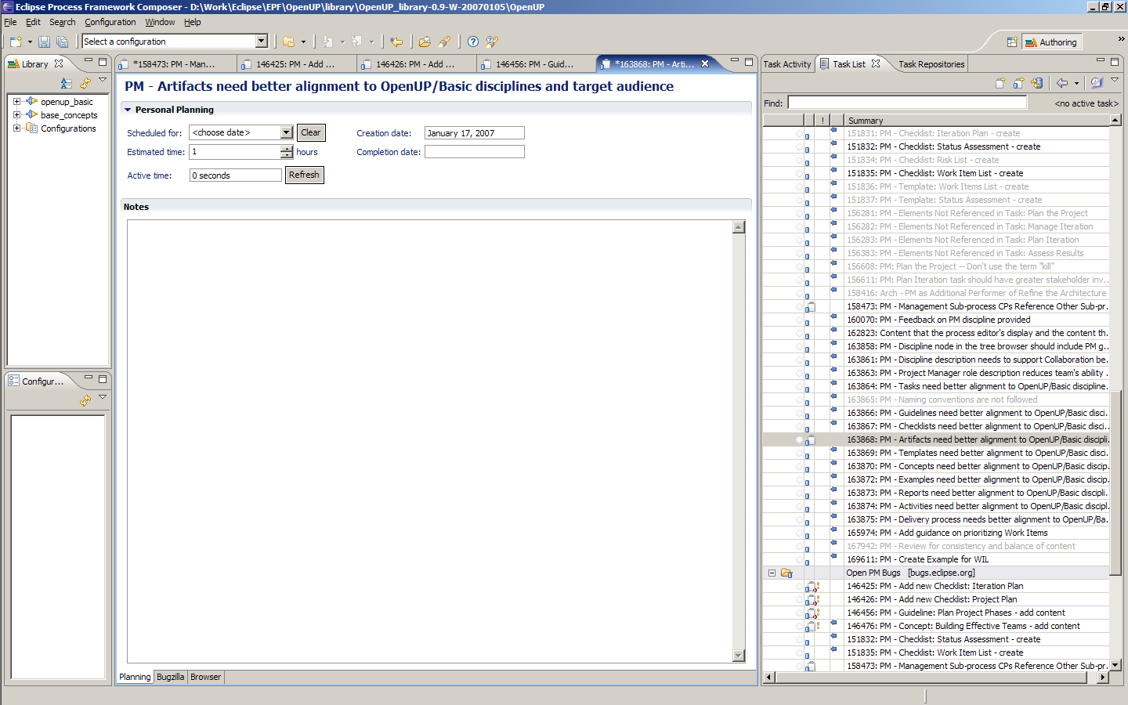
Figure 4 Mylar in EPF – Planning Tab
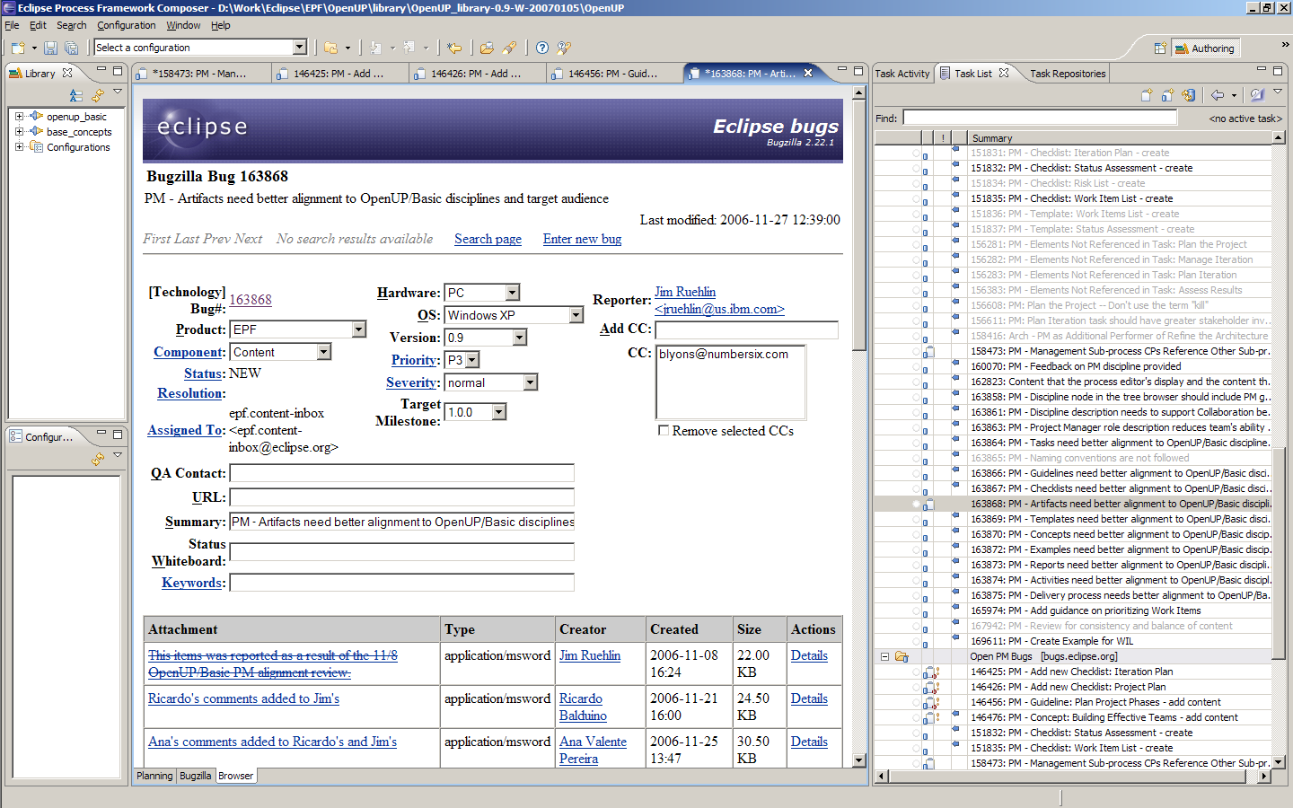
Figure 5 Mylar in EPF – Browser Tab

