Figure 1 Iteration

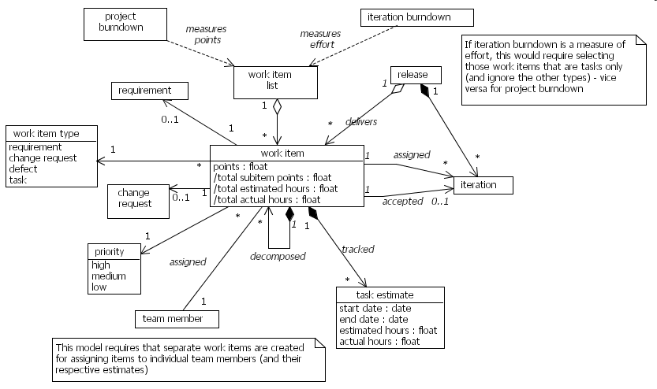
Figure 2 Work Item (merged with Task from previous model)
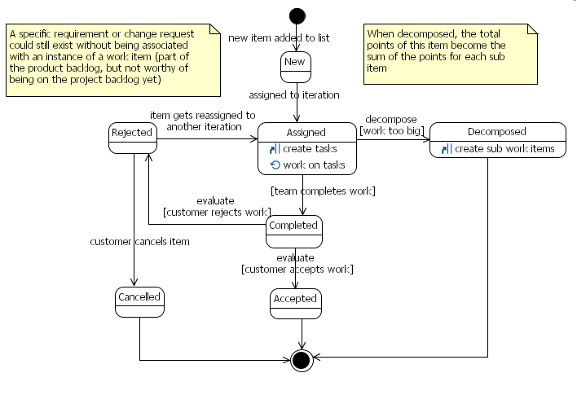
Figure 3 Work Item State model (same as before)

