Eclipse Process Framework (EPF) Composer

Installation Manual

Table of Contents

1. Download and Install 3
1.1. EPF Composer 3
1.2. Existing Content 6
1.2.1. EPF Library Downloads 6
1.2.1.1. EPF Wiki 7
1.2.1.2. EPF Practices 7
1.2.1.3. OpenUP 10
1.2.1.4. Other Libraries 10
1.2.2. Other Download Sites 10
1.2.2.1. TOGAF 11
1.3. Switching Method Libraries 16

Download and Install
The EPF Composer uses the Eclipse Rich Client Platform (RCP), it is a stand-alone application that installs independently from other Eclipse programmes.

EPF Composer
Go to http://www.eclipse.org/epf/ and click on “Downloads”. A new webpage comes up (http://www.eclipse.org/epf/downloads/downloads.php) and you will see:
- EPF Downloads
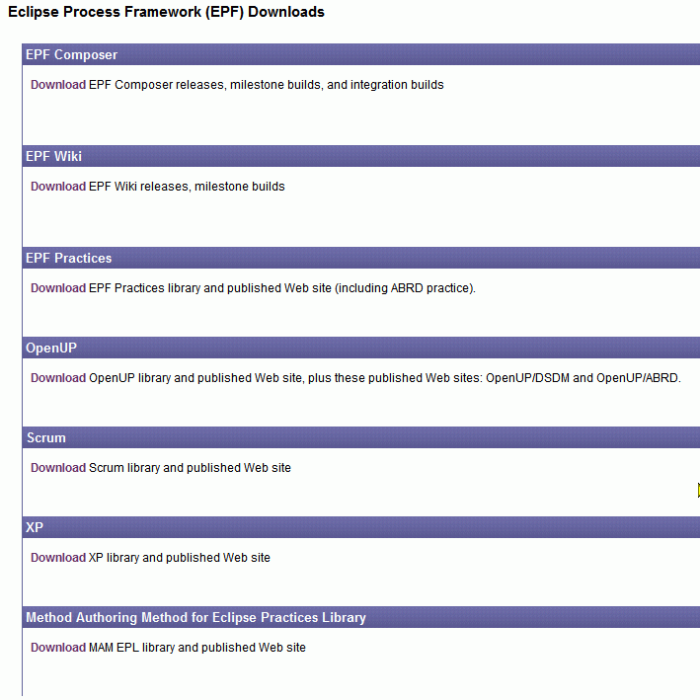
Under EPF Composer, click on “Download” which brings up yet another web page: (http://www.eclipse.org/epf/downloads/tool/tool_downloads.php).
- EPF Downloads
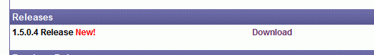

Click on “Download” and yet another web page comes up:
http://www.eclipse.org/epf/downloads/tool/epf1.5.0_downloads.php
Scroll down the page until you see the section Download.
- EPF Downloads
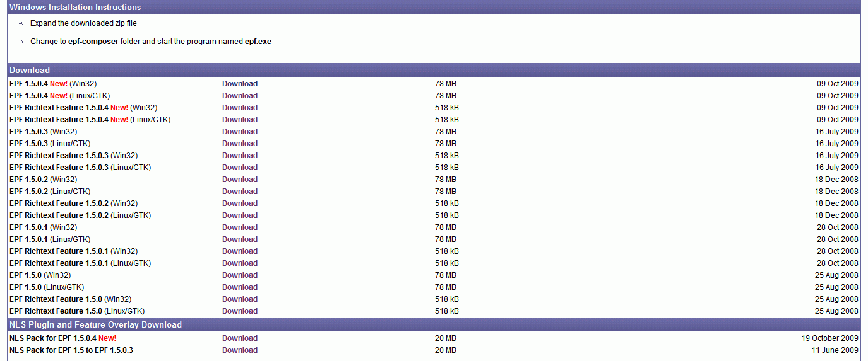

Comment: We have to say if and when the EPF Rich Text Feature and/or NLS Plug-in and Feature Overlay Download must be download and installed and how to install them.

Click on “Download” to the right of “EPF 1.5.04 New”. That brings up yet another webpage. The page will depend upon the version that you have selected.
- EPF Downloads
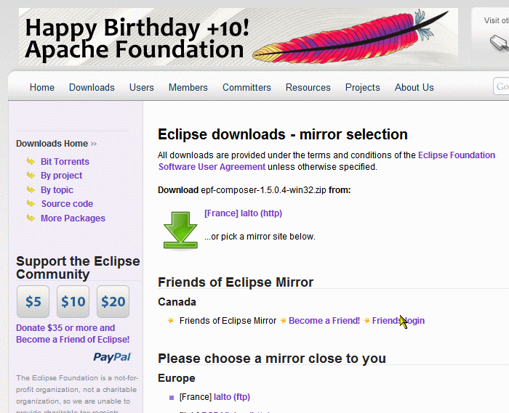

This time, you should click on the green arrow (not on “Download”).
You are then asked to save the file: epf-composer-1.5.0.4-win32.zip. The next step is to extract the zip file. The result is a folder with the name “epf-composer”. Then go to the “epf-composer” folder and start the EPF composer programme by double-clicking on the epf.exe file (for future use, it is recommended to create a short-cut on the desktop).
The Eclipse Process Framework Composer “Welcome” screen appears.
- EPF Welcome Screen
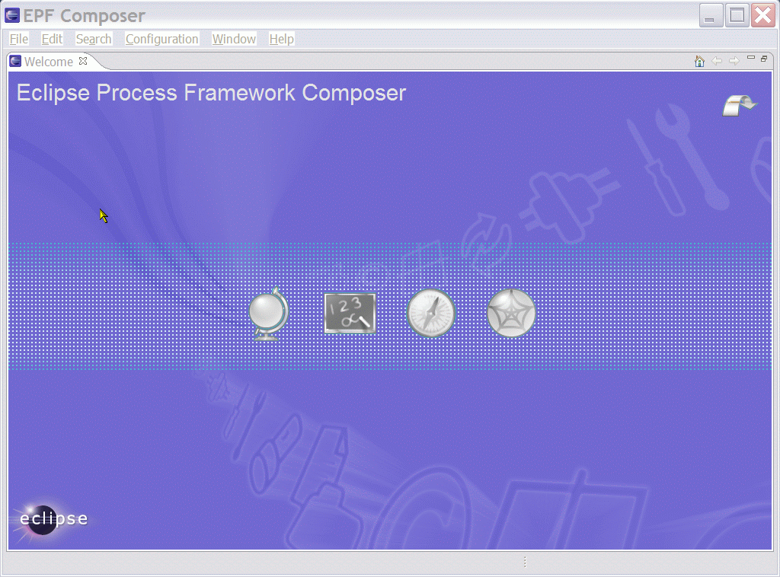
The arrow in the top right corner brings you directly to the Workbench. If you want to go back to the Welcome screen, go the menu item “Help” and select “Welcome”.
The workbench screen is empty:
- EPF Workbench Screen
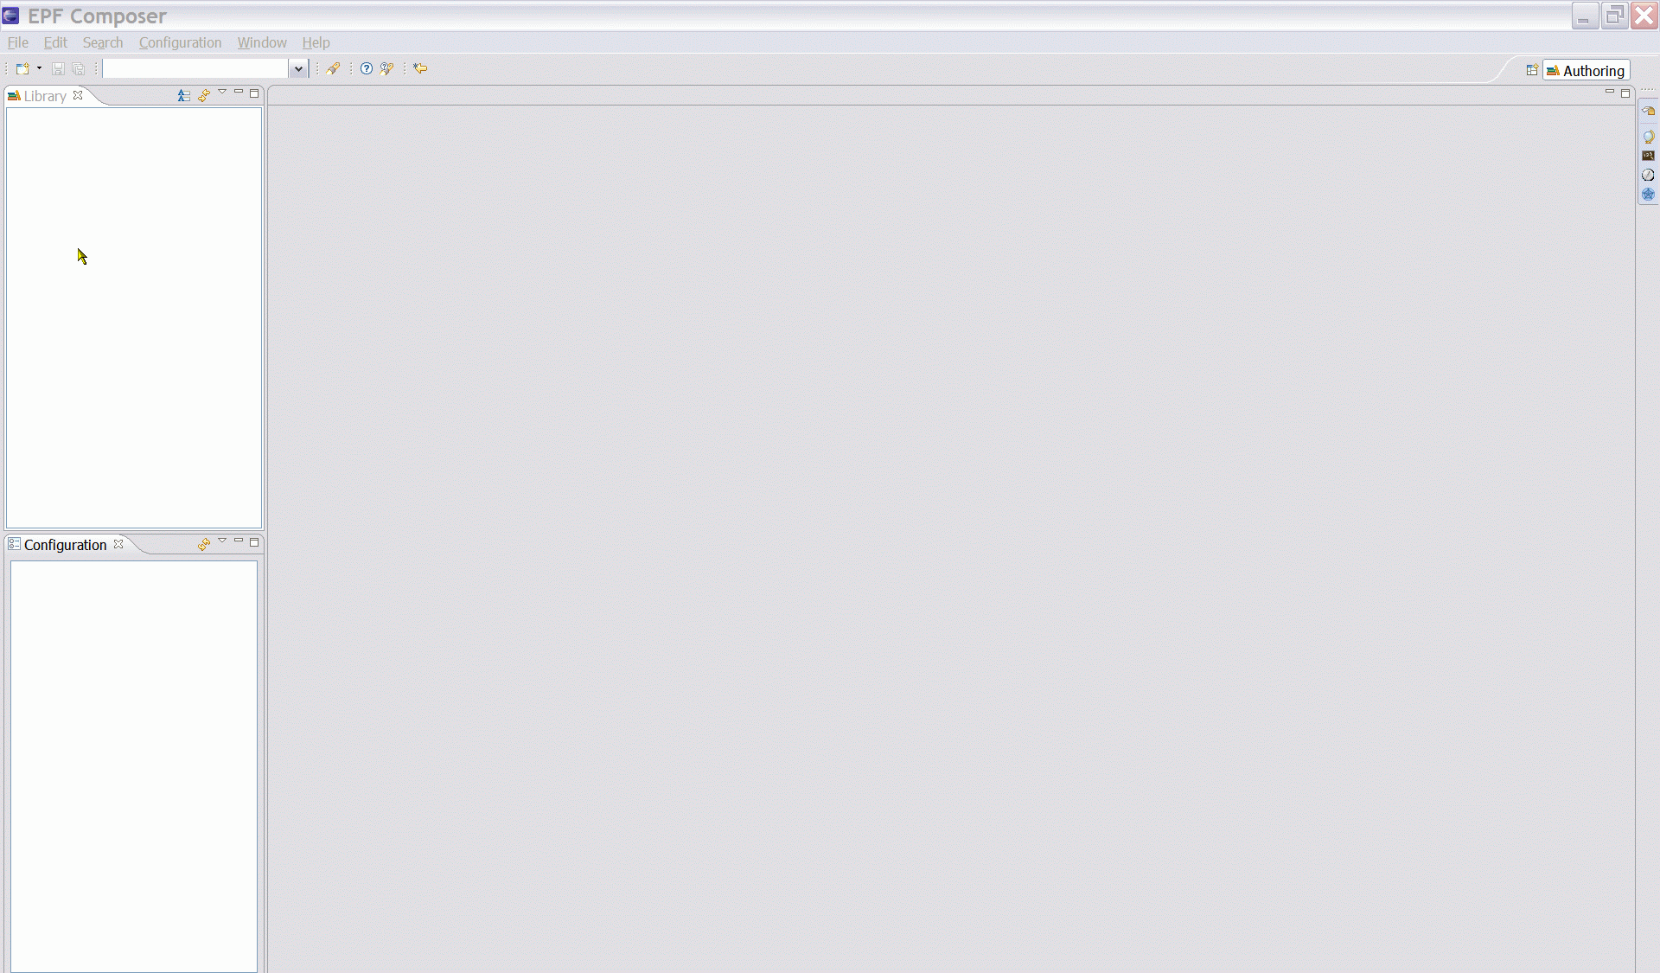

Existing Content
Already created content can be imported, either by importing method libraries, method plug-ins or XML files.
All method contents are stored in a method library and importing already created content requires either an existing method library or the creation of a new one. Importing a method library creates a new method library, while importing a method plug-in or an XML file requires an existing method library or the creation of a new method library before importing.
Existing method content import sources:
- Library Configuration
- Method Plug-ins
- XML
By installing already created method elements and by changing and extending the content, the authors can create process descriptions that are appropriate for their environment, without having to start from scratch.

EPF Library Downloads
A library is a container for method plug-ins and method configuration definitions. All method elements are stored in a library. To download existing content from the EPF site, go back to the first download page as in previous Figure 1, here figure 7: “EPF Downloads”.
- EPF Downloads

EPF Wiki
There is no need to download the EPF Wiki.
Explain why not needed and what the wiki pages are good for.

EPF Practices
The practices library is included as part of the EPF 1.5 Most of the open source content derives from OpenUP 1.0, refactored to support independent practices.
On the first download page (Figure 7): Click on “Downloads” under EPF Practices. A new webpage appears.
- EPF Practices Downloads
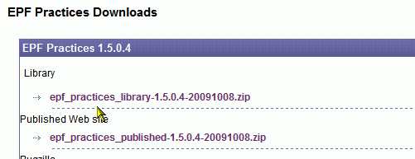
Download the two zip files. Extracting the zip files results in two folders: “epf_practices” and “epf_practices_published”.
The “source format” is published as EPF method plug-ins which can be edited once they have been loaded in the EPF Composer and which are typically published subsequently.
The already provided published version is a static html website (set of web pages) that can be installed on any computer, even those that do not run the EPF Composer. Therefore, if you only want to use the out-of-the-box content “as is”, you can simply unzip the *published*.zip, and run index.htm in your favourite browser and you will be able to navigate the already published content.
We recommend that you move the two folders under the “epf-composer” folder.
To install the epf practice libraries, start the EPF composer program by double-clicking on epf.exe again. The go to menu File à Open à Method Library. Click Browse and go to “epf_practices” folder under the “epf-composer” folder and click OK. The file that the programme is looking for is named: “library.xmi” which it finds in the “epf_practices” folder.
Then the “Copy Library” dialogue window pops up and tells you: “The library you are opening is a default library supplied with the composer.”
- Copy Library
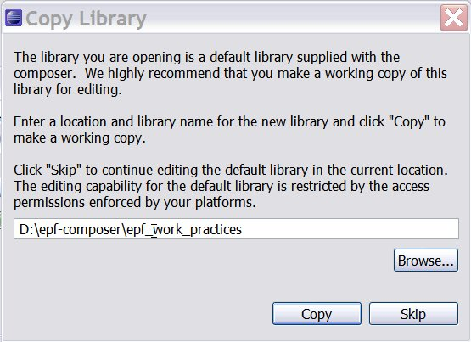
What this message tells you somewhat cryptically is that you have the choice between either using the files in the “epf_practices” folder or to create a separate folder and copy the files over to the new folder. In the latter case, you have two copies, one that you can change as you like and another with the original pristine and unchanged files. In this way you always have an unchanged reference copy.
You can for example create a new folder using the operating system’s File Explorer (in the case of MS Windows), with for example a folder name like “epf_work_practices”. Afterwards, having switched back to the EFP application, you click on Browse and browse so that it points to the new “epf_work_practices” folder. You then click OK which brings you back to the pop-up “Copy Library” window and you click on Copy and wait a few seconds. The workbench screen has now changed. The title bar shows the path and the name of the working folder.
- EPF Workbench Screen
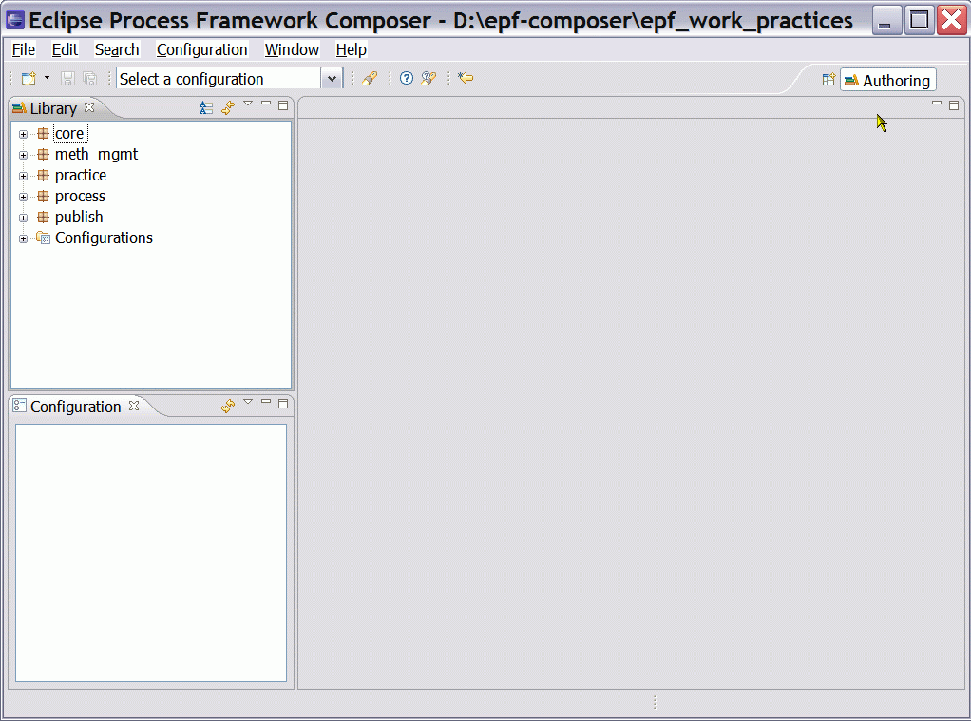

OpenUP
Library
The OpenUP Library is included in the EPF Practices and does not need to be installed separately.
Then why do we complicate things by including it?
Published OpenUP web pages
The UpenUP web pages are however available for download. Extract the files from the “openup_published-1.5.0.4-20091008.zip” file and place them in the “epf-composer” folder. Double-click on index.htm, this will open the Internet browser and you will be able to navigate the already published content

Other Libraries
For the other libraries follow the same steps. On the EPF Downloads page, see Figure 1, the following libraries are available for downloading.
- Scrum
- XP
- MAM (Method Authoring Method) for Eclipse Practices Library (EPL)

Other Download Sites
Already created method content can be downloaded from different sites.

TOGAF
There is a TOGAF 9 Method plug-in, which can be found at:
http://www.opengroup.org/architecture/togaf/epf_intro.html
Installation of a plug-in is different from the installation of a library.
Installation:
Once you have downloaded the TOGAF_9_Final_EPF_Export.zip file, the next step is to extract the zip file. The result is a folder and you can change its name. We called the folder “TOGAF_Export” for example. We suggest you place the folder under the “epf-composer” folder.
- Create new Method Library
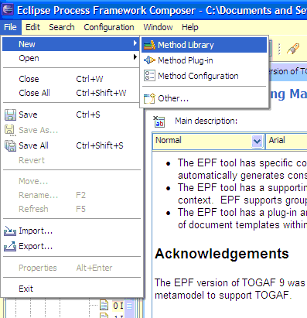
Again, you will create a working directory for the method; in our case we created a folder called “epf_work_TOGAF9”. Then open EPF and create a new Method Library.
- Create new Library Folder and point to the path.
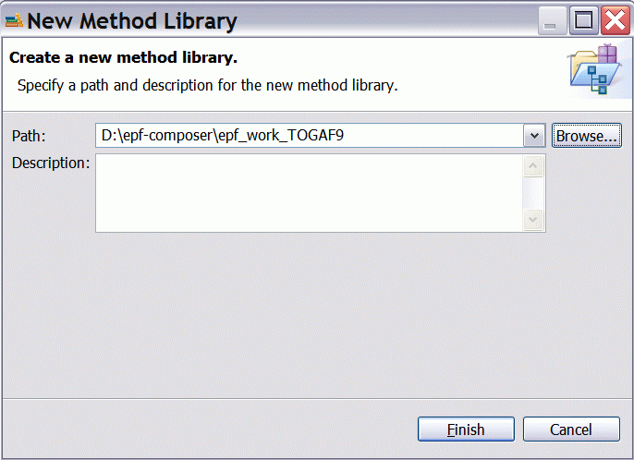
Click Finish and the Method Library is then created. You can now import the TOGAF9 Method Plug-in to this library.
- Import Method Plug-in
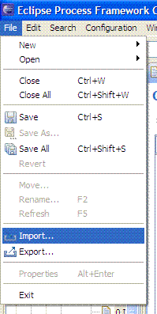
The result is the following window:
- Import Source Type
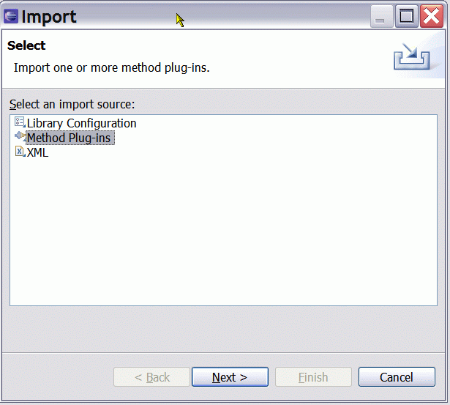
You will have to navigate to the Method Plug-in folder.
- Import Directory
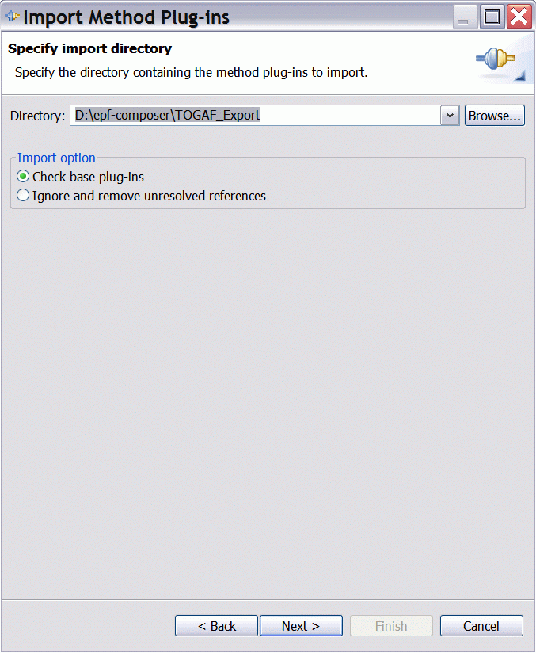

Having clicked on Next > then another screen appears:
- Method plug-ins
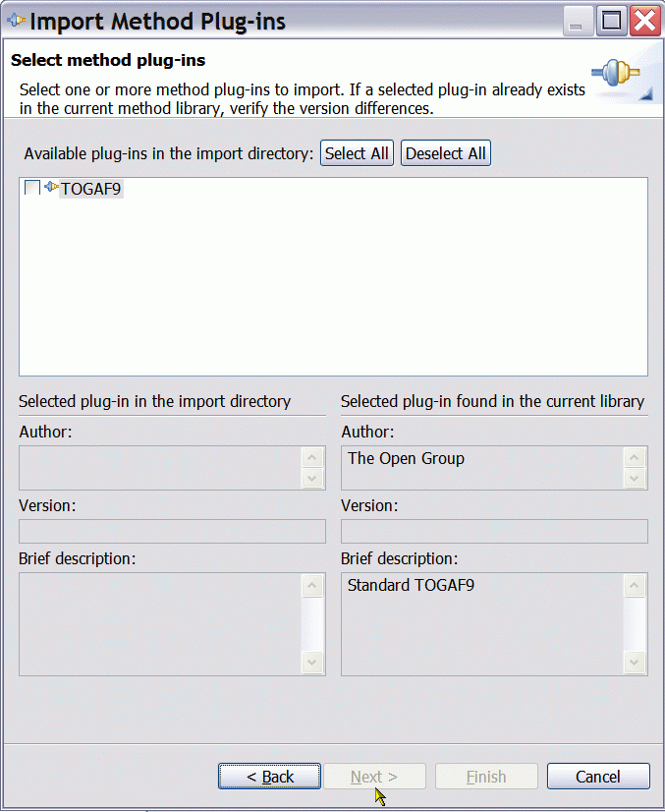
You select TOGAF9 and click on Finish. You are in business. You have now an Enterprise Architecture library in your work folder “epf_work_TOGAF9”.

- Import Directory
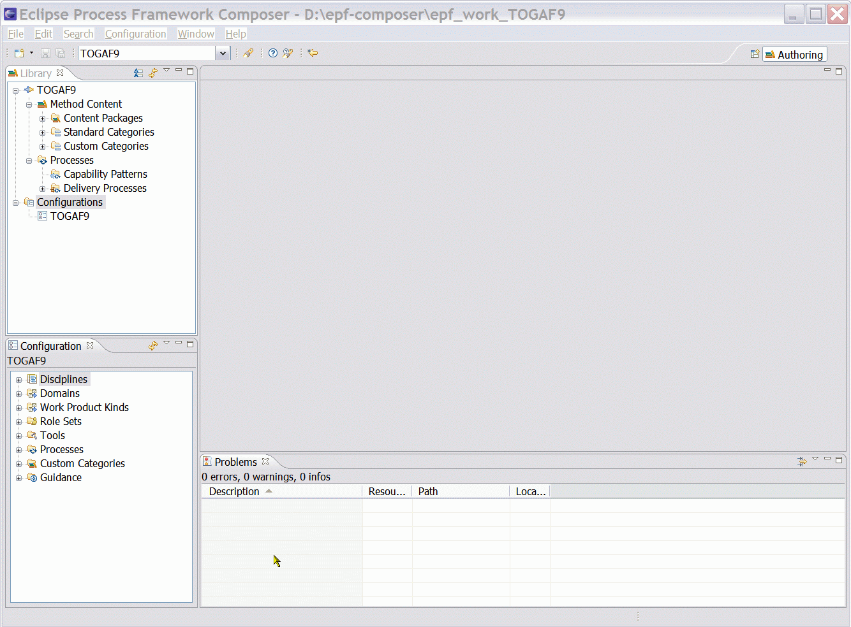

Switching Method Libraries
Start EPF and click on File à Open à Method Library. The Open Method Library dialogue box opens. Browse to select the folder with the library (or with the editable copy of the original library) files. In this case we have selected
- Open Method Library
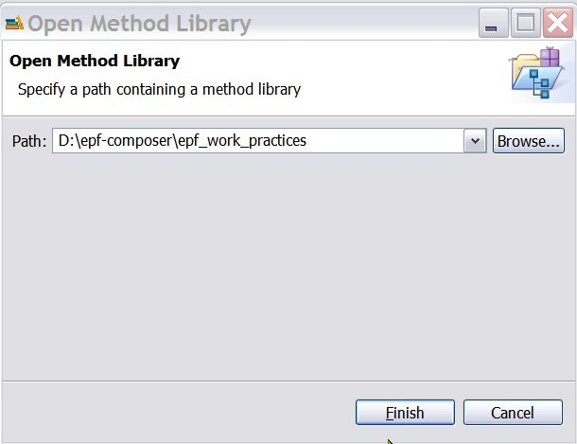
Then, somewhat surprisingly, the Copy Library dialogue box pops up again:
- Copy Library

Again, this message tells you, although not very clearly, that you have the choice between either using the files in the “epf_work_practices” folder or to create a separate folder and copy the files over. In the latter case, you have two copies. In our case, since we clicked on Copy when we installed the files the first time, the files in the “epf_work_practices” folder are already a copy of the files in the “epf_practices” folder and we do not need an additional copy of the copy of the original files, we therefore click on Skip to load the default working library in the “epf_work_practices” folder.

