Rodrigo Pastrana

Security Management

The Security Management (SM) services provide management for key stores, key pairs and certificates. The Security Management is a global service, i.e. the managed keys and certificates can be used in what ever mobile project. Security Management Implementations (SMI) will provide the security management logic, or will interface to stand-alone security tools which provide the security management logic. Security tools are typically packaged within many JDKs (SUN, IBM, etc), and readily available to Java developers.


<<Extension Point>>
Security Management
Security Management Implementation
Security Management Implementation
<<Extends>>
Security
Management Tool
Security Management Tool
Security Management Implementation
<<Security Management logic included>>
Figure 1

The SMI should provide the logic for the following tasks:
- Creating new password protected Keystores.
- Keystore password management.
- Create a new key pair. (A pair of public and private keys that can be used in signing mobile projects. A key pair is always associated with a public key certificate.)
- Open existing keystore files from the file system.
- Delete a key pair from a keystore.
- Import a certificate from the file system into a keystore, where the signed RSA X.509v3 certificate for the public key from the CA was saved.
- Provide a means of displaying data related to the alias key in its encrypted format.

Graphical User Interface Support

Security Management Preferences Page

A Security Management Preferences Page (SMPP) will be provided within the MTJ preferences category. The SMPP will provide configuration utilities for all detected SMIs. The SMPP provides an option to activate, or deactivate SMIs. The SMPP also provides a Security Management tool location editor, which is necessary to configure SMIs that depend on a stand-alone security tools.

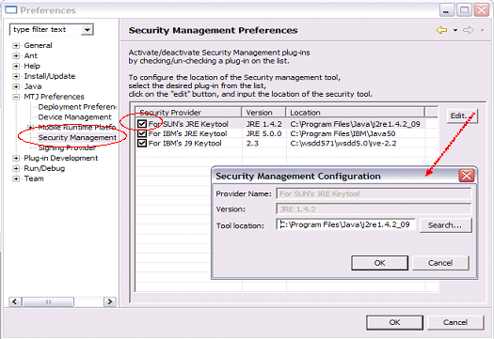
Figure 2
The SMPP classes, query all detected SMI for their vendor id, version, active state, and tool location (interface SecurityManagement.getToolLocation), and display the information in the SMPP table. The Security Management Configuration dialog, allows the user to locate the target security tool in the local file structure. Each SMI is responsible for storing the tool location (interface SecurityManagement. storeToolLocation); possibly by utilizing their own IPreferenceStore object.

Security Management for MTJ Dialog

The Security Management for MTJ Dialog provides the user a graphical interface to all the security utilities provided by the Security Management, and the Signing Provider Implementations. Since the Security Management and the Signing Provider services are so tightly coupled, both sets of services are enabled via a single dialog.

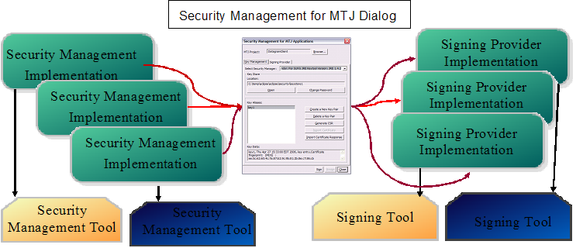
Figure 3

The dialog is accessible from the following locations:

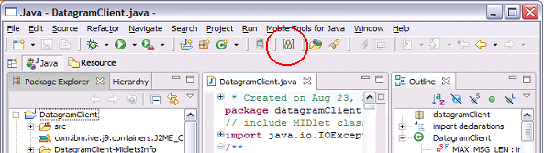
Figure 4 From the toolbar.

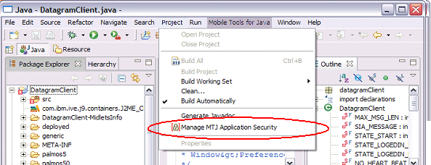
Figure 5 From the Mobile Tools for Java Menu

The user selected MTJ project name will be displayed in the top field of the dialog and sets that project as the target project for Security and Signing Management. A browse button is provided, which invokes a target project selection dialog (see Figure 7) which will only list MTJ projects in the current workspace. A target project does not need to be set in order to utilize any of the Security Management features provided in the dialog. A target project does need to be set to use the Signing Provider features.
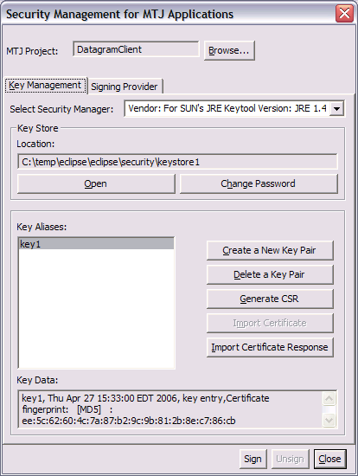
Figure 6

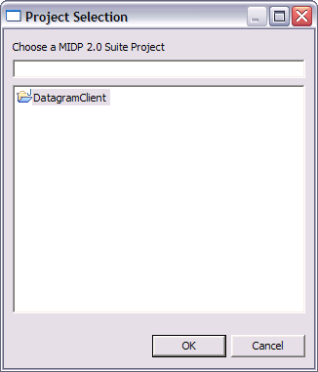
Figure 7
The Security Management for MTJ dialog is composed of two tab pages: “Key Management” and “Signing Provider”. The Key Management tab contains a drop down list, where all active SMI are listed, and the user can choose the desired SMI to work with. The selected SMI is responsible for fulfilling any Security Management task requested by the user from within the dialog. The user may request the following tasks:

- Open Key Store – Open the user clicks on the button Open Key Store, the system file browse dialog opens for the user to browse and select the key store file from its location on the users file system and click Open. Once the user selects key store file, he will be prompted to enter the password to the selected key store file.

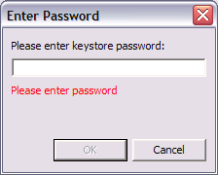
Figure 8

The system then calls the openKeyStore(…) method of the current SMI to open the key store file and access its contents using the user-entered password and displays a list of key aliases (if any) in the key alias list area in the tab page. The system also displays the key store file name once the user successfully accesses a key store file. The key store file name information only appears once the user has accessed a key store file.

- Change Key Store Password – Opens a new Change Password dialog, which will prompt the user for the old password and also force the user to enter the new password twice for verification purposes. Once the system verifies that the user has entered the same password in both the new password fields, it then calls the getPassWrd() method of the current SMI to change the password of the requested key store. This button will be deactivated until the user specifies a key store file.

- Create a New Pair – When the user clicks on the Create a New Key Pair button, a new dialog is opened which requests the user to enter the required information for creating a new key pair.

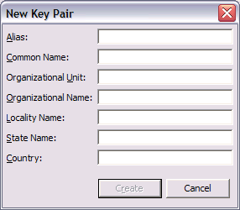
Figure 9

If the user has not selected a key store file before clicking on the Create a New Key Pair button the user will be prompted with a file system browse dialog to specify the file name and location of the new key store file. The user will also be forced to set a password for this new key store file. The system will call the current SMI to create the new key store with the new key pair and protect the key store with the user-entered password. The newly created key alias will be displayed in the list of key aliases in the key store.

- Delete a Key Pair – When the user clicks on the Delete a Key Pair button, the selected key alias information will be deleted from the key store by calling the deleteKey(…) method of the current SMI. The user will be prompted before the key pair is deleted from the key store. This button will be deactivated until the user specifies a key store file and also if the specified key store contains no key aliases.

- Generate CSR –When the user clicks on the Generate CSR button, the system will display a file system browse dialog to allow the user to select the directory location where he wishes to save his certificate request file (.CSR file) which will eventually be sent to a Certificate Authority (CA) for signing. The system will call the generateCSR() method of the current SMI to generate the CSR file for the user-selected key alias information. This button will be deactivated until the user specifies a key store file and also if the specified key store contains no key aliases.

Note: The MTJ security components are not going to be responsible for sending the Certificate Signing Request (CSR) file to a CA for signing. The user will be responsible for sending the file for signing.

- Import Certificate – After the user sends the CSR to the CA for signing, and the user has received a certificate from the CA and signed response for the CSR generated earlier, and the user clicks on the Import Certificate button, a file system browse dialog is displayed prompting the user to browse to the directory where the certificate file from the CA is saved and click Open. The system will call the importSignedCert(…) method of the current SMI to import the signing authority CA’s certificate (saved in a file) into the key store with a new key alias specified by the user. If the user attempts to import a signed certificate response without importing the signing authority (CA) certificate first, an error message will be displayed since the keystore will not recognize the signing authority of the request. This button will be deactivated until the user specifies a key store file.

- Import Certificate Response – When the user clicks on the Import Certificate Response button, a file system browse dialog is displayed prompting the user to browse to the directory where the signed certificate (.CER) response file from the CA is saved and click Open. The system will call the importSignedCert(…) method of the current SMI to import and store the signed certificate (saved in a file) into the key store entry identified by the key alias selected by the user. This button will be deactivated until the user specifies a key store file.

Security Management Implementations

Security Management Implementations (SMI) are extensions of the MTJ core extension point “org.eclipse.mtj.core.securityManagement". The SMI plug-in class should extend rg.eclipse.mtj.api.extension.impl.MtjExtensionImpl
and implement the org.eclipse.mtj.api.extension .SecurityManagement interface.

MSI plug-in classes should publish the vendor name and version at initialize-time, via the inherited methods:

public void setVendor(String newVendor)
public void setVersion(String newVersion)

SMI plug-in classes are expected to implement all of the following methods:

/**
* Method accesses the existing keystore, opens the keystore and
* returns a string array containing the key aliases within the
* keystore.
*
* @param keyStore
* @param storePass
* @param monitor
* @return
* @throws MtjException
*/
public String [] openKeyStore( String keyStore, String storePass, IProgressMonitor monitor) throws MtjException;

/**
* Returns the keystore type used by keystore
* @return
* @throws MtjException
*/
public String getStoreType() throws MtjException;

/**
* returns the current key alias
* Calling classes will set this value based on user selection from the keystore
* @return key alias that is currently being used.
* @throws MtjException
*/
public String getAliaskey() throws MtjException;

/**
* returns the current keystore password
* @return
* @throws MtjException
*/
public String getPassWrd() throws MtjException;

/**
* returns the location of the current keystore
* @return
* @throws MtjException
*/
public String getKeyStoreNameLoc() throws MtjException;

/**
* returns the validity of the current key pair
* @return
* @throws MtjException
*/
public String getValidity() throws MtjException;

/**
* sets the type of keystore to generate
* @param storeType
* @throws MtjException
*/
public void setStoreType(String storeType) throws MtjException;

/**
* sets the alias for the current key pair
* @param aliasKey
* @throws MtjException
*/
public void setAliaskey(String aliasKey) throws MtjException;

/**
* sets the password for the current keystore
* @param passWrd
* @throws MtjException
*/
public void setPassWrd(String passWrd) throws MtjException;

/**
* @param keyStoreNameLoc
* @throws MtjException
*/
public void setKeyStoreNameLoc(String keyStoreNameLoc) throws MtjException;

/**
* @param validity
* @throws MtjException
*/
public void setValidity(String validity) throws MtjException;

/**
* setValues - allows users of this class to set k
* @param loc
* @param alias
* @param psswd
* @param strtype
* @throws MtjException
*/
public void setValues (String loc, String alias, String psswd,String strtype) throws MtjException;

/**
* resetValues - Resets all values including keystore, password, alias key, etc
* @throws MtjException
*/
public void resetValues () throws MtjException;

/**
* isKeyStoreSelected - user of this class will specify the keystore name/location
* to manage.
* @return true if a keystore name and location was set during this session.
*/
public boolean isKeyStoreSelected () throws MtjException;

/**
* Generates new CSR
* @param certFile - location and name of file to generate
* @param monitor
* @return - True if success, otherwise false.
* @throws MtjException
*/
public boolean generateCSR( String certFile, IProgressMonitor monitor) throws MtjException;

/**
* Imports signed certificate to current keystore
*
* @param certFile - location of signed certificate to import
* @param monitor
* @return - True if success, otherwise false.
* @throws MtjException
*/
public boolean importSignedCert( String certFile, IProgressMonitor monitor) throws MtjException;

/**
* Deletes the current key pair, from the current keystore
*
* @param monitor
* @return - True if success, otherwise false.
* @throws MtjException
*/
public boolean deleteKey(IProgressMonitor monitor ) throws MtjException;

/**
* Changes the password of the current keystore.
*
* @param newStorePass - Changes the keystore password to newStorePass.
* @param storePass - Previous keystore password.
* @param monitor
* @return - True if success, otherwise false.
* @throws MtjException
*/
public boolean changeStorePassword(String newStorePass, String storePass, IProgressMonitor monitor) throws MtjException;

/**
* Creates a new key pair with the information passed in. Attaches the new key pair to the current keystore.
*
* @param alias - New key pair alias.
* @param commonName - New key pair common name.
* @param orgUnit - New key pair organization unit name.
* @param orgName - New key pair rganization name.
* @param localityName - New key pair locality name.
* @param stateName - New key pair state name.
* @param country - New key pair country name.
* @param monitor - Progress monitor.
* @return - true is success, otherwise false.
* @throws MtjException
*/
public boolean createNewKey(String alias, String commonName, String orgUnit, String orgName, String localityName, String stateName, String country, IProgressMonitor monitor) throws MtjException;

/**
* @param monitor
* @return
* @throws MtjException
*/
public String getCertificateInfo(IProgressMonitor monitor) throws MtjException;

/**
* SecurityManagement implementations that rely on an external security tool,
* are responsible for persistant storage of the tool location value.
* This method should return the location of the tool. Should never return null.
* @param monitor
* @return - Tool location.
* @throws MtjException
*/
public String getToolLocation(IProgressMonitor monitor) throws MtjException;

/**
* SecurityManagement implementations that rely on an external security tool,
* are responsible for persistant storage of the tool location value.
* @param loc - Directory where tool resides.
* @param monitor
* @throws MtjException
*/
public void storeToolLocation(String loc, IProgressMonitor monitor) throws MtjException;

Included Security Management Implementations
MTJ provides several functional SMIs that can also serve as templates for other SM implementations. The following SMIs are included with MTJ:

- org.eclipse.mtj.extension.smgmt – Implemented to make use of the “keytool” security management tool packaged in Sun’s JRE 1.4.2
- org.eclipse.mtj.extension.smgmt.IBM – Implemented to make use of the “keytool” security management tool packaged in IBM’s JRE 5.0
- org.eclipse.mtj.extension.smgmt.j9 – Implemented to make use of the “keytool” security management tool packaged in IBM’s J9 2.3.

Signing Provider
The Signing Provider (SP) services provide the means to sign mobile Java applications. Signing Provider Implementations (SPI) will provide the mobile Java application signing logic, or will interface to stand-alone signing tools which provide the signing logic. Signing tools are typically packaged within many JDKs (SUN, IBM, etc), and readily available to Java developers.

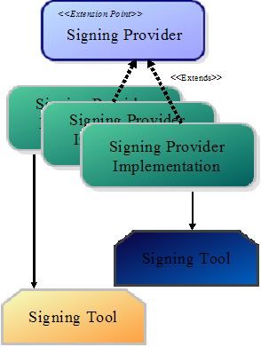
Figure 10
The SPI should provide the logic for the following tasks:
- Sign an MTJ project with a public key + certificate information
- Determine whether an existing project is currently signed.
- Un-sign MTJ projects that are currently signed.

Graphical User Interface Support

Signing Provider Preferences Page

A Signing Provider Preferences Page (SPPP) will be provided within the MTJ preferences category. The SPPP will provide configuration utilities for all detected SPIs. The SPPP provides an option to activate, or deactivate SPIs. The SPPP also provides a Signing Provider tool location editor, which is necessary to configure SPIs that depend on a stand-alone signing tools.

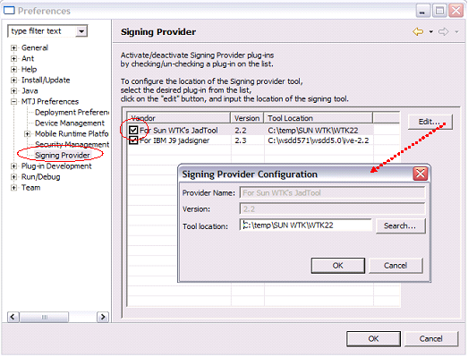
Figure 11

The SPPP classes, query all detected SPI for their vendor id, version, active state, and tool location (interface SigningProvider.getToolLocation), and display the information in the SPPP table. The Signing Provider Configuration dialog, allows the user to locate the target signing tool in the local file structure. Each SPI is responsible for storing the tool location (interface SigningProvider.storeToolLocation); possibly by utilizing their own IPreferenceStore object.

Signing Provider User Interface

The Graphical User Interface to all the Signing Provider utilities is provided by the Security Management for MTJ Dialog. Since the Security Management and the Signing Provider services are so tightly coupled, both sets of services are enabled via a single dialog. Access to the Security Management for MTJ Dialog is discussed in the Security Management for MTJ Dialog section of this document.

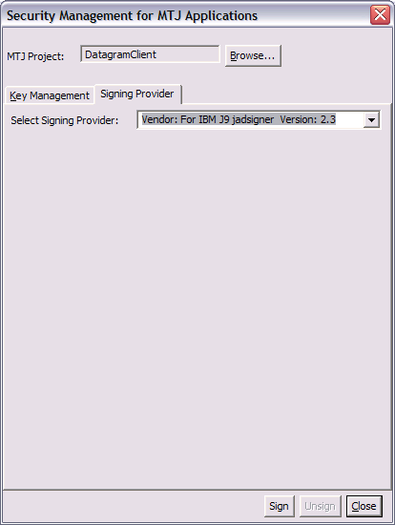
Figure 12

The user selected MTJ project name will be displayed in the top field of the dialog and sets that project as the target project for Security and Signing Management. A browse button is provided, which invokes a target project selection dialog (see Figure 13) which will only list MTJ projects in the current workspace. A target project needs to be set, in order to enable the Signing Provider features. Once a target project is selected, the “Unsign” button will be enabled if the project is currently signed. The “Sign” button is enabled if the target project is not currently signed, a keystore has been opened, and a key alias has been selected.

Figure 13
The Security Management for MTJ dialog is composed of two tab pages: “Key Management” and “Signing Provider”. The Signing Provider tab contains a drop down list, where all active SPI are listed, and the user can choose the desired SPMI to work with. The selected SPI is responsible for fulfilling any Signing Provider task requested by the user from within the dialog. The user may request the following tasks:

- Sign the MTJ project – User selects the “Sign” button. The system creates a org.eclipse.mtj.api.signings.SigningCertificate with the relevant information, and pass it to the current SPI via a call to the sign(…) method. The SPI accesses the necessary security artifacts, and incorporates them into the target build as necessary. Since this process can be lengthy, the SPI is encouraged to set, and update the monitor passed in by the calling class.

- Determine if Project is Signed – When the user selects a target project, it is an implicit request to determine if the project is currently signed. The system queries the signing state of the current project by calling the isSigned(…) method of the current SPI.

- Unsign the MTJ project – User selects the “Unsign” button. The system passes this request to the current SPI by calling the unsign(…) method of the current SPI. The SPI. The SPI removes the security artifacts from the target project.

Security Management Implementations

Signing Provider Implementations (SPI) are extensions of the MTJ core extension point "org.eclipse.mtj.core.signingProvider". The SPI plug-in class should extend org.eclipse.mtj.api.extension.impl.MtjExtensionImpl
and implement the org.eclipse.mtj.api.extension. SigningProvider interface.

MPI plug-in classes should publish the vendor name and version at initialize-time, via the inherited methods:

public void setVendor(String newVendor)
public void setVersion(String newVersion)

SPI plug-in classes are expected to implement all of the following methods:

/**
* Method returns the deployment types that are supported by itself.
*
* @return
*/
public DeploymentType[] getSupportedTypes() throws MtjException;

/**
* Method signs the deployment with the certificates.
*
* @param deployment
* @param targetFolder
* @param certificates
* @param monitor
* @return
*/
public boolean sign(Deployment deployment, IFolder targetFolder, SigningCertificate certificates, IProgressMonitor monitor) throws MtjException;

/**
* Method unsigns the deployment
*
* @param deployment
* @param targetFolder
* @param monitor
* @return boolean success
*/
public boolean unsign(Deployment deployment, IFolder targetFolder, IFile jadFile, IProgressMonitor monitor) throws MtjException;

/**
* Method determines and reports if deployment is signed
*
* @param deployment
* @param targetFolder
* @param monitor
* @return boolean success
*/
public boolean isSigned(Deployment deployment, IFolder targetFolder, IFile jadFile, IProgressMonitor monitor) throws MtjException;

/**
* SigningProvider implementations that rely on an external security tool,
* are responsible for persistant storage of the tool location value.
* This method should return the location of the tool. Should never return null.
* @param monitor
* @return
* @throws MtjException
*/
public String getToolLocation(IProgressMonitor monitor) throws MtjException;

/**
* SigningProvider implementations that rely on an external security tool,
* are responsible for persistant storage of the tool location value.
* @param loc
* @param monitor
* @throws MtjException
*/
public void storeToolLocation(String loc, IProgressMonitor monitor) throws MtjException;

Included Signing Provider Implementations
MTJ provides several functional SPIs that can also serve as templates for other SP implementations. The following SPIs are included with MTJ:

- org.eclipse.mtj.extension.sp.j9 – Implemented to make use of the “jadsigner” signing tool packaged in IBM’s J9 2.3.
- org.eclipse.mtj.extension.sp– Implemented to make use of the “JadTool.jar” signing tool packaged in Sun’s Wireless Tool Kit 2.2.

