The idea is to create a project hierarchy above the flat workspace to make possible to build together members of this hierarchy.
A container is a project that creates a logical grouping of subprojects. Containers can ease the building of large multi-project systems. You can have containers practically anywhere you want on the file system, with one exception: containers can't appear in the parent folders of other projects (because this would create a projects-in-projects problem).
Containers let you specify just about any number of build configurations . Each build configuration contains a list of subprojects and specifies which build target to be built for each of those projects. Note that each build configuration may contain a different list and mix of subprojects.
Below is a fragment of New Container project wizard. User defines basic configuration populating it with C/C++ project of any type or another container projects. Targets are the same as MBS project build configuration, "debug" or "release" for example.
Each configuration can be entirely distinct from other configurations in the same container. For example, you could have two separate configurations, say "Development" and "Released,", in your top-level container. The "Development" configuration would build the "Development" configuration of any sub-containers, as well as the appropriate build variant for any subprojects. The "Released" configuration would be identical, except that it would build the "Released" variants of subprojects.

Below is a fragment of New Container Project Wizard
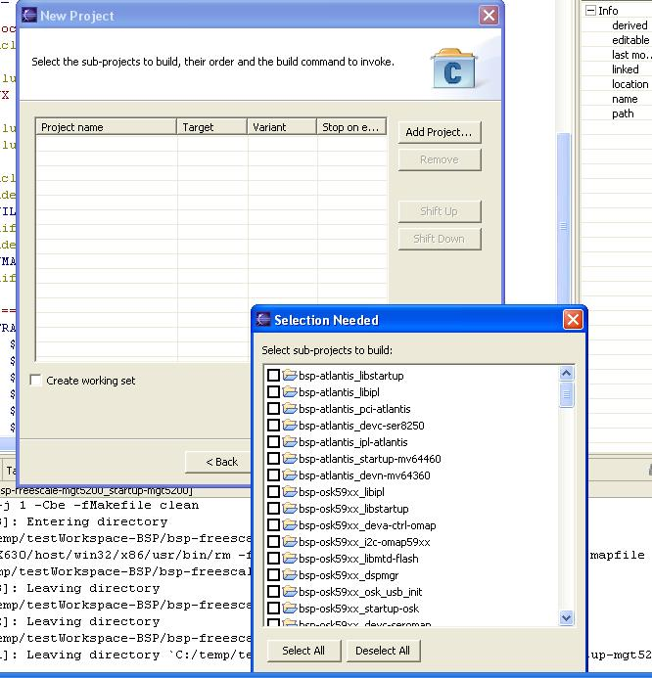
After container project created, more container configurations can be added to it. Below is an example of the typical container hierarchy:
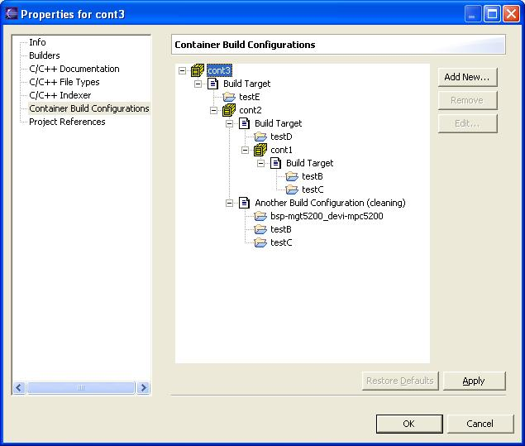
In order to build default configuration of the container project user can just run build from the local menu. Another option is to select configuration you want to build and possibly modify it before the build launching:
