Problem
Tool option tooltips in Property Pages (Tool Setting Page).sometimes obstruct view. Please see the screen shot below for an example. 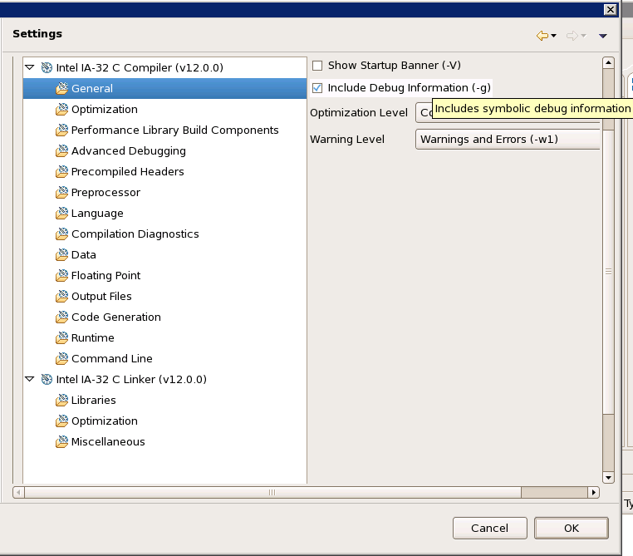

Proposed Solution
Enable users to display the option tooltips at a fixed location as seen in the screen shot below.
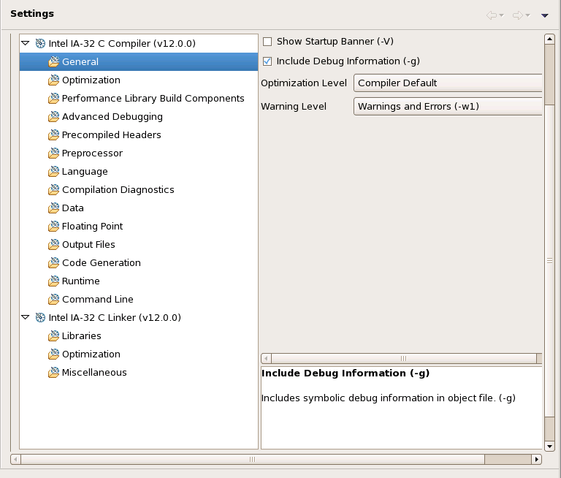
I did consider some alternatives (Please refer to “Alternatives Considered” below) designs but selected this mainly because this design gives users a similar feel to Visual Studio, which is a big plus for us (CDT integration for Intel Compiler) since we also support Visual Studio integration and are trying to give them common looks whenever we can (for example, using same option names). This approach also seems to require clean, minimal modification.

Some details on the UI:
The tooltip box has the vertical scroll bar and is of a fixed height independent of th e text length (i.e. longer tooltip text doesn’t make it higher, or shorter text shorter). But, the implementation uses SashForm so a user can adjust its size just as (s)he can adjust the widths of the existing option list / option edit panes.
The option name (in bold) and the tooltip are displayed.
If no tooltip is available, a blank box is displayed.
The display is “sticky”, i.e. text will remain in the box until replaced by another.

New Preference Page
Create a new Preference page (C/C++ -> Tooltip Display) that lets the CDT users choose between the current hovering tooltip and the new “fixed location” tooltip display. Set the former as the default since not all tools provide option tooltips. (For example, gnu tools do not).
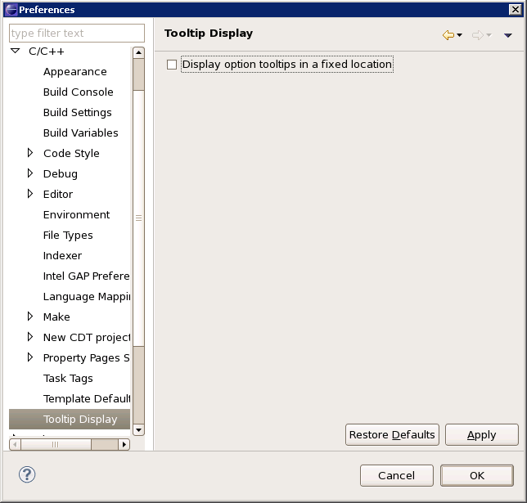

Implementation
All changes are contained in org.eclipse.cdt.managedbuilder.ui.

Changes related to the “Tool Settings” tab
properties/BuildOptionSettinsUI:
1) Currently, the tooltips are created and displayed using the SWT widgets’ built-in tooltip support (swt.widgets.*.setToolTipText). BuildOptionSettingsUI copies the option tooltip text onto the corresponding widgets using setToolTipText. We can replace these setToolTipText calls with setData calls if the fixed-location tooltip is needed.
- add a MouseHover listener to the widgets if the fixed-location tooltip is needed. The listener calls getData() on the widgets and display the data at the fixed location

properties/ToolSettingsTab:
Create a nested SashForm in place of EditArea and place the EditArea and TipArea in the new SashForm if the fixed-location tooltip is needed.

Changes related to the new Preference page
Create preferences/PrefPage_Tooltip.java

Modify plugin.xml (and plugin.properties) to support the new preference page.

Alternatives Considered
- Make a tooltip draggable so that a user can get it out of the way if (s)he needs to
This appeared to be simplest, but I did not find an easy way to do this using either the jface or swt tooltip. I could make one “from scratch” but the idea didn’t feel appealing considering I could implement the VS-style “tooltip box” (the final solution) very easily. Swing wasn’t considered since CDT doesn’t use Swing at all.
.
2. Compute a better display location that doesn’t get into a user’s way for a regular (non-draggable) tooltip.
We’d need to calculate good tooltip location. The location can be fixed or nonfixed.
I didn’t really investigate how hard/easy it is to calculate good nonfixed location or whether we’re guaranteed to always find one.
The intuitive fixed location is at the top or bottom of the option list (the right pane), but displaying a tooltip (potentially) so far from the object, I think, goes against the way the hovering tooltip is meant to be used.

3. Create a new view and display info in there.
I got the idea because the editor tooltip does this. (via the “Show in Javadoc View” option). But this won’t work well since the view would be hidden by the open property pages.

