Chart User Interface (v 2.0) Feature Specification
User Interface changes for Charts in BIRT v 2.0
This document is intended to give an overview of the UI changes for Charts in BIRT v 2.0.

Table of Contents
Introduction 1
References: 1
Chart Builder 1
Existing User Interface 1
Need for a new User Interface 3
Requirements from the User Interface 3
New User Interface Overview 3
New Chart UI – Property Editor 8
Report Design – Popup Menu for Charts 9

Introduction
This document describes the general functionality and appearance of the BIRT Chart Builder that will be available in version 2.0. It is not a complete design document or functional specification but is rather intended to give a feel for what the new UI will look like and the major changes / new functionality it will introduce.

References:

Chart FAQ:
http://www.eclipse.org/birt/wiki/index.php?n=FAQ.Charts

Chart Builder
The Chart Builder is the primary user interface for creating and modifying charts in BIRT. The builder is currently made up of a two-step dialog. The first step (shown by default when a new chart is added) involves selecting the chart type. Once the chart type has been selected, the user proceeds to a second step where (s)he has access to the full set of properties and structures in the chart.

Existing User Interface
This section describes the User Interface as it exists in BIRT 1.0 and has been added to highlight the changes in appearance and indeed approach, of the new User Interface with respect to the old one.
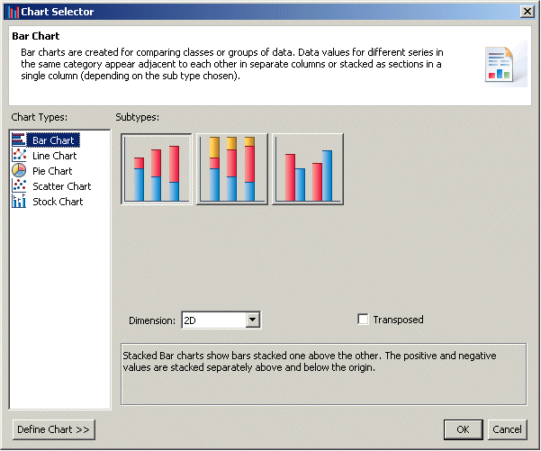
Figure 1. BIRT 1.0 Chart UI : Chart Selector
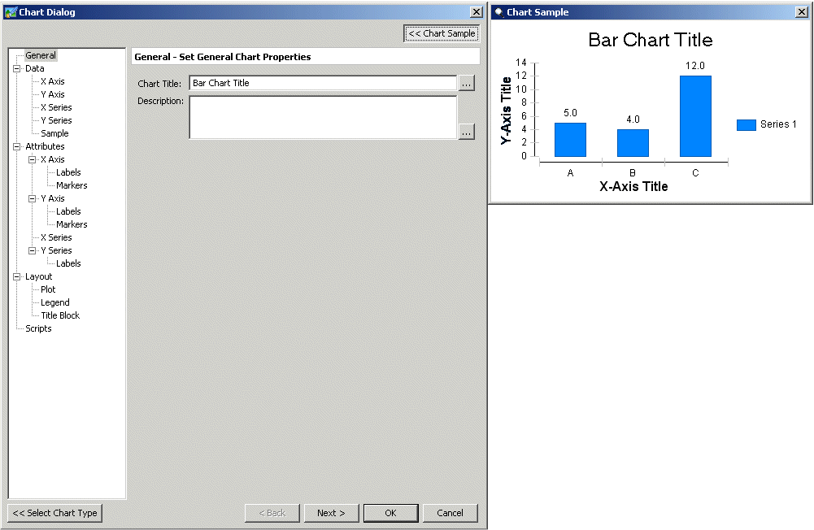
Figure 2. BIRT 1.0 Chart UI : Chart Builder

Need for a new User Interface
It currently (as of version 1.0) provides access to all the features and structures supported by the chart library. Due to this ‘up-front’ approach, the UI is a little overwhelming for a first time user. It is also difficult to use efficiently for performing common operations from a report designer’s point of view.

Requirements from the User Interface
The new user interface will be designed and built with the following requirements in mind:
- Ease of Use – The new UI should be very easy to use and it should be possible for someone with little or very limited knowledge of chart concepts to build reasonable charts quickly.
- Extensibility – The new UI should be as extensible as possible while staying within the confines specified by the first requirement. As far as possible, this new UI should not break backward compatibility with extensions defined in v 1.0. This however will not be guaranteed.

New User Interface Overview
This section describes the broad framework that the new UI will follow. It is intended to show the general philosophy being adopted rather than a detailed description of the final appearance and functionality of this feature. The details of the design will likely change based on further discussions and feedback from the community.
The new UI will in general follow the guidelines below:

Easy to Use
The primary goal of the new user interface will be to make the process of chart creation and editing much more approachable to a new (or casual) user. Creation of a standard chart will be very significantly simplified with relation to the old user interface.
As a consequence, there will be more visual cues in the form of labels and / or layouts that will hint at how specific sub-tasks could be performed in the UI.
To further make the user interface easy to use, the builder will include the facility of ‘Live’ Preview. This will allow users to see the effect of changing various properties on the chart as they make the changes. It will also allow for using the actual data from the DataSource instead of sample data. In this case, the chart will be much closer to the ‘final’ chart the user will see in the report. This will remove significantly reduce the number of ‘iterations’ users will have to go through to get the chart looking just the way they want it.

Task Oriented
The new UI will be built around the concept of ‘tasks’. A task can be considered as a sequence of actions that together serve a specific purpose. An example of a task would be ‘chart type selection’.
The user interface will be built as a collection of ‘panels’ each of which is dedicated to a specific commonly performed task related to chart building or editing. This division will allow these panels to be independently accessed from the designer (maybe as part of a cheat sheet). This will allow for removal of specific panels if a particular task is not to be allowed in a given situation.
The UI will be divided up to handle the following specific common tasks:
- Selecting / Changing Chart Type

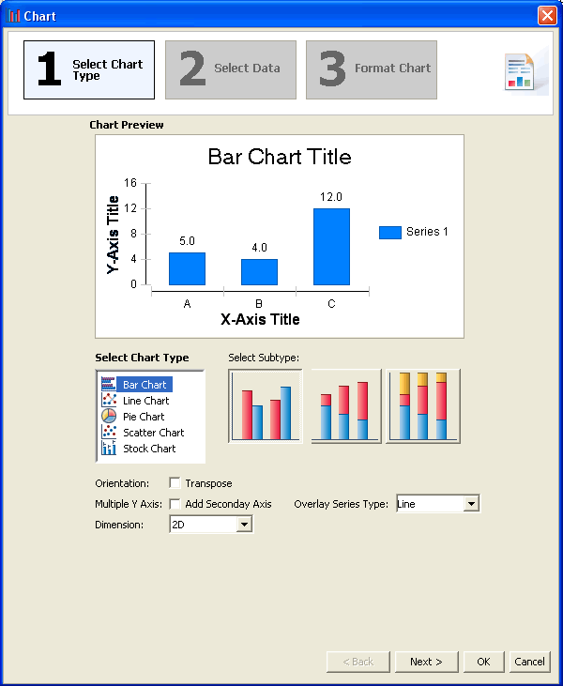
Figure 3. BIRT 2.0: New User Interface for Chart Builder – Type Selection
The first task in creating a chart is to decide the chart type and subtype including its dimension (2D, 2D with depth or 3D) and whether or not it will be transposed (displayed horizontally rather than vertically). The buttons show the general appearance of the chart and change based on selections in this sheet.
- Setting / Modifying Chart Data
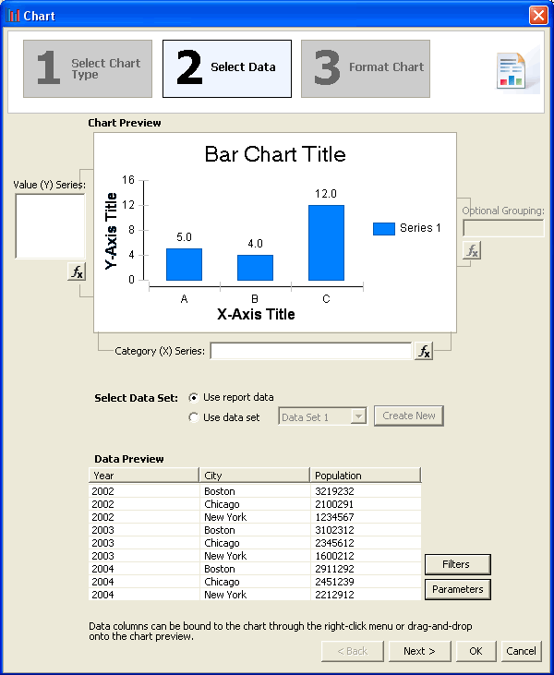
Figure 4. BIRT 2.0: New User Interface for Chart Builder – Data Binding
The next step is to specify where the data for the chart will come from and how it will be displayed. (What is displayed along the X Axis? What along the Y Axis? etc.)
- Formatting Chart Layout / Appearance
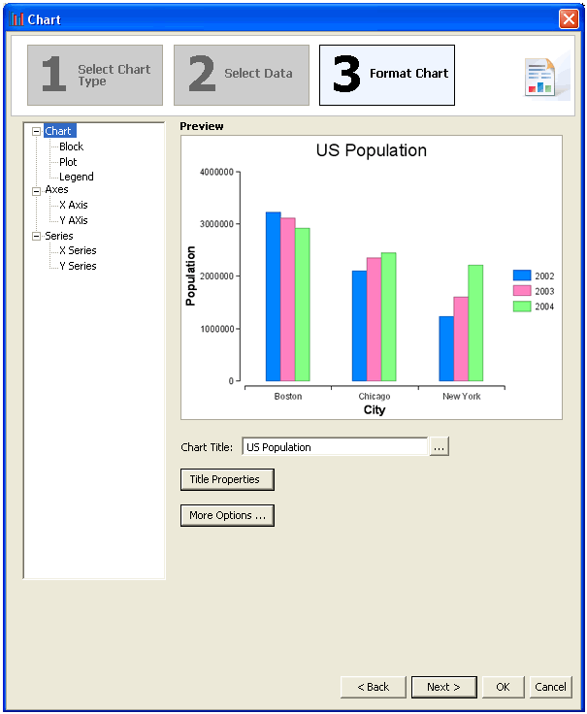
Figure 5. BIRT 2.0: New User Interface for Chart Builder – Formatting
The final (and optional) step involves changing the formatting and layout of the chart. This is when the user makes changes to the colors, fonts and layout of various components of the chart.

Modular
The new user interface will be designed as a modular collection of elements. This will allow for additional flexibility in how it can be used when integrated. The modules will be created around the task they allow the user to perform rather than any structural relationship in the chart.

Extensible
The new user interface will be built with a view to support as many of the extensions defined in BIRT 1.0 as possible. The appearance or location of the old extensions will likely not be the same as before though.

New Chart UI – Property Editor
This functionality will be new in v 2.0. The ‘Property Editor’ is a view in the BIRT Design perspective that provides users access to the most common properties of a report item. This UI only exposes those properties that a user is expected to change most often. It does not replace a dedicated UI for complex items.
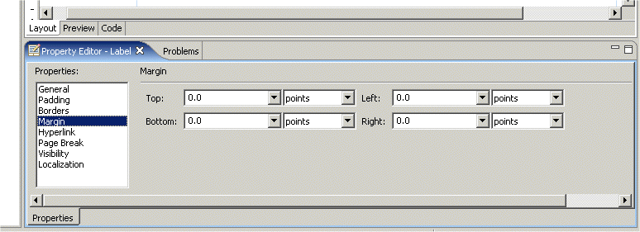
Figure 6. Birt 1.0 : Property Editor View

In BIRT 1.0, the property editor for a chart was simply the default property editor shown for all report items. It did not provide access to any of the chart-specific properties a user would change. In 2.0, a new UI will be introduced that will allow users access to some of the most commonly changed chart properties so that they do not need to launch the builder for minor changes.
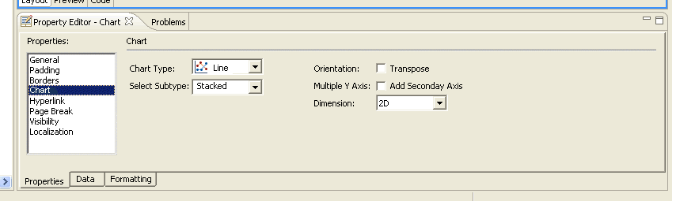
Figure 7. BIRT 2.0 : New Property Editor Pane for Charts

Report Design – Popup Menu for Charts
In BIRT 2.0, right-clicking on a chart in the report design will bring up a popup menu that will, in addition to the standard items, include chart-specific items that will allow users direct access to elements of the builder and other functionality.
Functionality that will be made available from the popup menu:
- Change Chart Type…
- Edit Chart Data…
- Format Chart…
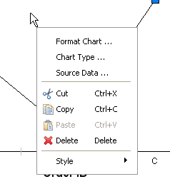
Figure 8. BIRT 2.0 : Additional options in popup menu for Charts

