BIRT Chart Types Enhancements
Functional Specifications
David Michonneau
This document describes the chart types support for BIRT 2.0. That includes new chart types and improvement of existing chart types

Table of Contents
Introduction 1
3D Charts 1
3D Definition 1
Chart types in 3D 3
API 3
Chart Builder 4
Pie Chart 4
Explosion 4
Minimum Slice 5
Chart Builder 6
Line Charts 6
Curve Fitting 6
Meter/Dial Charts 7
Definition 7
API 8
Chart Builder 8
Area Charts 8
There are three enhancements in bugzilla requiring this new chart type: 8
Definition 8
API 8
Chart Builder 9

Introduction
Chart types are a combination of series types and chart attributes. They can be divided into two categories: charts with axis and chart without axis (such as pie charts). New series types will be provided, as well as improvements of the existing ones. Some new chart attributes will also be added to support the new types.
This document will focus on the functional specifications of the new and improved types and also list the model/API changes.

3D Charts

3D Definition
BIRT 1.0.1 support Charts in 2D and 2D with depth. 2D with depth (sometimes mentioned as 2.5D) is not to be confused with real 3D Charts. Here is a diagram outlining the difference between the two:
Chart 2D with depth
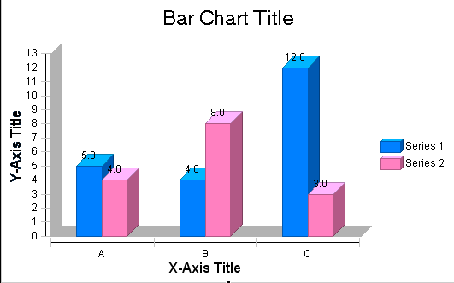

3D Chart
The 3D chart not only displays the series with depth: each serie is placed on a different plan. Additionally it is also possible to rotate the 3D chart from any angle. Walls and floors are also displayed to enhance the 3D appearance, but they can be hidden.

Chart types in 3D
Here is the list of chart types where you can apply 3D:
- Bar Charts
- Line Charts
- Area Charts

API

3D attribute
Although the current engine cannot render 3D charts yet, the existing model API support the 3D attribute. The Chart interface has two methods to set/get the chart dimension (now used for 2D/2D with depth):
public interface Chart extends Eobject
{
…
ChartDimension getDimension();
void setDimension(ChartDimension value);
…
}
The 3D value is represented by ChartDimension.THREE_DIMENSIONAL_LITERAL

Angle attribute
The angle attribute to rotate the chart will be added in ChartWithAxes interface through 2 methods:
public interface ChartWithAxes extends Chart
{
…
double get3DRotation();
void set3DRotation( double angleInDegrees );
…
}
The rotation angle will be applied clockwise, and must be within the 0-90 range. The angle is only effective for 3D charts and will be ignored otherwise.

Floor/Wall attributes
The floor and wall attributes are already defined in ChartWithAxes interfaces:
public interface ChartWithAxes extends Chart
{
…
Fill getFloorFill();
void setFloorFill(Fill value);
…
Fill getWallFill();
void setWallFill(Fill value);
…
}

Chart Builder
The 3D attribute will be added to the combo list in the Chart Builder, which now holds the 2D and 2D with depth values. It will only be available when bar/line/area chart type is selected.

Pie Chart
Two improvements will be added to the Pie Chart type: explosion based on expression, and a minimum slice feature.

Explosion
Pie Charts can be exploded through an explosion attribute, but this applies uniformly to all the slices. Here is how it looks like:
The new feature will allow setting the explosion of the slices based on an expression: this way the user can highlight some particular slices. Here is an example of a chart with only one exploded slice:
The expression can access, among others, the value of the current slice (absolute or in percentage), as well as the value of the base serie it represents. TBD
If no expression is set, the explosion will apply to all slices. If the expression is set, the explosion will only apply to slices where the expression evaluates to true.

API
A new method setExplosionExpression will be added to PieSeries interface:
public interface PieSeries extends Series
{
…
public void setExplosionExpression( String expression );
public String getExplosionExpression( );
…
}
Builder UI
The Chart Builder UI will provide a new textbox with a scripbuilder button next to the explosion attribute in the PieSeries screen. Mockup TBD

Minimum Slice
With this feature, the user has the ability to specify the minimum value (absolute or in percentage) for a slice. Values under that minimum will be aggregated under an “others” label. In this example, the min value is 10, “others” is the sum of 6 (cat3) and 4 (cat4):
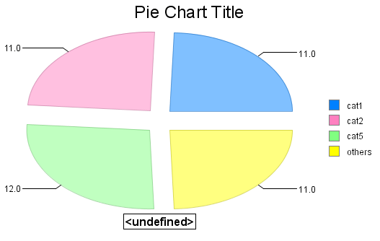

API
Several methods will added to the ChartWithoutAxes interfaces in order to set/get:
- the value of the minimum slice
- the value type of the minimum slice (percent vs absolute). Default is absolute
- the label of the minimum slice. Default is “others”, internationalized
This feature will be applicable to all charts without axes.
public interface ChartWithoutAxes extends Chart
{…
public void setMinSlice( double value );
public double getMinSlice( double value );
public void setMinSlicePercent( boolean isPercent );
public boolean getMinSlicePercent( );
public void setMinSliceLabel( String label );
public String getMinSliceLabel( );
…
}

Chart Builder
TBD

Line Charts
A new feature will be available for Line Charts (or more precisely, Line Series): curve fitting. This is an enhancement filed in bugzilla: https://bugs.eclipse.org/bugs/show_bug.cgi?id=87823

Curve Fitting

Definition
Here is an example of curve fitting chart:
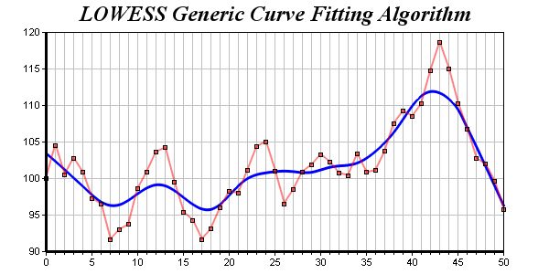
The blue line shows the general trend of the data. The idea is to find a mathematical model representing the data. This is usually done by mathematical regression and there are different algorithms available. For instance one approach is the user providing a parameterized function that he believes represents the data, the algorithm will compute the best approximation of the parameters based on the data points. Alternatively, it is possible the user does not assume any particular function. Several algorithms are available, the example shows the LOWESS algorithm.
The goals of curve fitting are numerous: once a curve can be computed, it is possible to seek its area, maxima, minima, tangentes, peak values, etc…
Specification
BIRT Chart will use the LOWESS algorithm, without parameterized function provided by the user. The curve will be drawn over the line chart in a color chosen by the user. No characteristics will be computed from the curve.

API
A new interface will be added
public interface FittingCurve
{
LineAttributes getLineAttributes();
void setLineAttributes(LineAttributes value);
Label getLabel();
void setLabel(Label value);
Anchor getLabelAnchor();
void setLabelAnchor(Anchor value);
void unsetLabelAnchor();
}
New methods will be added to the ChartWithAxes interface:
public interface ChartWithAxes extends Chart
{
…
setFittingCurve( FittingCurve );
FittingCurve getFittingCurve( );
…
}

Chart Builder
The Chart Builder UI will provide a checkbox to show the fitting curve, and a property sheet to set its attributes. Mockup TBD

Meter/Dial Charts
This is a new Chart type, part of the “chart without axis” family. This is an enhancement filed in bugzilla: https://bugs.eclipse.org/bugs/show_bug.cgi?id=101646

Definition
“Meter charts are useful for displaying the current value of a certain measurement. The value is indicated by a pointer and the scale of the meter dial. The background of the meter can be divided into regions with different colors, each representing a range of measurement values. The meanings of regions can be displayed in tooltips as the mouse pointer moves over them. Example of meter charts or dial graphs can be gauges, speedometers, or clocks.” (Bugzilla entry)
Here is an example of a meter/dial chart:
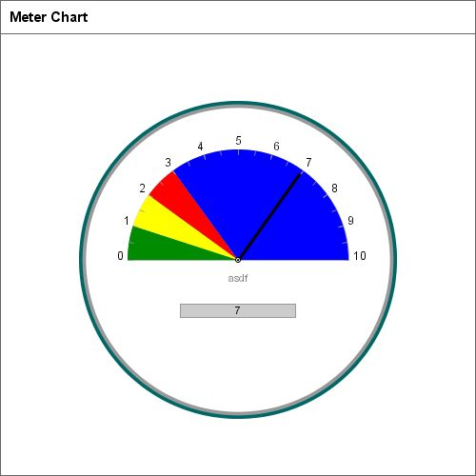

API
TBD

Chart Builder
TBD

Area Charts

There are three enhancements in bugzilla requiring this new chart type:
101648,101651,101407

Definition
Area charts are very similar to Line Charts, the only difference being that the area between the X axis and the line is filled in color. The painted areas can be set as transparent or opaque (transparent being the default for a 3D Area Chart, whereas opaque is the default for a 2D Area Chart).
Area charts benefit of course of all the Line Chart features. Let’s only mention they can be stacked, and percent stacked as well, shown in 2D, 2D with depth or 3D.

API
The transparency of the Area is controlled on the Series interface level:
public interface Series extends EObject
{
…
boolean isTranslucent();
void setTranslucent(boolean value);
…
}

The AreaSeries simply extends the LineSeries interface, without any new method:
public interface AreaSeries extends LineSeries
{
}
Note that by default no marker is shown for the AreaSeries

Chart Builder
A new type will be added in the first screen of the builder for Area Charts. It can be declined in stacked and percent stacked as well.
The transparency of the area will be set in the Y series attribute page.

