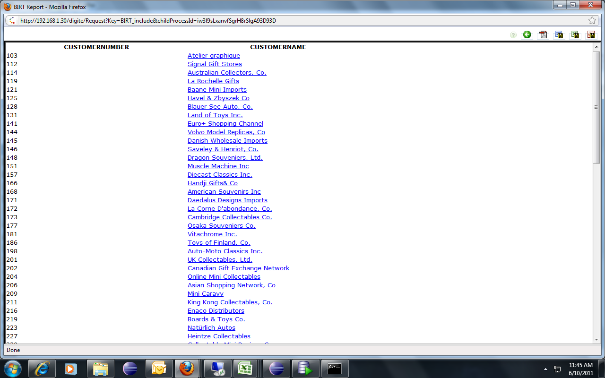

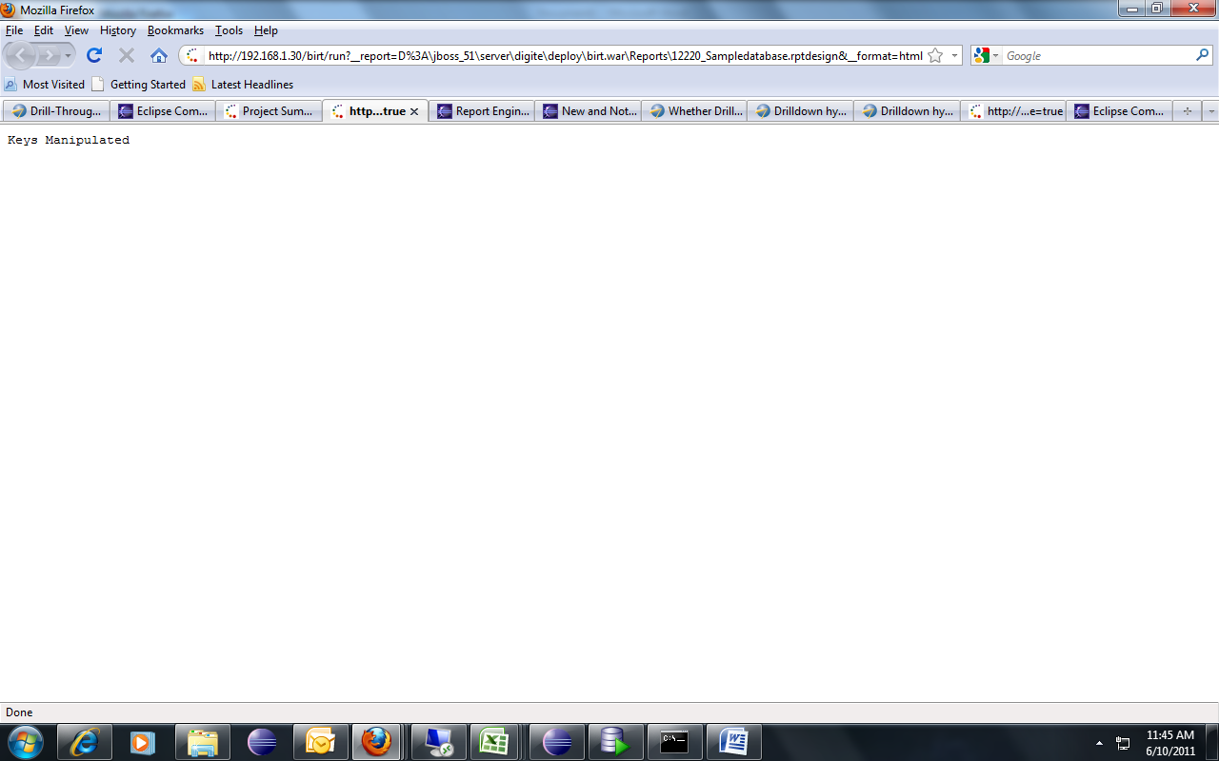

Plz look on the URL

http://192.168.1.30/birt/run?__report=D%3A\jboss_51\server\digite\deploy\birt.war\Reports\12220_Sampledatabase.rptdesign&__format=html&SearchParam=Atelier+graphique&__locale=en_US&__svg=false&__designer=false&__pageoverflow=0&__masterpage=true

