Set up:
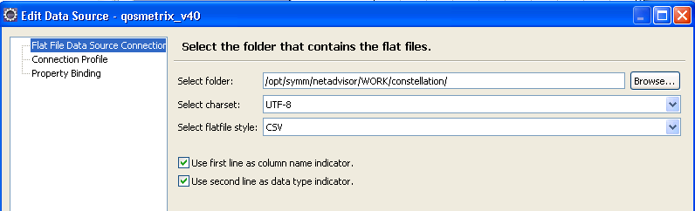
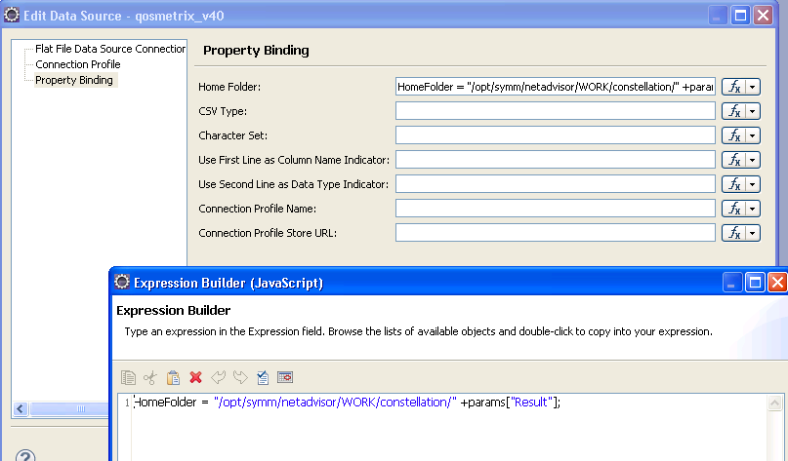

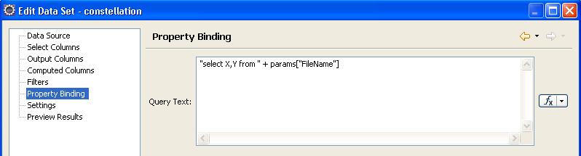

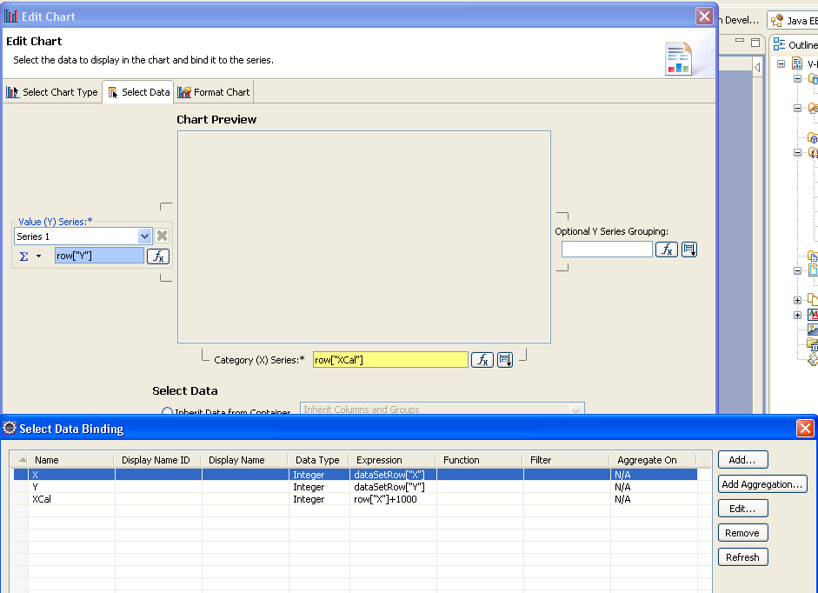

Result:
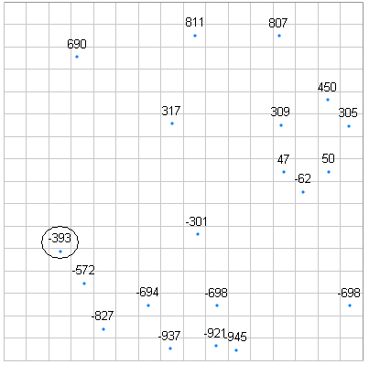
This is content of data file:
SampleTime,X,Y
TimeStamp,INT,INT
"2011-09-08 13:43:30",549,309
"2011-09-08 13:43:30",-588,690
"2011-09-08 13:43:30",-70,-937
"2011-09-08 13:43:30",-58,317
"2011-09-08 13:43:30",670,-62
"2011-09-08 13:43:30",-192,-694
"2011-09-08 13:43:30",-549,-572
"2011-09-08 13:43:30",70,811
"2011-09-08 13:43:30",-682,301
"2011-09-08 13:43:30",925,305
"2011-09-08 13:43:30",82,-301
"2011-09-08 13:43:30",929,-698
"2011-09-08 13:43:30",537,807
"2011-09-08 13:43:30",-443,-827
"2011-09-08 13:43:30",564,47
"2011-09-08 13:43:30",192,-698
"2011-09-08 13:43:30",815,50
"2011-09-08 13:43:30",184,-921
"2011-09-08 13:43:30",807,450
"2011-09-08 13:43:30",298,-945
"2011-09-08 13:43:30",-682,-694

Without last two lines, the chart show correct data. When add the last two lines from above, there is a y value as -393 shows up on chart, but it’s not in data set. Also the last two data doesn’t show.

