Example of 2 tables, beneath each other, bound to Dataset and Dataset1. WOSTATUS and WOSTATUS1 are nested in those stacked tables. The subreports WOSTAUS and WOSTATUS1 are bound to the table parameters WONUM and WONUM1 from the parent table. See code below:
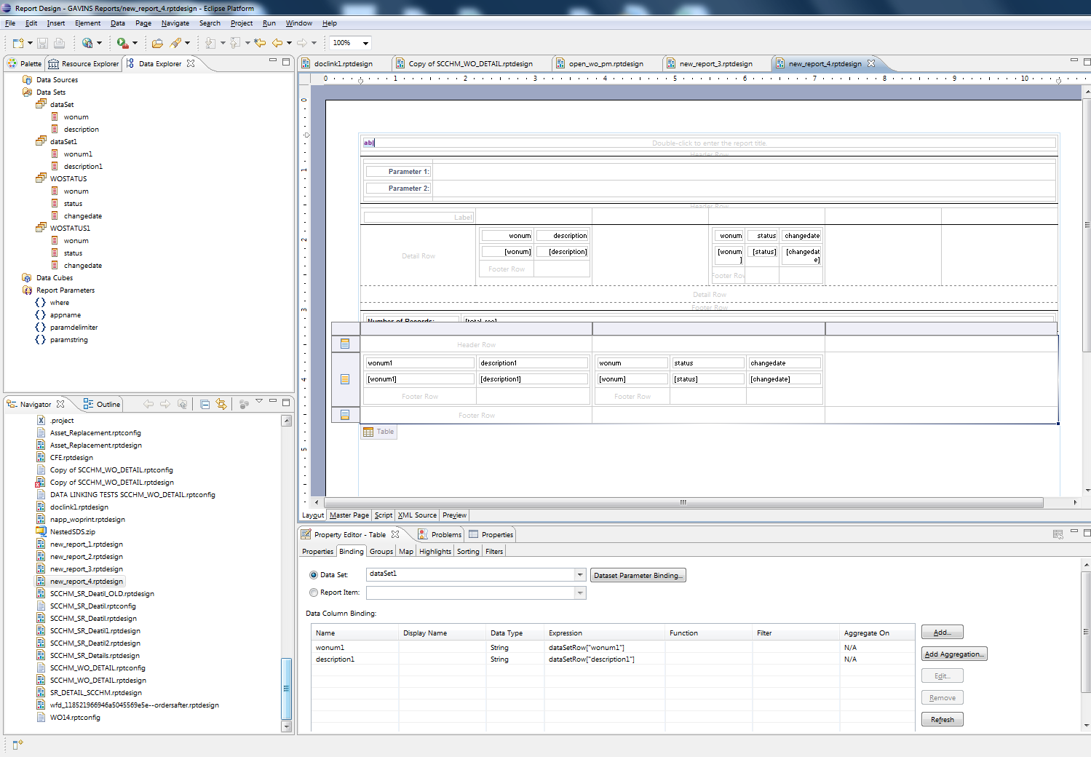
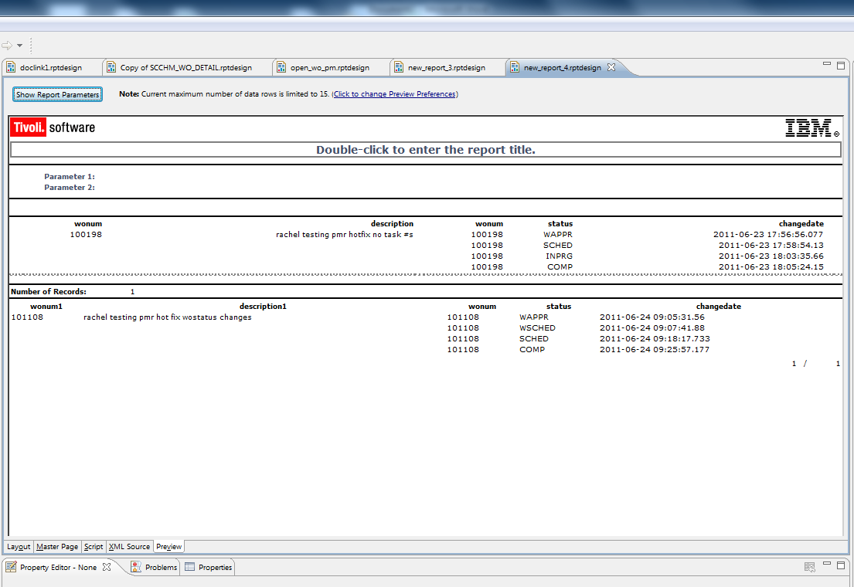
//Dataset:
maximoDataSet = MXReportDataSetProvider.create(this.getDataSource().getName(), this.getName());
maximoDataSet.open();

var sqlText = new String();

// Add query to sqlText variable.
sqlText = "select wonum, description from workorder"
// Include the Maximo where clause
+ " where " + params["where"]
+ " and wonum = '100198' "
;

maximoDataSet.setQuery(sqlText);
//linking to WOSTATUS by the bound table row
maximoDataSet = MXReportDataSetProvider.create(this.getDataSource().getName(), this.getName());
maximoDataSet.open();

var sqlText = new String();

// Add query to sqlText variable.
sqlText = "select wonum, status, changedate from wostatus"
// Include the Maximo where clause
+ " where " + params["where"]
+ " and wonum = '" + rows[0]["wonum"] + "'"
;

maximoDataSet.setQuery(sqlText);
//Dataset1
if (!maximoDataSet.fetch())
return (false);

// Add a line for each output column
// The specific get method should match the data type of the output column.
row["wonum1"] = maximoDataSet.getString("wonum1");
row["description1"] = maximoDataSet.getString("description1");

return (true);
// linking to WOSTATUS1 by the bound table row
maximoDataSet = MXReportDataSetProvider.create(this.getDataSource().getName(), this.getName());
maximoDataSet.open();

var sqlText = new String();

// Add query to sqlText variable.
sqlText = "select wonum, status, changedate from wostatus"
// Include the Maximo where clause
+ " where " + params["where"]
+ " and wonum = '" + rows[0]["wonum1"] + "'"
;

maximoDataSet.setQuery(sqlText);

