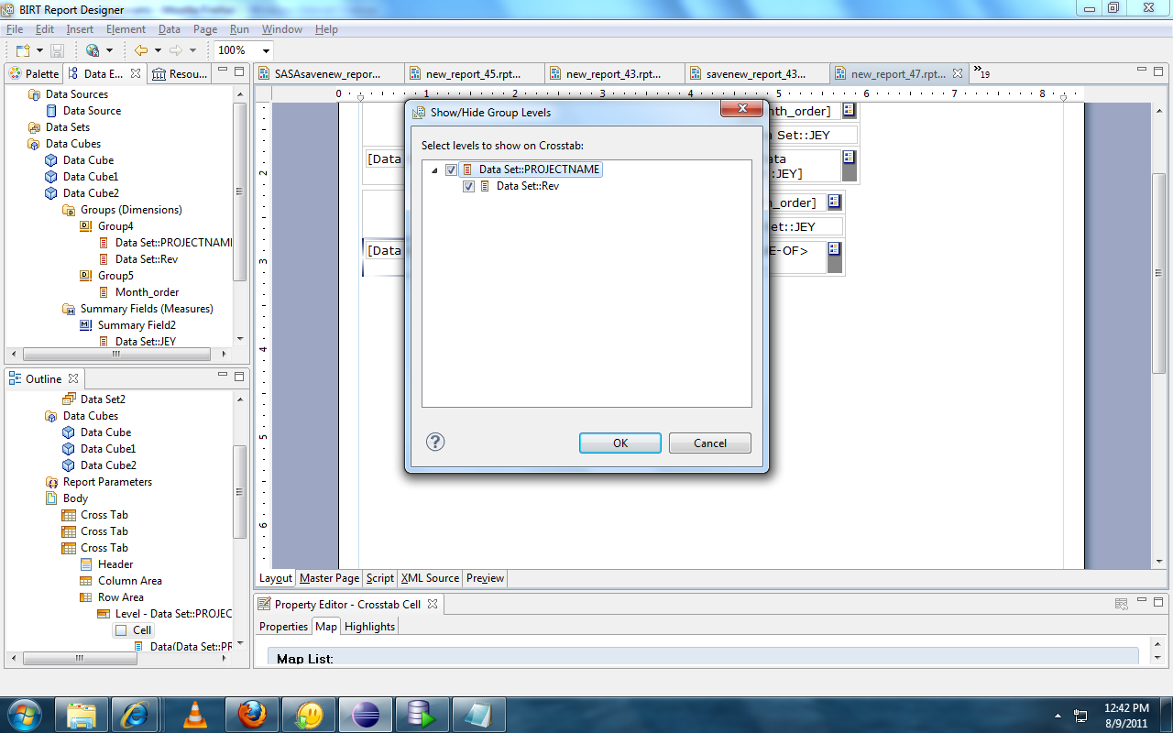

I am adding one more group,
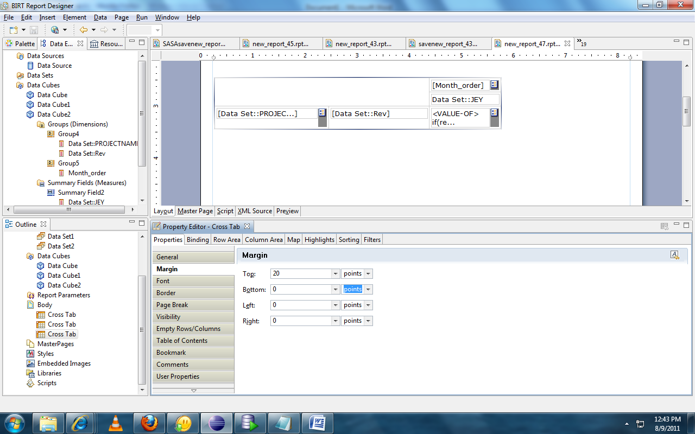
I am using the following script,
<VALUE-OF>
if(reportContext.getPersistentGlobalVariable
(data["Data Set::PROJECTNAME_Data Set::Rev"]) == null){

if (data["Data Set::JEY_Group4/Data Set::PROJECTNAME_Group4/Data Set::Rev_Group5/Month_order"] == null){
temp = 0;
}
else{
temp = data["Data Set::JEY_Group4/Data Set::PROJECTNAME_Group4/Data Set::Rev_Group5/Month_order"];
reportContext.setPersistentGlobalVariable(data["Data Set::PROJECTNAME_Data Set::Rev"], temp.toString());
}
}
else{
temp = parseInt(reportContext.getPersistentGlobalVariable(data["Data Set::PROJECTNAME_Data Set::Rev"]))+
data["Data Set::JEY_Group4/Data Set::PROJECTNAME_Group4/Data Set::Rev_Group5/Month_order"]
reportContext.setPersistentGlobalVariable(data["Data Set::PROJECTNAME_Data Set::Rev"], temp.toString());
}
temp;</VALUE-OF>

But it displays the error.
Now where I have to change in the script,

