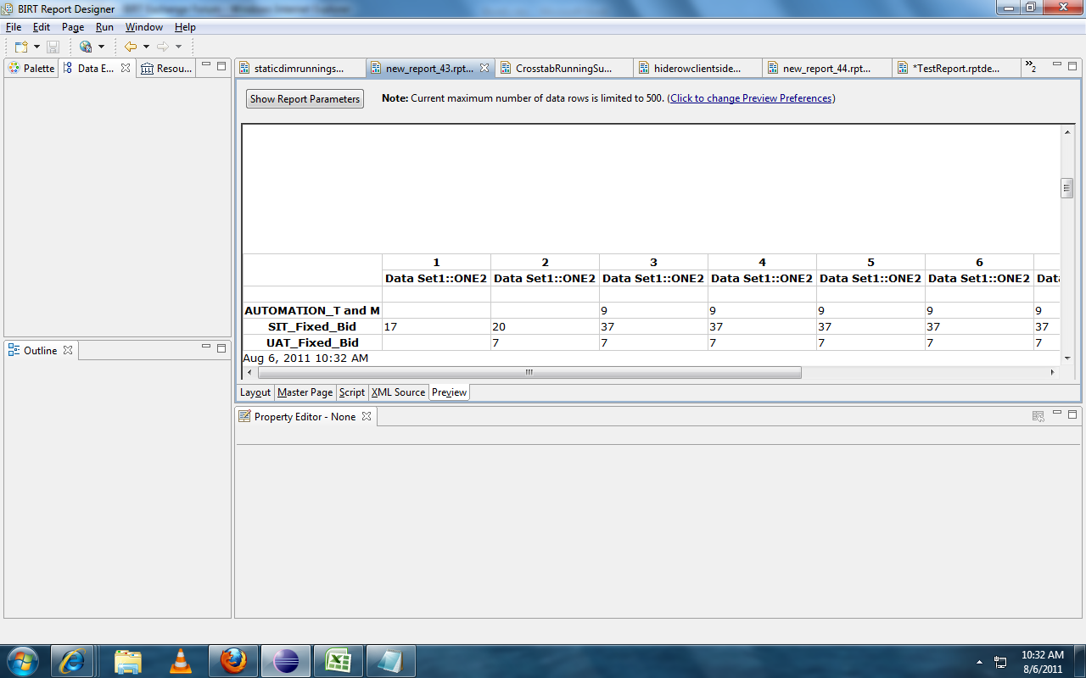

This is output and it is right.

If I add one more summary field in the same cross tab. Please find the Snopshot below.
The name of the field is TWO2. This added in Datacube also.
There are three projects.
The values of first summay field is
17,3,17
The values of second summay field is
15,3,15.
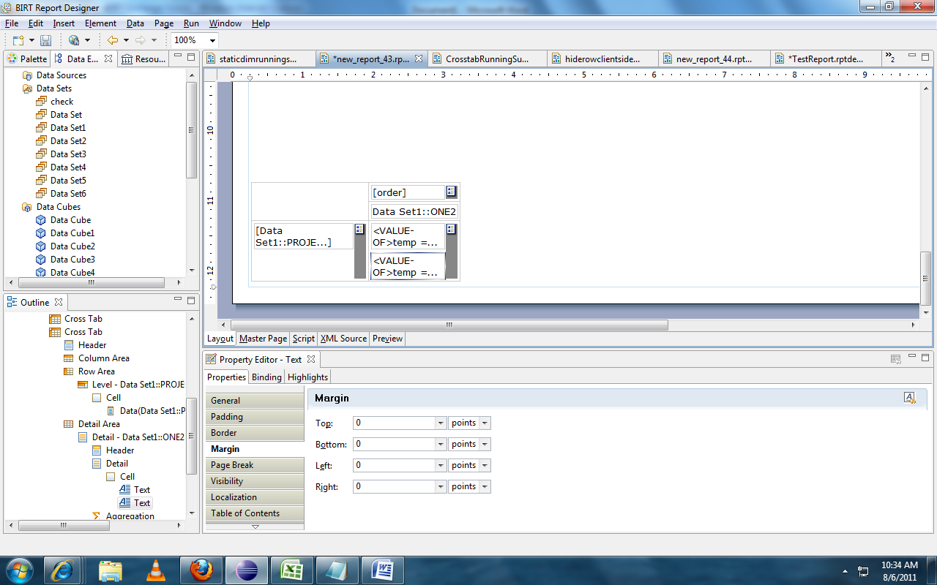

So my output should come like,
17,20,37,37,37……..
15,18,33,33,33……

But the out is coming like,
For first summary field 17, 35,55
For second summary field 32,38,70
Plz see snapshot below. Its calculating row wise and column wise running sum.
