Screen One--------- Display of Empty Row….EMPTY row ………..
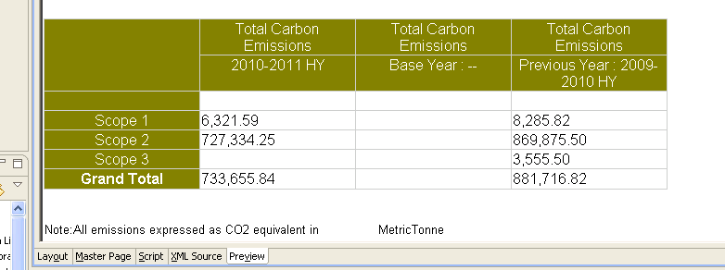

In screen 2 I have Query result Set that
I have 4 fields from query
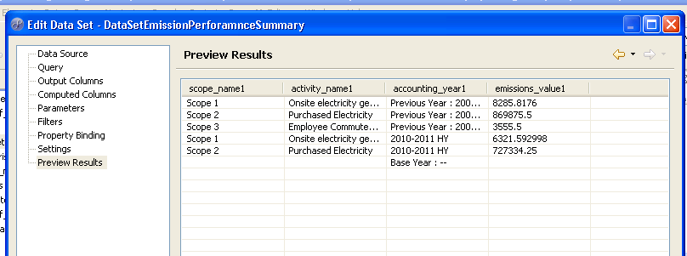

This is the definition of the cross Tab.
I have dragged accounting year dimension over emission value measure so that it display year wise.
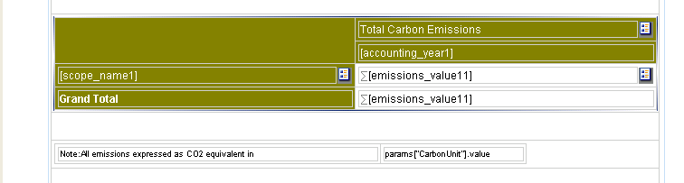

IN this screen Cross Tab properties I have not ticked anything for displaying empty rows and.
