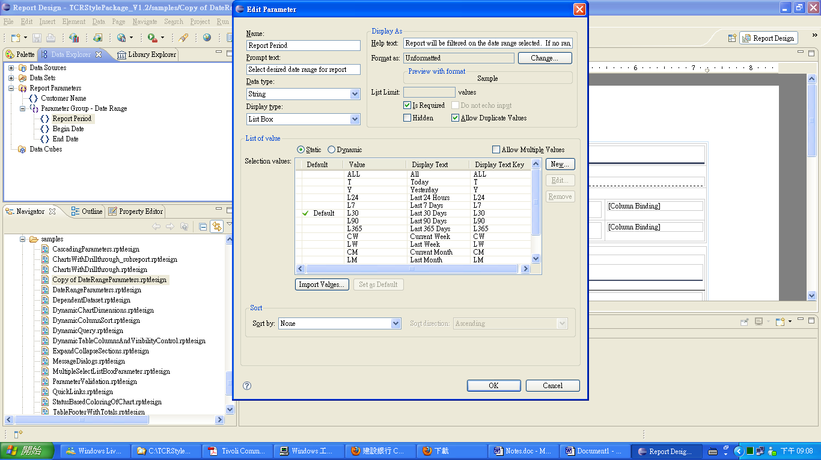

remove “all”, “today” from the static list
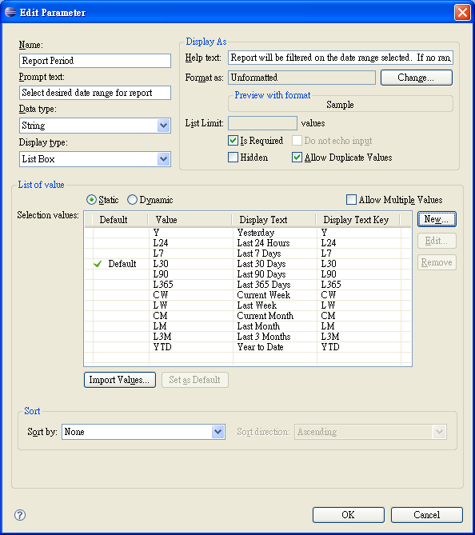

press Ok button and save the file.
Go to xml source tab,
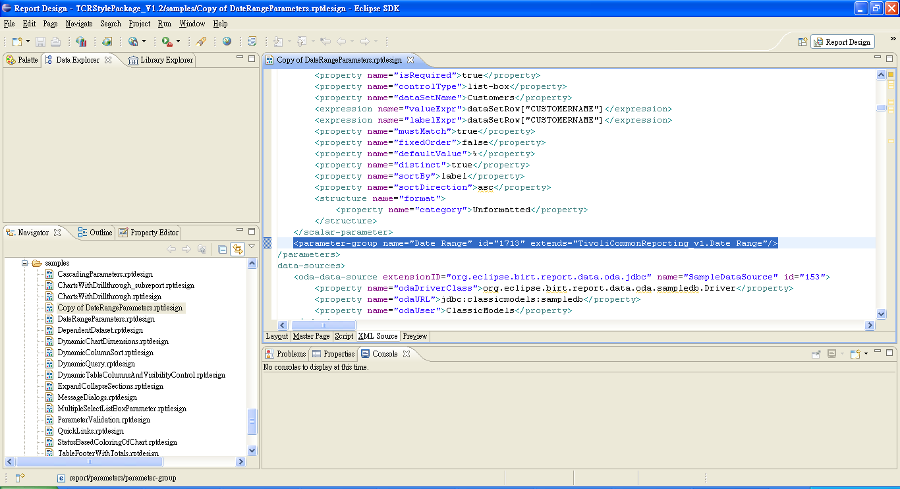
the parameter-group name="Date Range" has not override!!
Run the report, still show “all”, “today” (in Chinese)!!

So how to remove the static value so make it different from the library report parameter?

