Html
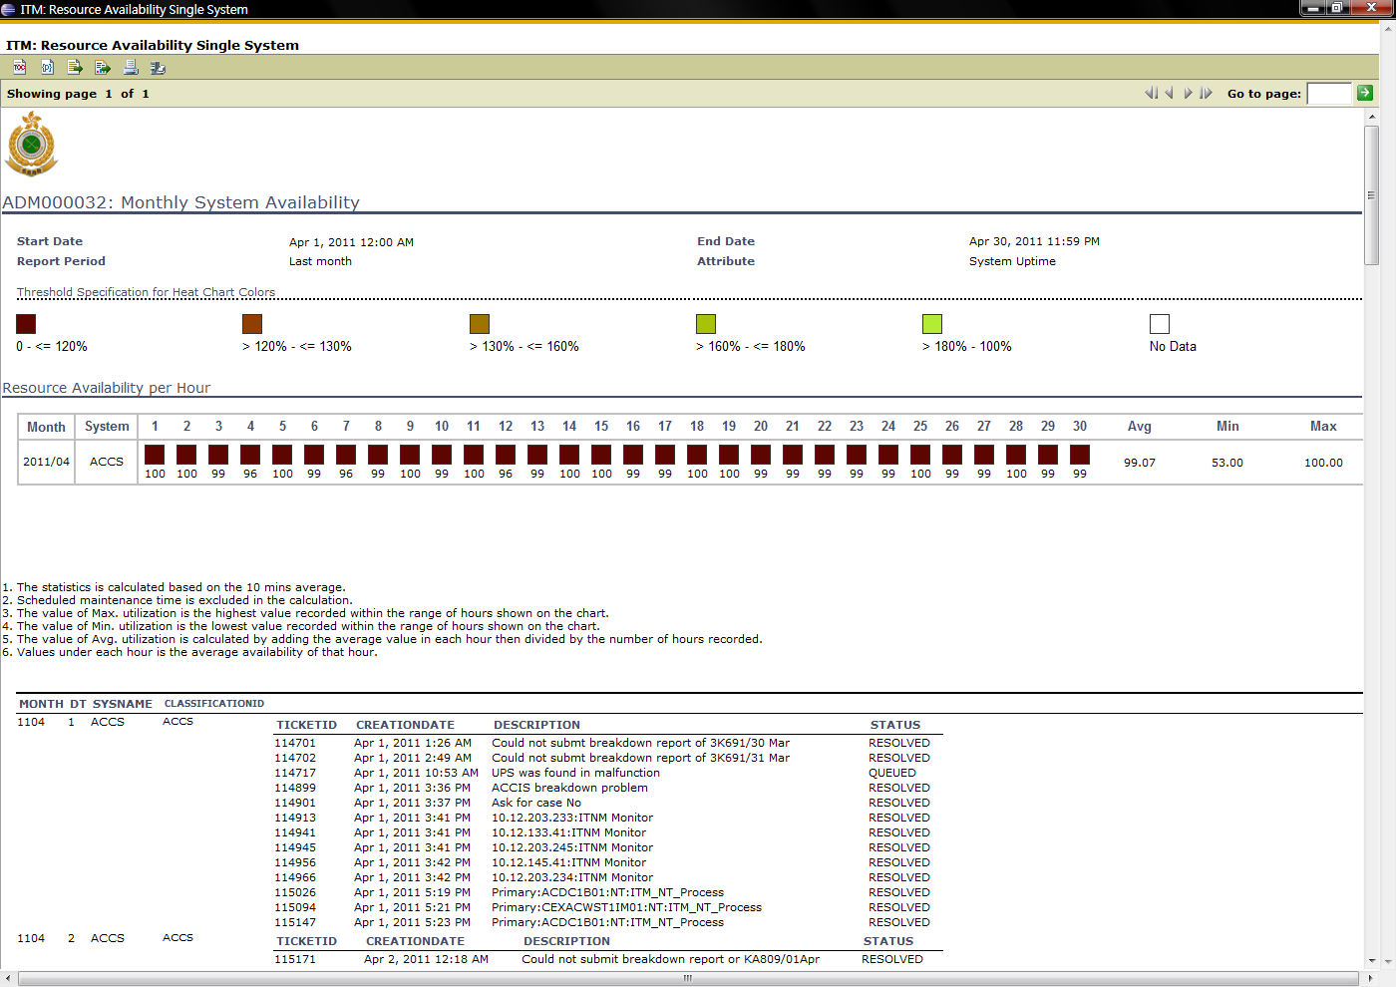
Pdf…, left hand side, month, dt is disappear!!, right hand side, status is disappear!!
