Eclipse Data source Connection Problem

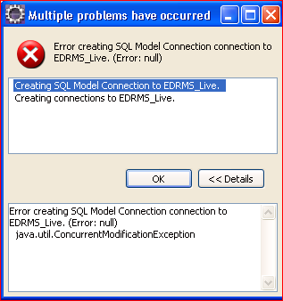

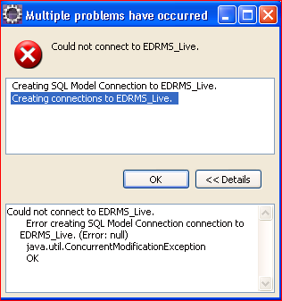

The two error messages on starting Eclipse

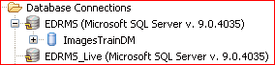

Data source showing EDRMS_Live connecting but not allowing access to database

