My Parameters:
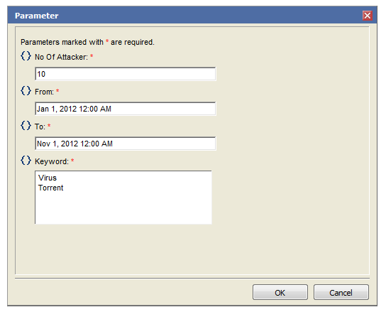

OUTPUT:

Top 10 Local Hosts By Events With Keyword "Virus"

 | 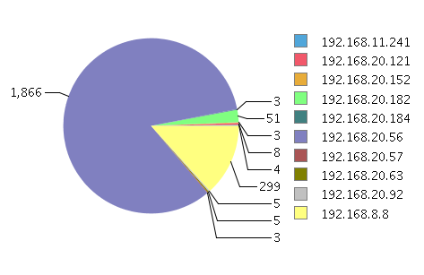
    Host Addresses
    Occurences
  192.168.20.56 | 1866
  192.168.8.8 | 299
  192.168.20.182 | 51
  192.168.20.121 | 8
  192.168.20.92 | 5
  192.168.20.63 | 5
  192.168.11.241 | 4
  192.168.20.57 | 3
  192.168.20.184 | 3
  192.168.20.152 | 3

What I want:
* With list keyword values, there will be a loop which will create dynamic queries as well as tables and charts and will generate as shown below. For each keyword the following section will be generated.

---------------------------------------- This section will be created dynamically by copying the above table and chart. There will as many as tables and chart as the number of values in Keyword (List Values) ------------------------------------------------------------------------------------------------

Top 10 Local Hosts By Events With Keyword "Torrent"

  Host Addresses
  Occurences
192.168.20.56 | 1866
192.168.8.8 | 299
192.168.20.182 | 51
192.168.20.121 | 8
192.168.20.92 | 5
192.168.20.63 | 5
192.168.11.241 | 4
192.168.20.57 | 3
192.168.20.184 | 3
192.168.20.152 | 3

