1. Launch rendering

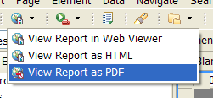

2. See the results

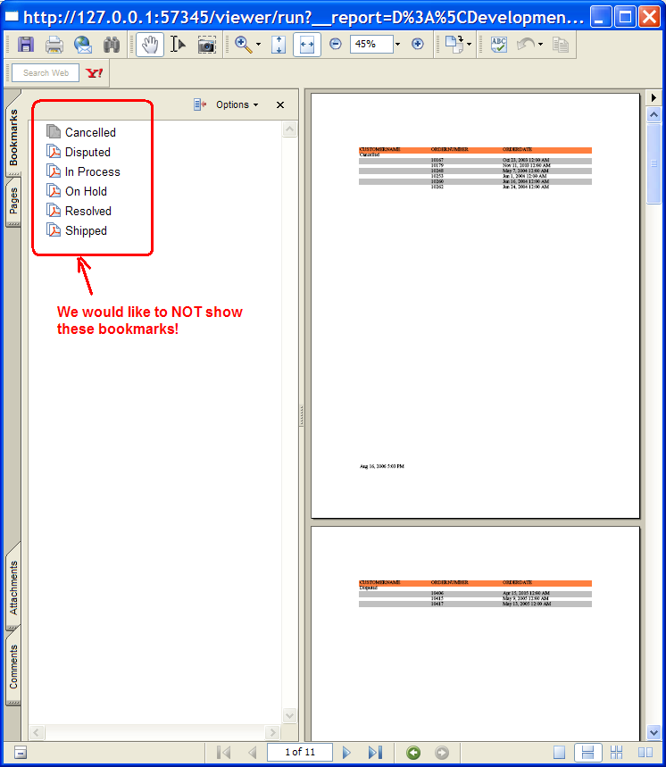

- Now try to remove the TOC expression from the grouping data:

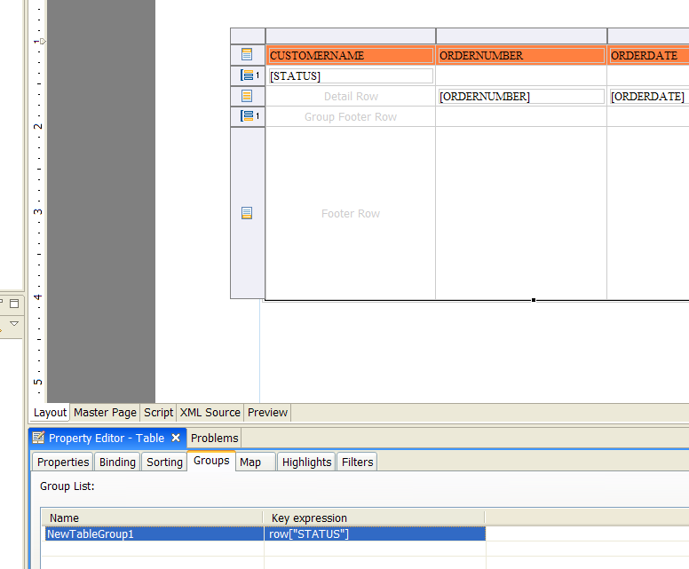

- Try to remove TOC expression

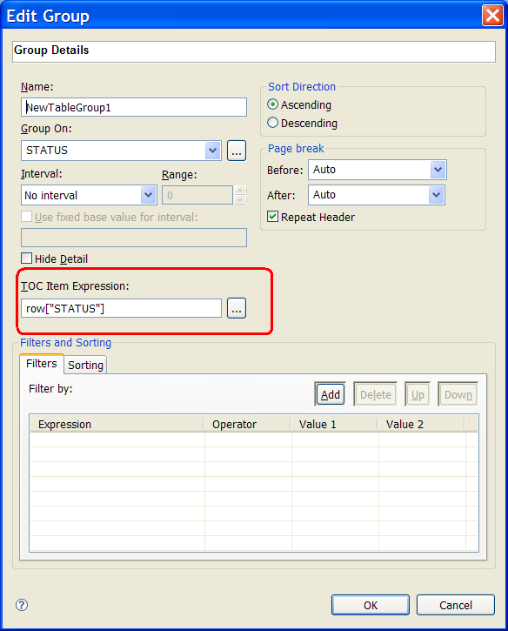

- remove the expression and save the report design

6. Double click the grouping entry again and you will see that TOC Item Expression is still there.

