I followed the step, but i'm stuck on following step

the original step :

To register a new activity in the Droid1 project, follow these steps:
1. Open the Droid1 project in Eclipse.
2. Right-click /src/com.androidbook.droid1 and choose New Class. The New
Java Class window opens.
3. Name your new class DroidActivity2.
4. Click the Browse button next to the Superclass field and set the superclass to
android.app.Activity.
5. Click the Finish button. You see the new class in your project.
6. Make a copy of the main.xml layout file in the /res/layout resource directory
for your new activity and name it second.xml. Modify the layout so that
you know it’s for the second activity. For example, you could change the text
string shown. Save the new layout file.
7. Open the DroidActivity2 class. Right-click within the class and choose
Source-Override/Implement Methods.
8. Check the box next to the onCreate(Bundle) method. This method is added
to your class.
9. Within the onCreate() method, set the layout to load for the new activity by
adding and calling the setContentView(R.layout.second) method. Save the
class file.
10. Open the Android manifest file and click the Application tab of the resource
editor.
11. In the Application Nodes section of the Application tab, click the Add button
and choose the Activity element. The attributes for the activity are shown in
the right side of the screen.
If you have an existing Activity selected, you’ll be adding to that. Instead, select
None or choose the Create a New Element at the Top Level, in Application radio
button at the top of the dialog.
12. Click the Browse button next to the activity Name field. Choose the new activity
you created, DroidActivity2.
13. Save the manifest file.

ok. let's see how i do it with my print screen...

1. Open the Droid1 project in Eclipse.
(PS: the Droid1 project is only a simple hello-world project which i create in earlier chapter.)

2. Right-click /src/com.androidbook.droid1 and choose New Class. The New
Java Class window opens.
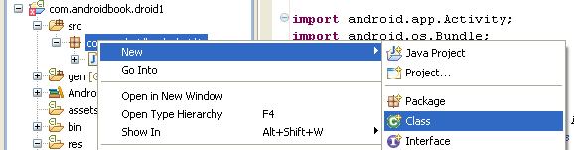3. Name your new class DroidActivity2.
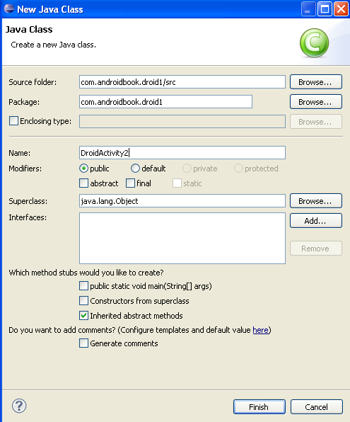
4. Click the Browse button next to the Superclass field and set the superclass to
android.app.Activity.

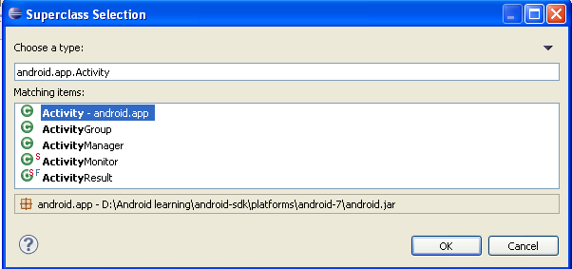

5. Click the Finish button. You see the new class in your project.
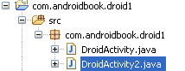

6. Make a copy of the main.xml layout file in the /res/layout resource directory
for your new activity and name it second.xml. Modify the layout so that
you know it’s for the second activity. For example, you could change the text
string shown. Save the new layout file.
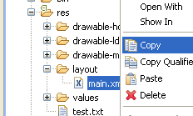
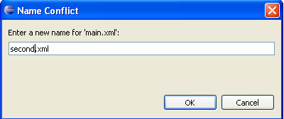
the tutorial asked me modify something from second.xml to make it unique, so you can confirm what is the file you loaded during you project-testing. i guess it isn't hurt if i skip my print screen for how i modify the files.
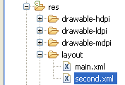

7. Open the DroidActivity2 class. Right-click within the class and choose
Source-Override/Implement Methods.
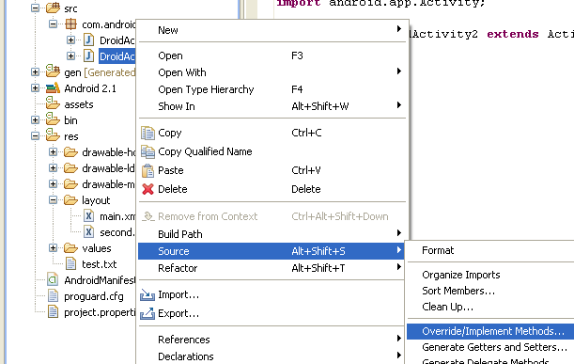

8. Check the box next to the onCreate(Bundle) method. This method is added
to your class.
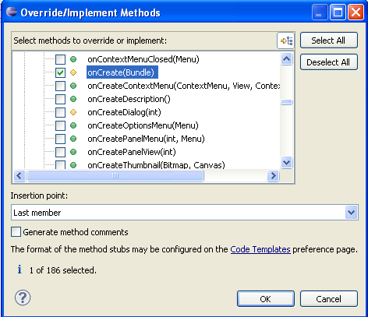

9. Within the onCreate() method, set the layout to load for the new activity by
adding and calling the setContentView(R.layout.second) method. Save the
class file.

finally reach the step i'm stuck
i'm not sure how to correctly calling the setContentView(R.layout.second) method
i tried to type in the code by my self, but since the program doesn't organize my "second.xml"
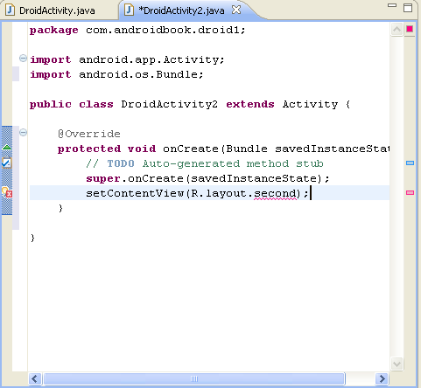
so, what should i do to solve this? or is there anything wrong in my steps?

